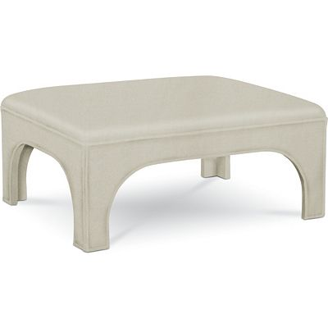

Size: 75cm-W x 60cm-H

Color: White

Material: Poplar Solids

Amount: 45

Price : 100$

Type: Small cabinet

Description: Style Authority. Get taken away by the casual yet compelling beauty of our Keystone side chair! It's as ready for a place in an open-concept kitchen as it is in a dining nook. The Parsons-style design provides the practicality of full back support as well as easy-clean faux leather in a deep brown finish. Espresso-toned wood legs and supports keep the look perfectly grounded.