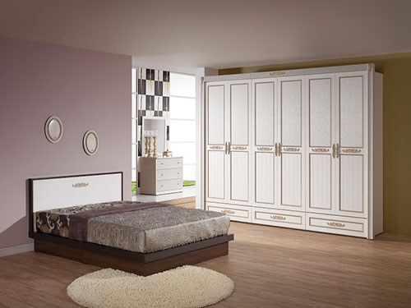

Size: 2m-W x 60cm-H

Color: Brown

Amount: 8

Price : 210$

Type: Bed

Description: Work of Art. Our well-designed, well-crafted Mosaic Queen bed shows off a tile-like motif that reflects its name, while providing superior function. This piece features dark brown veneers, even legs and both the headboard and footboard boast a grid-like, square tile pattern, completing the contemporary look.