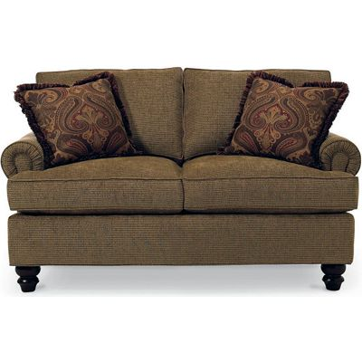

Size: 155cm-W x 90cm-H

Color: Dark red

Material: Microfiber

Amount: 20

Price : 200$

Type: Sofa

Description: Easy Living. Seeking cozy comfort that leaves a nice cushion in your budget? Look no further than our Adrian Red sofa! The full look offers a semi-attached cushion design, which contours to the body while retaining its shape, while flared pillowtop arms keep form and function in mind. Boasting a vibrant red color, the inviting fabric combines soft as suede® touchability with the smart performance of microfiber. Toss pillows shown are not included.