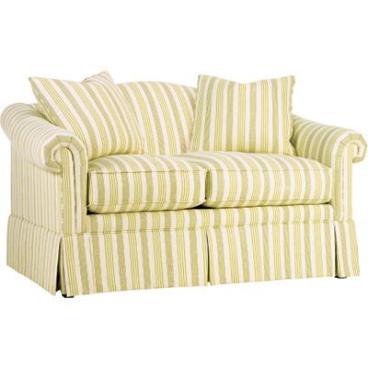

Size: 150cm-W x 90cm-H

Color: Yellow & White

Material: Cotton

Amount: 31

Price : 380$

Type: Sofa

Description: In Bloom. Give your room a dose of springtime appeal — year round! — with our Springfield sofa! As pleasing as new blossoms coming up in a garden, the pale green fabric is light and airy, and the lovely floral pillow fabric brings a breath of fresh air inside. Roll arms, box cushions and plush backs keep you fully relaxed, and premium construction elements offer long-lasting support. Simple stripes give the main 100% cotton fabric a touch of added interest.