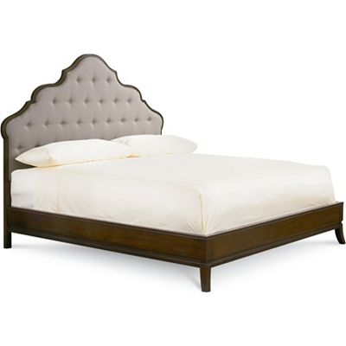

Size: 150cm-W x 180cm-H

Color: Cherry and grey

Material: Wood

Amount: 21

Price : 200$

Type: Bed

Description: Curved Concept. Your eye will delight in the beautiful veneers and curved lines of our Vanderbilt Queen storage bed. With just a hint of art deco style, this bed boasts a subtly concave footboard with two convenient storage drawers with luscious, diagonally set Prima Vera veneers. The curved headboard features plush microfiber fabric and smart nailhead trim. Sleek, burnished metal drawer pulls and a warm brown cherry finish give this bed the perfect finishing touch. (Mattress set not included.)