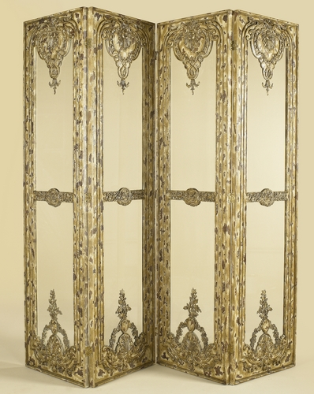

Size: 150cm-W x 180cm-H

Color: Gold and yellow

Material: Wood and class

Amount: 32

Price : 100$

Type: dielectric

Description: