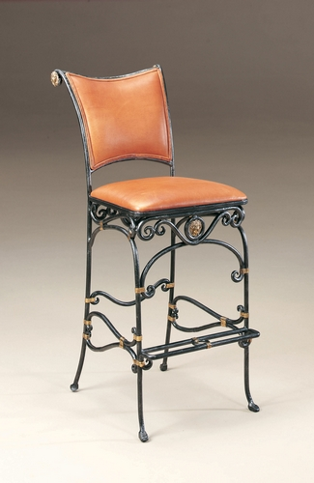

Size: 150cm-W x 90cm-H

Color: Black and yellow

Material: Metal and Microfiber

Amount :32

Price : 70$

Type: Chair

Description: Charming Appeal. Our hospitable Roanoke side chair adds a cozy yet updated and casual style to your dining space, with its solid wood construction and signature rustic oak finish paired with a complementary black rubbed trim. This inviting bow back chair features decorative spindle shape legs and stretchers, along with tapered seat back bars, enhancing the delightfully simple design.