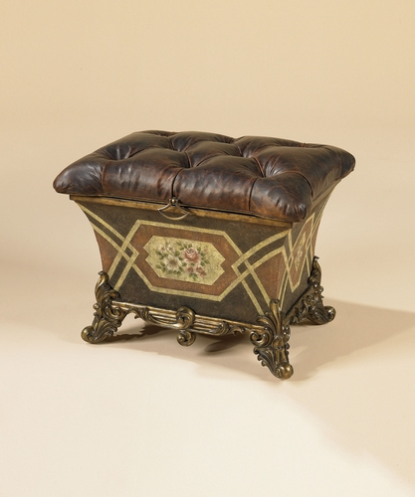

Size: 50cm-W x 50cm-H

Color: Gold and yellow

Material: Wood microfiber

Amount: 13

Price : 100$

Type: Chair

Description: Beauty and the Bistro. Upholstered in easy care faux leather, our Brooke collection brings a touch of bistro style right into your home. Available in three different heights — standard, counter height and bar level — this seating group combines the inviting tones of the fruitwood finish on the all-wood legs and frame with the deepest, darkest brown possible on the comfortably padded seat and cushioned back. The interplay of those two tones is enhanced by the tufted detailing, for a look that's fun, fashionable and inviting.