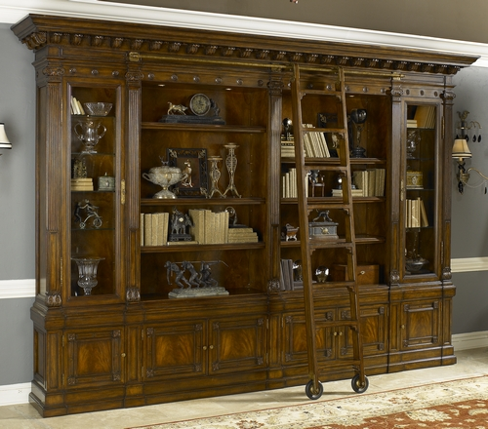

Size: 250cm-W x 220cm-H

Color: Cherry

Material: Wood

Amount: 2

Price : 1000$

Type: Bookcase

Description: Complete your Italian countryside decorating scheme with our Verona Six-Shelf Bookshelf. Adorned with the iconic "X" detail for which this bestselling collection is known, it's a contemporary home office solution disguised as a rustic find.