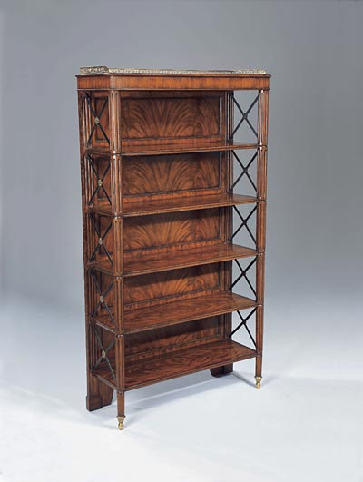

Size: 75cm-W x 170cm-H

Color: brown

Material: Wood microfiber

Amount: 13

Price : 250$

Type: Bookcase

Description: Complete your Italian countryside decorating scheme with our Verona Six-Shelf Bookshelf. Adorned with the iconic "X" detail for which this bestselling collection is known, it's a contemporary home office solution disguised as a rustic find.