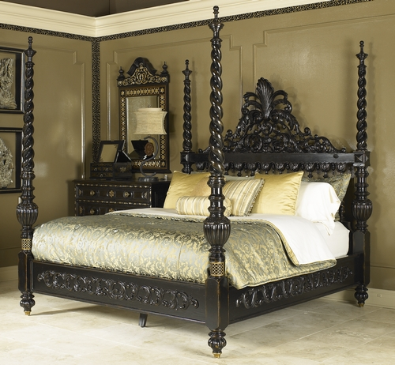

Size: 250cm-W x 220cm-H

Color: Black

Material: Wood

Amount: 2

Price : 1000$

Type: Bed

Description: Coveted Choice. Our Plantation Cove Black Poster Queen bed is stylish and inviting, ideal for anyone who enjoys casual comforts and timeless appeal. The classic black finish and the strong, clean lines make the furniture easily adaptable to your bedroom's existing color scheme and versatile enough to work well with additional décor. Shaped finials on top of the four tall, chamfered posts and louver-style panels on the headboard and footboard distinguish this bed and serve as the finishing touches to this grand and graceful piece. (Mattress set not included.)