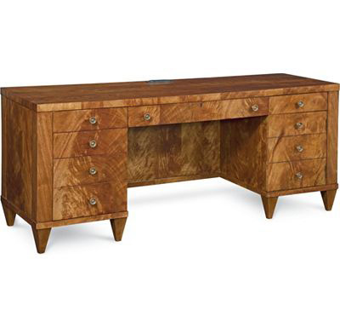

Size: 150cm-W x 75cm-H

Color: Brown

Material: Wood

Amount: 21

Price : 250$

Type: Desc

Description: Oak with fruitwood stain