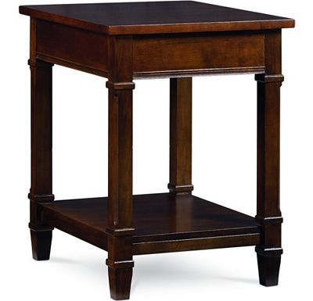

Size: 50cm-W x 80cm-H

Color: Brown

Material: Wood

Amount: 53

Price : 80$

Type: Table

Description: Stylish Nook. If you want to add fashion-forward décor to your plate, then our Alcove table is for you! With its use of mixed materials and a cool crossover base, this eye-catching round table shows that you're style savvy. The floating glass tabletop and lower shelf with quarted-matched veneers are accented by a mirror-finished metal ring. A merlot wood finish completes the strikingly modern look.