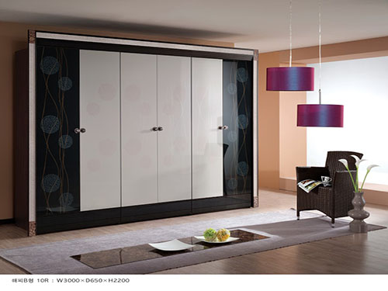

Size: 3m-W x 270cm-H

Color: White

Material: Wood, class

Amount: 17

Price : 510$

Type: Bed

Description: