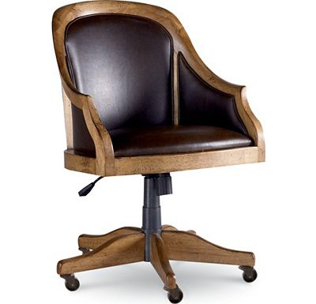

Size: 50cm-W x 90cm-H

Color: Black

Material: Wood

Amount: 23

Price : 150$

Type: Chair

Description: Sure Bet. Get the on-trend look of modern masterpieces of furniture design with our Casino accent chair. In an homage to the classic design by Mies van der Rohe, this piece has an architecturally-inspired silhouette with its sculptural chrome frame and box style seat and back cushions. Button-tufted details add a graceful touch and keep the look from being too severe, and the versatile white bonded leather upholstery will easily blend with any room's color scheme. Velcro-adhered cushions ensure that the look is always crisp and clean.