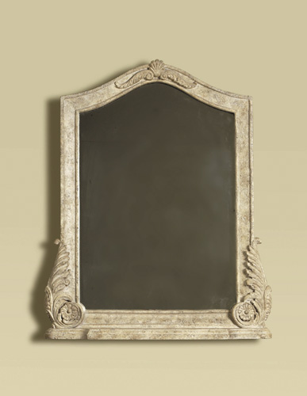

Size: 50cm-W x 75cm-H

Color: Grey

Material: Wood

Amount: 2

Price : 1000$

Type: Bed

Description: Fashion House. At the cutting edge of style and home design is our Casa Moda floor mirror. An exquisite chocolate finish on the all-wood frame sets the tone for this minimalist full-length mirror.