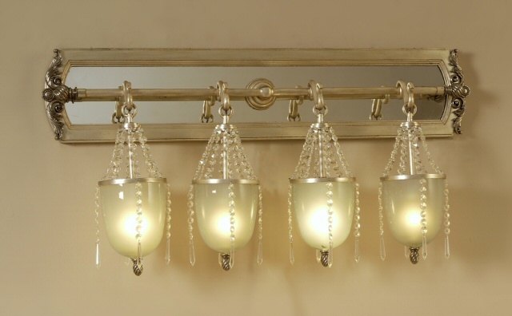

Size: 50cm-W x 35cm-H

Color: White

Material: Class wood

Amount: 2

Price : 120$

Type: Lamp

Description: This lamp very nice four lamp.