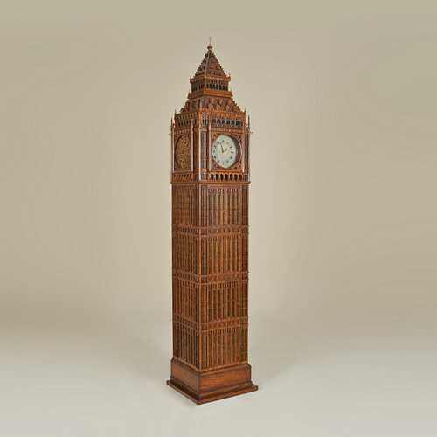

Size: 30cm-W x 100cm-H

Color: Brown

Material: Plastic

Amount: 1

Price : 320$

Type: Clock

Description: You Like play chess. This table is you li it.