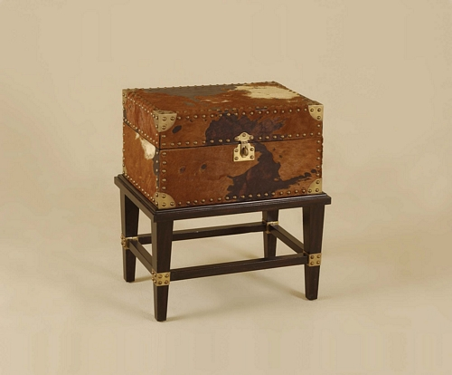

Size: 50cm-W x 75cm-H

Color: Grey

Material: Wood

Amount: 10

Price : 120$

Type: Chest

Description: This table is you li it.