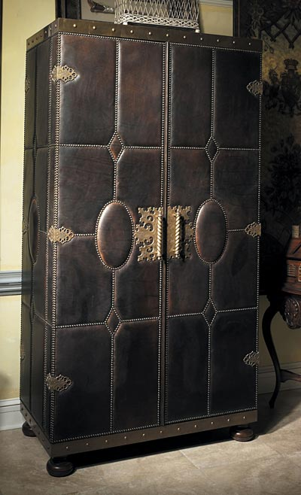

Size: 75cm-W x 150cm-H

Color: Grey

Material: Wood

Amount: 1

Price : 220$

Type: Cabnet

Description:. This table is you li it.