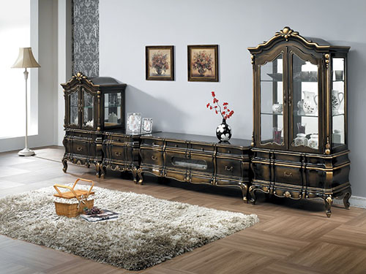

Size: 3m-W x 150cm-H

Color: Dark brown, grey

Material: Wood, class

Amount: 7

Price : 510$

Type: Entertaiment

Description: Full Form. Our Crescent collection is just the thing to complete your home theater! Mixing clean lines with a stunning merlot finish and cool frosted glass, the design makes a modern statement without sacrificing practicality. Multi-tiered storage gives you more than enough space for all your media components, as well as for those personal pieces that make a place your own.