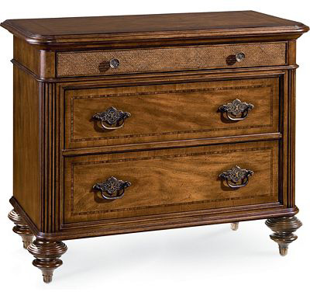

Size: 100cm-W x 80cm-H

Color: Brown

Material: Wood

Amount: 5

Price : 170$

Type: Cabinet

Description: Coveted Choice. Our Plantation Cove Brown chest is stylish and inviting, ideal for anyone who enjoys casual comforts and timeless appeal. The classic black finish and the strong, clean lines make this furnishing easily adaptable to your bedroom's existing color scheme and versatile enough to work well with additional décor. Seven drawers provide ample storage options, while brushed nickel drawer pulls add the homey finishing touches to this grand and graceful piece.