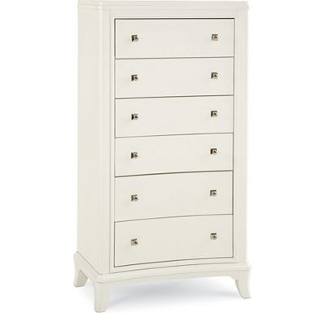

Size: 60cm-W x 110cm-H

Color: White

Material: Wood

Amount: 20

Price : 210$

Type: Cabinet

Description: Stylishly Aligned. Strong European inspiration combines with design-savvy touches in our Bally White chest, making your fashionable taste unmistakably known. The crisp white finish gives this chest a cool, fresh feeling, while the opaque glass top adds a sense of polished style. Brushed nickel hardware and generous drawer-and-shelf storage round out this chic piece.