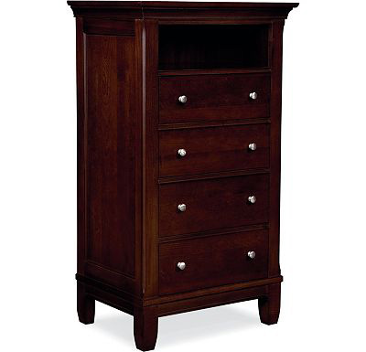

Size: 60cm-W x 110cm-H

Color: Brown

Material: Wood

Amount: 35

Price : 160$

Type: Cabinet

Description: Sleek Style. Our Urban Living chest will add an element of modern sophistication to your bedroom. A unique, blended cherry finish creates subtle depth and rich tones. The five generously-sized drawers are accented with button pulls in a contemporary gunmetal finish. Tall, tapered legs and recessed panels give this piece an added dash of heirloom elegance.