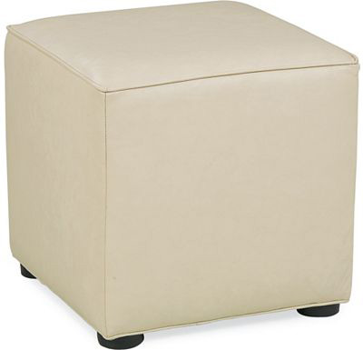

Size: 60cm-W x 60cm-H

Color: White

Material: Microfiber

Amount: 50

Price : 110$

Type: Chair

Description: Living Room Royalty. Our Monarch collection will leave you feeling like the king or queen of the castle, as you luxuriate in the plush, chocolate-colored corduroy fabric and ample top cushion of this cocktail ottoman. This piece boasts welted trim on the cushion and modern, cylindrical legs, completing the comfortable look.