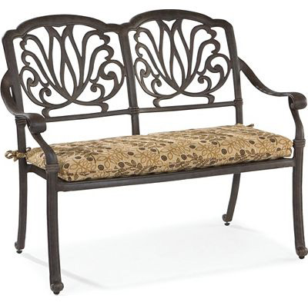

Size: 120cm-W x 80cm-H

Color: Black

Material: Wood and microfiber

Amount: 32

Price : 110$

Type: Chair

Description: Double Time. The easygoing charm of our Chesapeake counter-height bench will make you want to linger even longer at mealtime! The combination of black and oak wood finishes immediately draws your eye in, then bringing your attention to the sweet country-inspired design. Sphere details on the tapered legs round out this sure-to-be long-standing favorite.