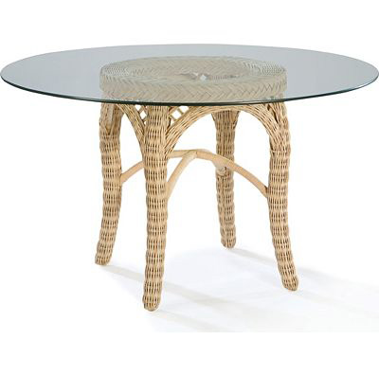

Size: 40cm-W x 80cm-H

Color: Green

Material: Wood and Class

Amount: 32

Price : 110$

Type: Table

Description: Charming Appeal. Our hospitable Roanoke table adds a cozy yet updated and casual style to your dining space, with its solid wood construction and signature rustic oak finish paired with a complementary black rubbed trim. This piece boasts an impressive, oak-veneered tabletop and thick, carved pedestal with contoured leg supports, enhancing the delightfully simple design. A hidden butterfly leaf is included to conveniently accommodate guests or a large family.