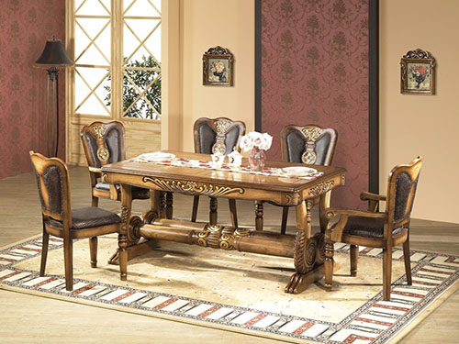

Size: 1.5m-W x 70m-H

Color: Brown

Material: Poplar Solids and Cherry Veneers

Amount: 20

Price : 600$

Type: Dining table

Description: Superb Vintage. Impeccably crafted with a nod to old world design, our Chateau Emillion collection imbues your home with elegance and beauty. Graceful curves and ornate details adorn the double pedestals, the tabletop and the legs and backs of the chairs. Made of all wood and finished in a rich, antiqued brown, this collection is sure to only improve with age.