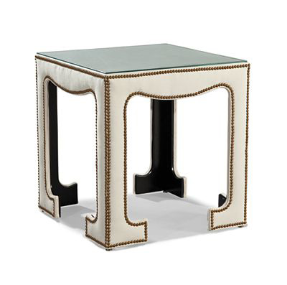

Size: 40cm-W x 60cm-H

Color: White and brown

Material: Metal and microfiber

Amount: 31

Price : 110$

Type: Chair

Description: Stylish Nook. If you want to add fashion-forward décor to your plate, then our Alcove Beige chair is for you! The Parsons-style design, enhanced by versatile beige microfiber, creates a comfortable setting, and a merlot wood finish completes the strikingly modern look.