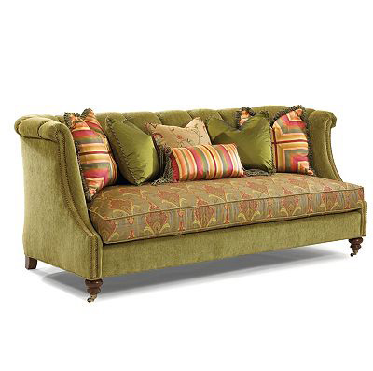

Size: 200cm-W x 80cm-H

Color: White and brown

Material: Wood and microfiber

Amount: 20

Price : 230$

Type: Sofa

Description: Home Pride. Our Palmer III 72" sofa offers an enviable combination for your home — it's the perfect blend of long-lasting comfort and fashion! The style is casually contemporary, but with features that stand the test of time: easygoing roll arms, welted seat cushions and simply angled wood feet. Premium foam cores and sinuous seat springs work overtime to keep you relaxed, while the bark finish exudes visual warmth. The accent pillows sport classic stripes and French script for a perfect dose of effortless decorating appeal.