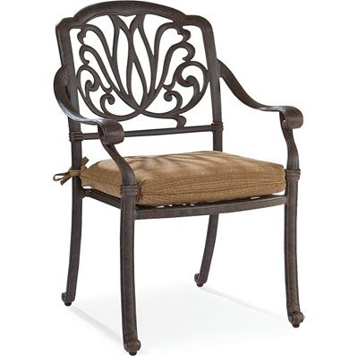

Size: 60cm-W x 60cm-H

Color: Black

Material: Wood

Amount: 33

Price : 110$

Type: Chair

Description: Superb Vintage. Impeccably crafted with a nod to old world design, our Chateau Emillion arm chair imbues your home with elegance and beauty. Graceful curves and ornate details adorn the legs and back of this piece, while the seat and back cushions are upholstered in brown bonded leather and the back is decorated with nail head trim. Made of all wood, featuring rolled flourishes on the arms and finished in a rich, antiqued brown, this arm chair is sure to only improve with age.