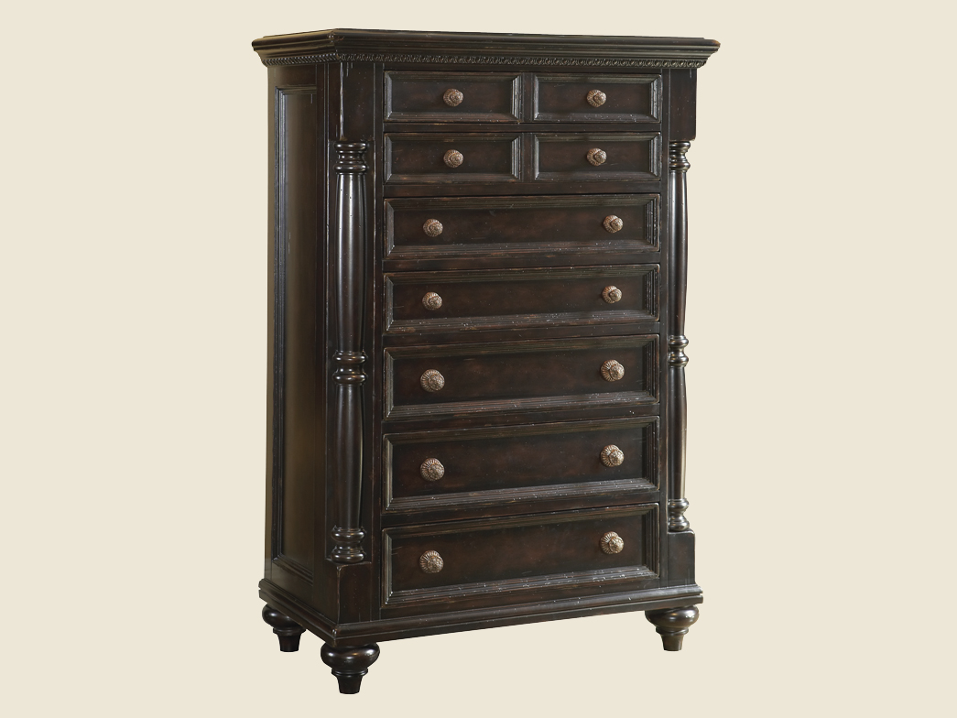

Size: 60cm-W x 100cm-H

Color: Black

Material: Wood

Amount: 33

Price : 110$

Type: Chair

Description: Bring home youth furniture that is both sporty and spiffy with our Varsity Merlot chest! Durably constructed with hardwood solids and topped by rich, merlot-finished veneers, this piece can withstand the wear-and-tear of kids and look great at the same time. This chest features five ample drawers and a lift top with anti-slam support that provides extra storage.