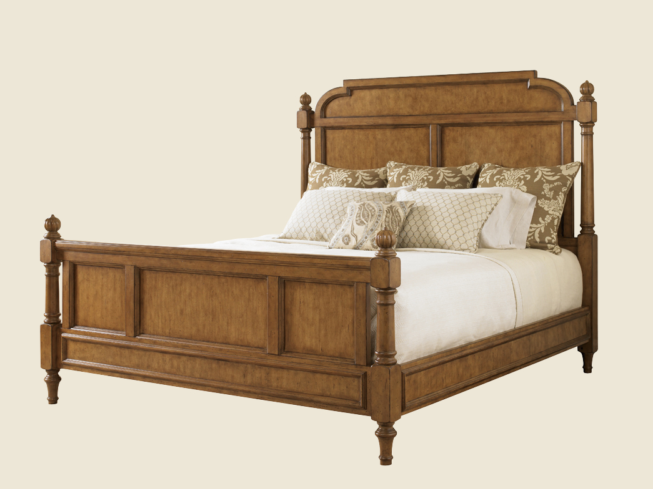Size: 150cm-W x 80cm-H

Color: Green

Material: Wood

Amount: 13

Price : 450$

Type: Bed

Description: Sleek Style. Our Urban Living Queen bed will add an element of modern sophistication to your bedroom. A unique, blended cherry finish creates subtle depth and rich tones. The panel bed headboard and footboard feature eye-catching veneers oriented on the diagonal for extra visual interest. Tall, tapered legs and recessed panels give the bed an added dash of heirloom elegance. (Mattress set not included.)