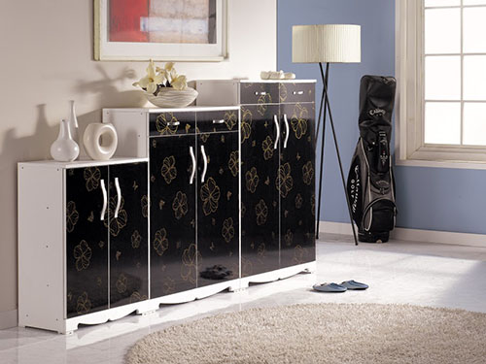

Size: 75cm-W x 1.3m-H

Color: Black and white

Material: Hardwood Solids and Veneers

Amount: 21

Price : 600$

Type: Cabinet

Description: Bring home youth furniture that is both sporty and spiffy with our Varsity Merlot chest! Durably constructed with hardwood solids and topped by rich, merlot-finished veneers, this piece can withstand the wear-and-tear of kids and look great at the same time. This chest features five ample drawers and a lift top with anti-slam support that provides extra storage.