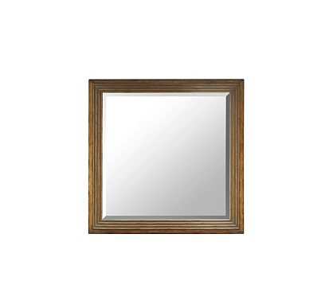

Size: 40cm-W x 40cm-H

Color: Brown

Material: Wood

Amount: 32

Price : 40$

Type: Mirror

Description: Fashion House. At the cutting edge of style and home design is our Casa Moda floor mirror. An exquisite chocolate finish on the all-wood frame sets the tone for this minimalist full-length mirror.