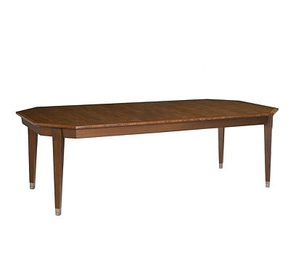

Size: 150cm-W x 75cm-H

Color: Green

Material: Wood

Amount: 45

Price : 170$

Type: Table

Description: Style Authority. Get taken away by the casual yet compelling beauty of our Keystone table! It's as ready for a place in an open-concept kitchen as it is in a dining nook. The genuine stone veneers of the tabletop pair wonderfully with the espresso-finished wood, creating an arresting style that catches the eye.