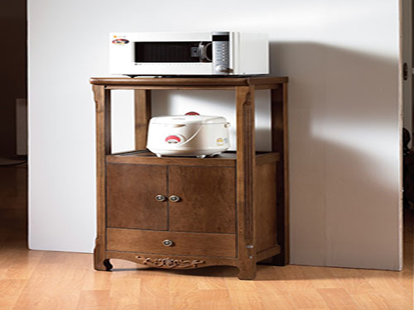

Size: 50cmd-W x 70m-H

Color: Brown

Material: Poplar Solids and Veneers

Amount: 12

Price : 50$

Type: Small cabinet

Description: Bring home youth furniture that is both sporty and spiffy with our Varsity Merlot chest! Durably constructed with hardwood solids and topped by rich, merlot-finished veneers, this piece can withstand the wear-and-tear of kids and look great at the same time. This chest features five ample drawers and a lift top with anti-slam support that provides extra storage.