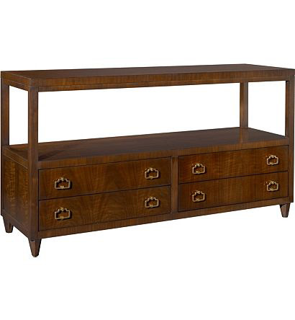

Size: 150cm-W x 80cm-H

Color: Brown

Material: Wood

Amount: 13

Price : 150$

Type: Cabinet

Description: Simply Palatial. With its exotic combination of materials, the elegance of our Morocco nightstand evokes the history and architecture of its namesake. The Old World styling is evident in every fluted carving and metal scrollwork detail. Continuing the far-flung theme is an acanthus leaf motif. The rich pecan finish, antiqued door-knocker pulls and burl veneers complete the majestic look.