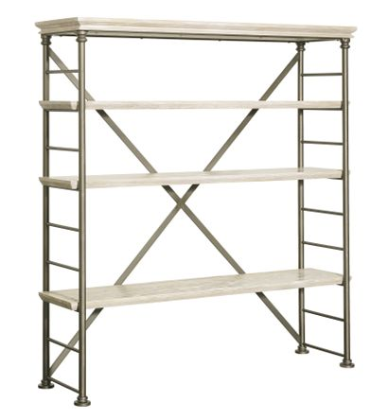

Size: 150cm-W x 80cm-H

Color: Brown

Material: Wood

Amount: 13

Price : 150$

Type: Cabinet

Description: We've taken traditional style and created a modern-day classic with our Campaign Bookshelf. Inspired by the strength, elegance and portability of British campaign-style furniture, this architecturally stunning bookshelf features an open construction with six shelves and two back beams that form an "X."