**Management Manual**

**Responsibilities of manager in management section is to control your candidates overflow and managing test question**

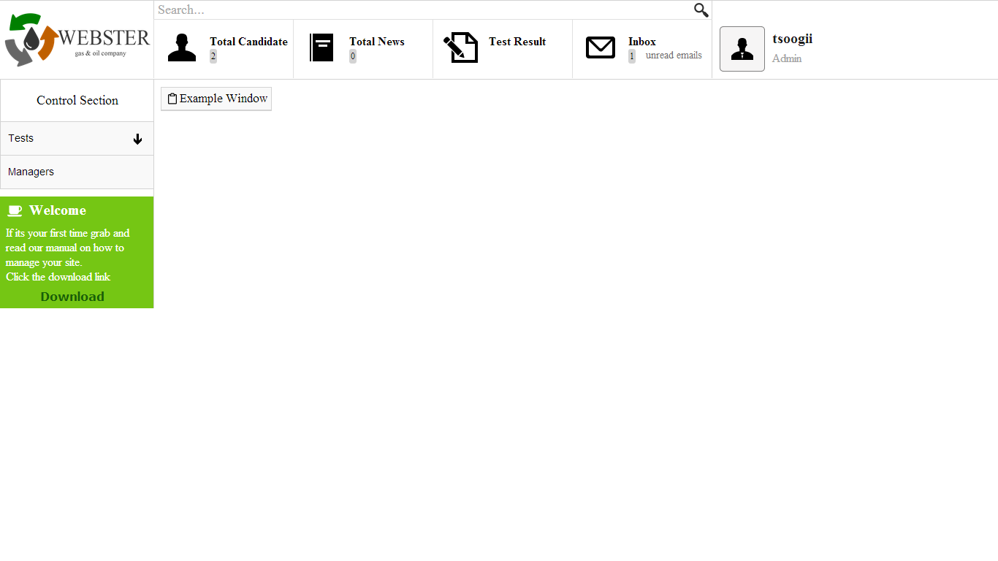

**As you see here in the header you can:**

1. **View full list of Candidates**
2. **Managing news section**
3. **Test results with candidates information**
4. **Mail from registered visitors**

**On the left navigation panel:**

1. **Tests to add, edit, delete any type of test questions**
2. **Editing your own manager username & password**

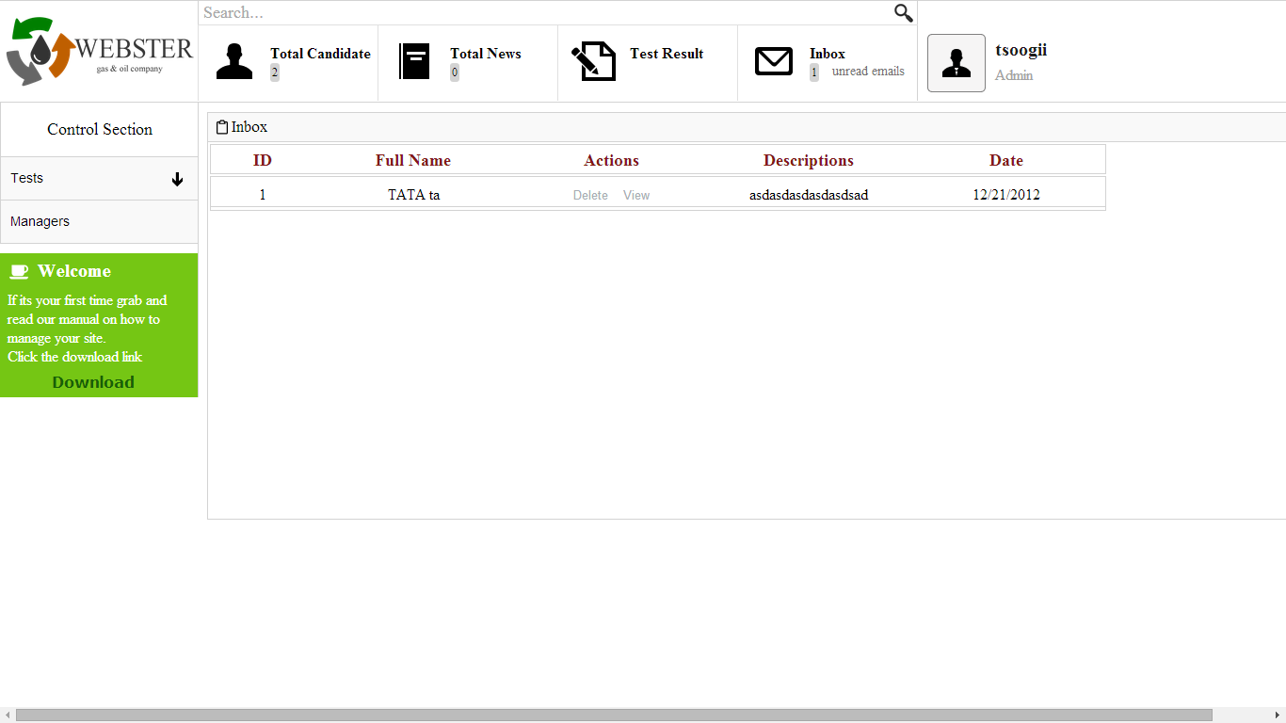

**This is inbox.**

**Manager can view registered visitors details and accept them to take test interview or you can just delete that mail**

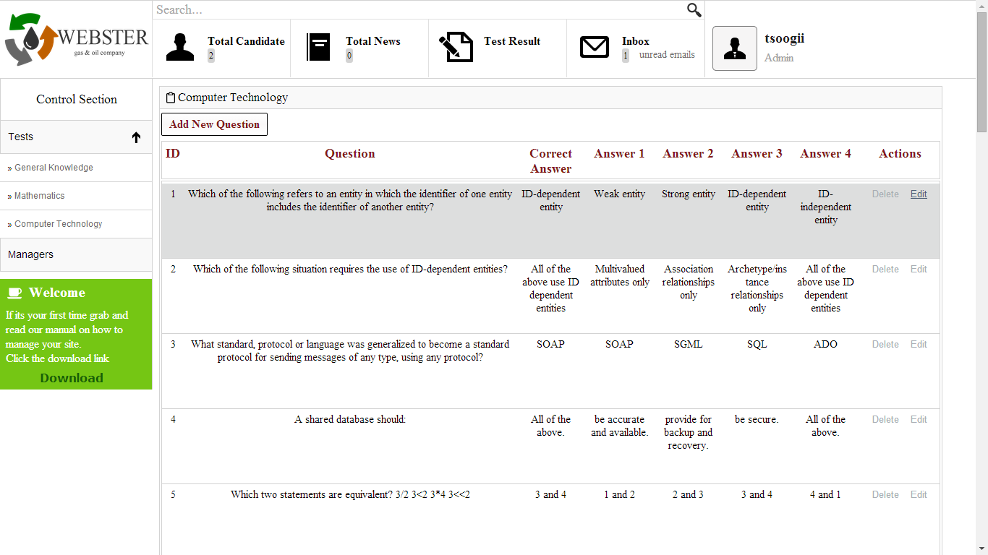

**This is test question section**

**Full list of your test questions and you can:**

1. **Add whole new test question with answers**
2. **Edit existing questions**
3. **Delete existing questions**