**Activity #2 – Web Design**

Task Sheet #2 Written Output

Name: Ace Lawrence Z. Clavano Date: April 19, 2024

*Per Page Analysis*

1. Personal Home Page

Overall Assessment:

* + The code structure is well-organized, featuring clear comments and class names, making it easy to comprehend.
  + Semantic HTML elements are applied effectively, contributing to improved accessibility and search engine optimization.
  + CSS styling maintains consistency and adheres to a unified design scheme.
  + External font imports and image usage contribute to the visual appeal of the webpage.
  + The layout is responsive, with styles adapted for various screen sizes.
  + Despite these strengths, there are areas for improvement, including optimizing images for quicker loading times, ensuring compatibility across different browsers, and enhancing accessibility through the implementation of proper ARIA roles and attributes.

1. Academic Information

Overall Analysis:

* The code structure is well-organized and easy to read, with clear comments and class names.
* Semantic HTML elements are utilized effectively, enhancing accessibility and SEO.
* CSS styling is consistent and follows a coherent design scheme.
* External font imports are included for visual appeal.
* The layout is responsive, with styles for different screen sizes.
* However, some improvements could be made, such as optimizing images for faster loading and ensuring cross-browser compatibility.

1. Personal Information

Overall Analysis:

* The code structure is well-organized and easy to understand, with clear comments and class names.
* Semantic HTML elements are used effectively, enhancing accessibility and SEO.
* CSS styling is consistent and follows a coherent design scheme, ensuring a visually appealing layout.
* Flexbox is utilized for layout management, providing flexibility and responsiveness.
* However, some improvements could be made, such as optimizing images for faster loading and ensuring cross-browser compatibility.

1. Family Information

In summary:

* + The code is structured neatly and is easily comprehensible, thanks to clear comments and well-named classes.
  + Semantic HTML elements are employed effectively, boosting both accessibility and search engine optimization.
  + CSS styling is consistent throughout, maintaining a cohesive design scheme that contributes to an aesthetically pleasing layout.
  + Flexbox is used for managing layout, offering flexibility and responsiveness.
  + Nonetheless, there are areas for enhancement, such as optimizing images to improve loading times and ensuring compatibility across various web browsers.

1. About Me

Overall, the code is neatly structured and comprehensible, featuring explicit comments and class labels. Semantic HTML elements are employed adeptly, bolstering both accessibility and search engine optimization. The CSS styling maintains consistency throughout, adhering to a unified design concept for an aesthetically pleasing layout. Flexbox is effectively leveraged for layout control, delivering adaptability and responsiveness. Nevertheless, there are areas that could be refined, including optimizing image assets for improved loading times and ensuring compatibility across different web browsers.

1. Resume

Overall:

* The HTML code presents a well-structured and styled webpage containing resume information.
* It effectively utilizes CSS for styling and layout management, ensuring a visually appealing and user-friendly design.
* The content is organized logically, making it easy for visitors to read and comprehend the information presented.
* However, some areas for improvement could include adding more descriptive alt attributes to images for accessibility and optimizing the layout for smaller screens to enhance responsiveness.

*Screenshots*

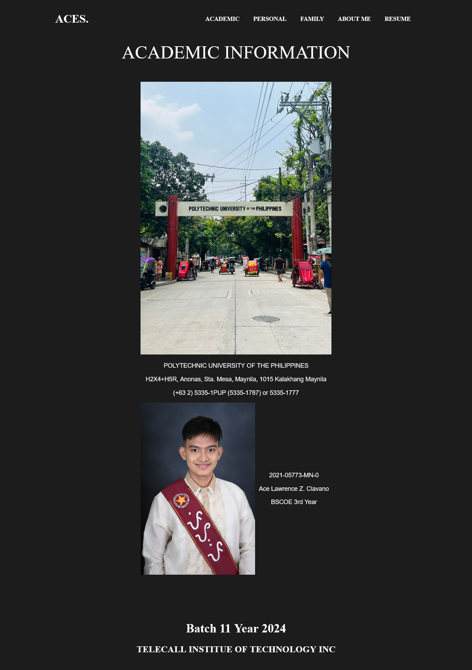

*Overview*

The HTML documents are structured to represent different sections of a personal website, including academic, personal, family, about me, and resume information. Each document begins with a header containing navigation links to other sections of the website.

In terms of styling, CSS is used consistently across all documents to create visually appealing layouts. Various fonts are imported to enhance the design, and flexbox is utilized for layout management, ensuring flexibility and responsiveness.

Each section of the website contains relevant content presented in a clear and organized manner. Semantic HTML elements are employed effectively, contributing to accessibility and search engine optimization. Additionally, images are included to complement the content and enhance the visual appeal.

The resume section provides detailed educational background, skills qualification, and seminars/training attended. The information is presented logically, making it easy to read and understand. The use of tables enhances the presentation of seminar/training details.

Overall, the provided information demonstrates a well-structured and visually appealing personal website, with clear navigation and organized content. However, there are opportunities for improvement, such as optimizing images for faster loading and ensuring cross-browser compatibility for a better user experience.

Link to Output: <https://drive.google.com/drive/folders/1J-ypV4kgekyVZaQGi06pm9O6jVbgaDw-?usp=sharing>