Polygon Triangulation
In computational geometry, polygon triangulation is the decomposition of a polygonal area (simple polygon) P into a set of triangles i.e., finding a set of triangles with pairwise non-intersecting interiors whose union is P.

The three algorithms have been implement for triangulation of a simple polygon are:
1> DCEL data structure to store polygon partitioning.
2> Partitioning a polygon into y-monotone polygons.
3> Triangulate each y-monotone polygon.
1> DCEL
DCEL was implemented with the following declarations:
class DCEL
{
public:

DCEL();
virtual ~DCEL();
void initialise(vector<Point>);
void addHalfEdges(int i, int j);
void addHalfEdges(Vertex* v1, Vertex* v2);
void triangulateYMonotone();
void getTriangles(vector<Triangle>& ) ;

Vertex* start_vertex;
vector<Vertex*> v_list;
vector<Face*> f_list;
vector<HalfEdge*> e_list;

};
Other details can be found in the documentation.

2>Partitioning a polygon into y-monotone polygons.
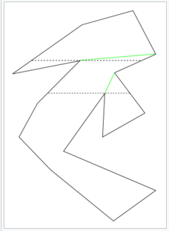

A simple polygon may be decomposed into monotone polygons as follows:

For each point p, check if the neighboring points are both on the same side of the sweep line (e.g. to the left of the sweep line, in the case of a vertical sweep line), which is a vertical (or horizontal) line on which the point p being iterated lies. If they are, check the next sweep line on the other side. Break the polygon on the line between the original point and one of the points on this one.

Note that if you are moving downwards, the points where both of the vertices are below the sweep line are 'split points'. They mark a split in the polygon. From there you have to consider both sides separately.

Using this algorithm to triangulate a simple polygon takes O(n log n) time.

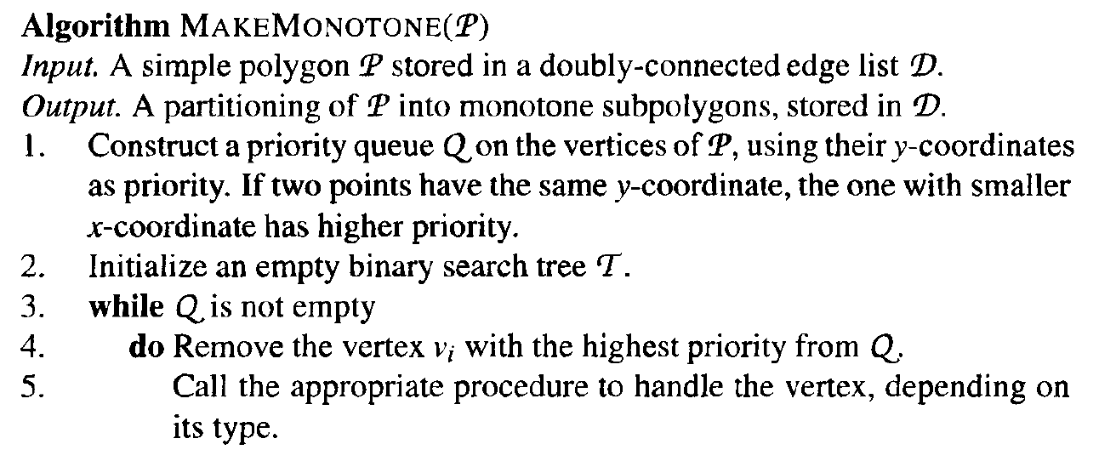

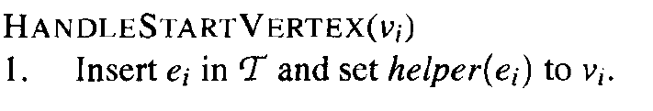

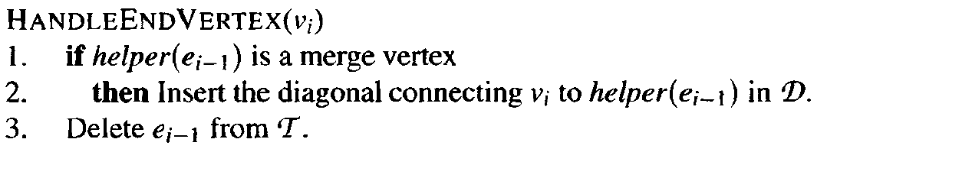

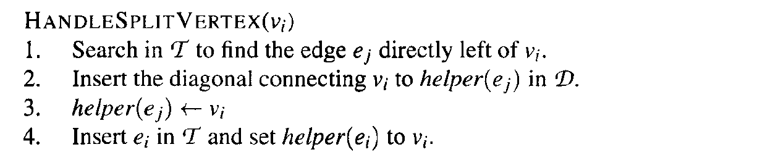

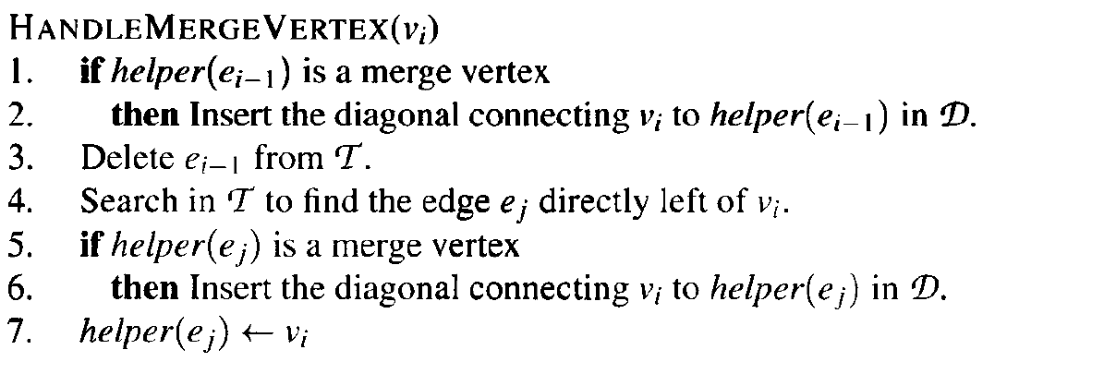
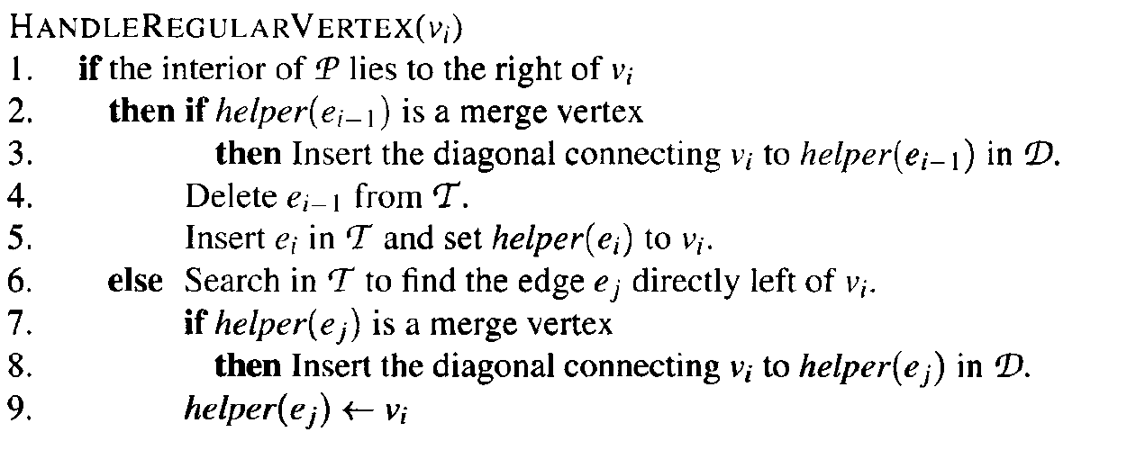

3> Triangulate each y-monotone polygon-

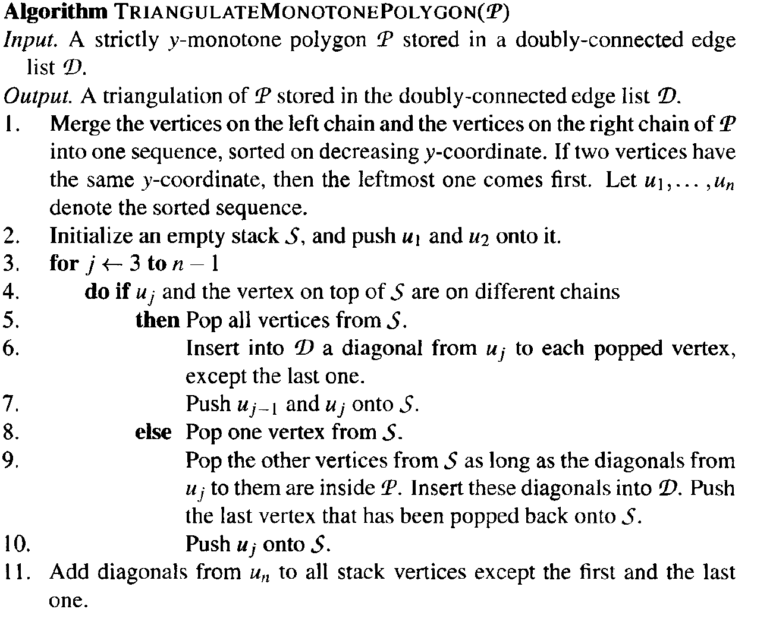
This algorithm take O(n) time.
But as Decomposing the polygon into monotone pieces takes O(n log n) time the whole program runs in O(n log n ) time and this algorithm uses O( n ) storage.

Screenshots of Test:

1>With 5 points:

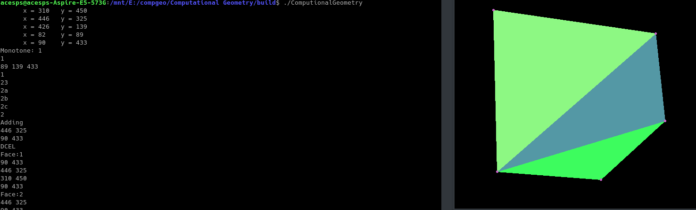
2> With 10 points:INPUT:
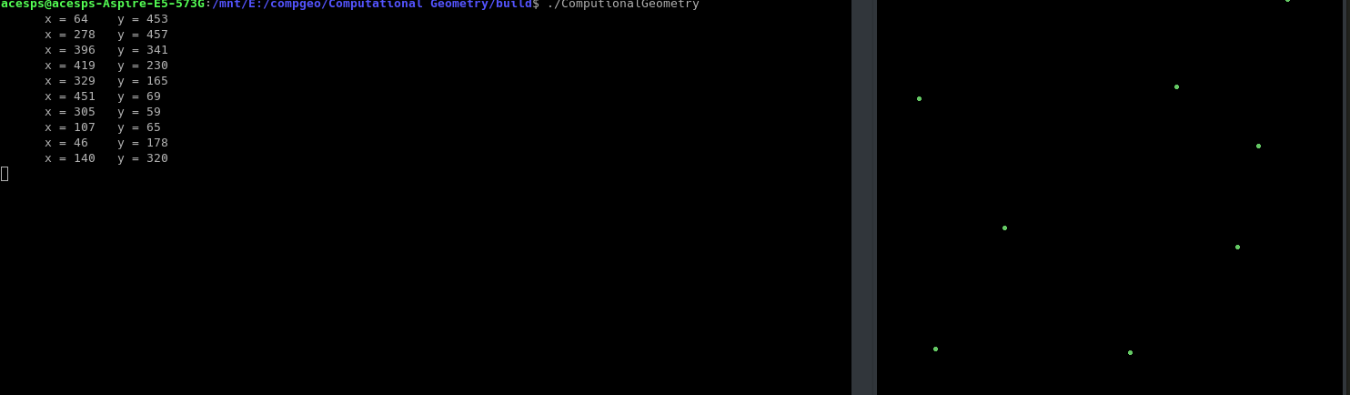
OUTPUT:

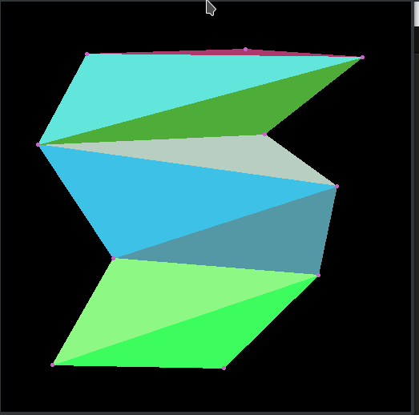

3> With 15 points :
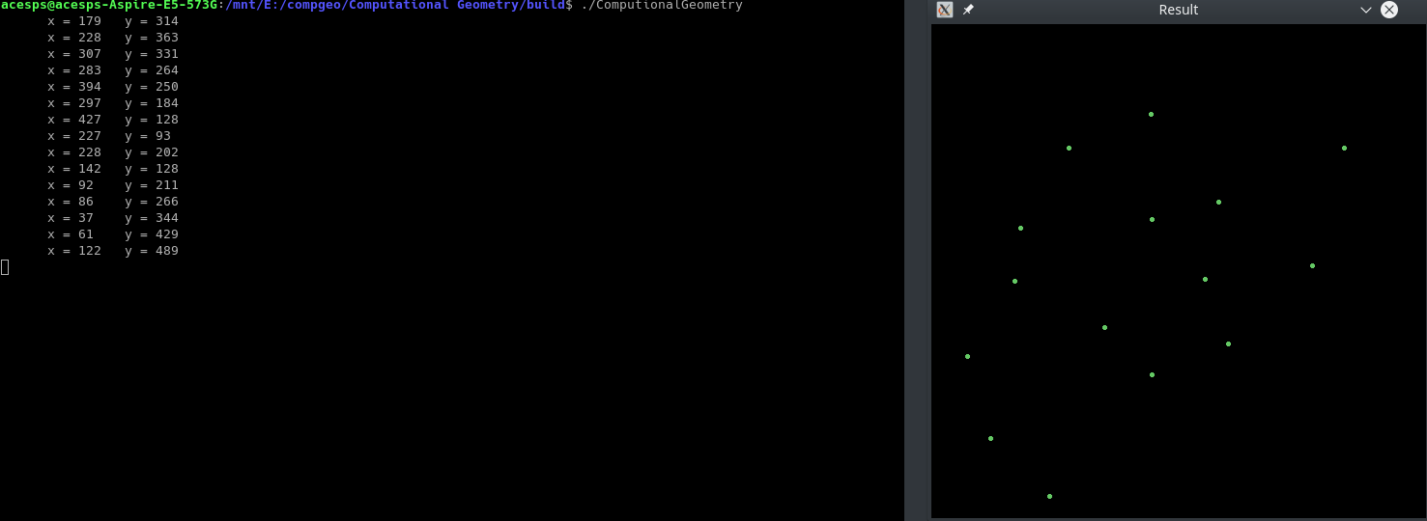
INPUT:

OUTPUT:

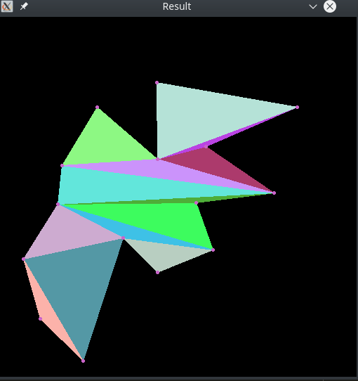

4> With 20 points:
INPUT:
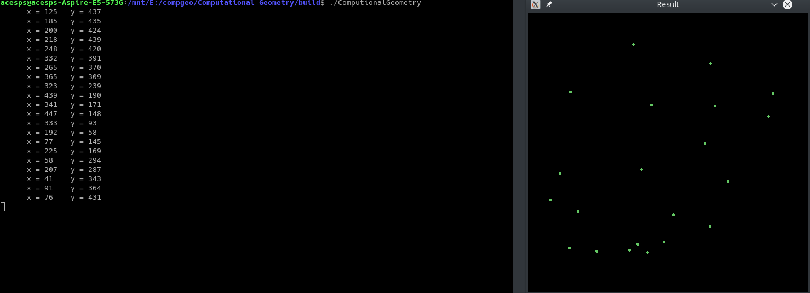

OUTPUT:

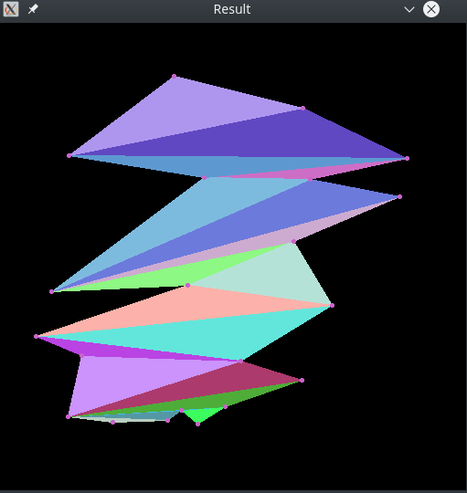

5>With 25 points:
INPUT:
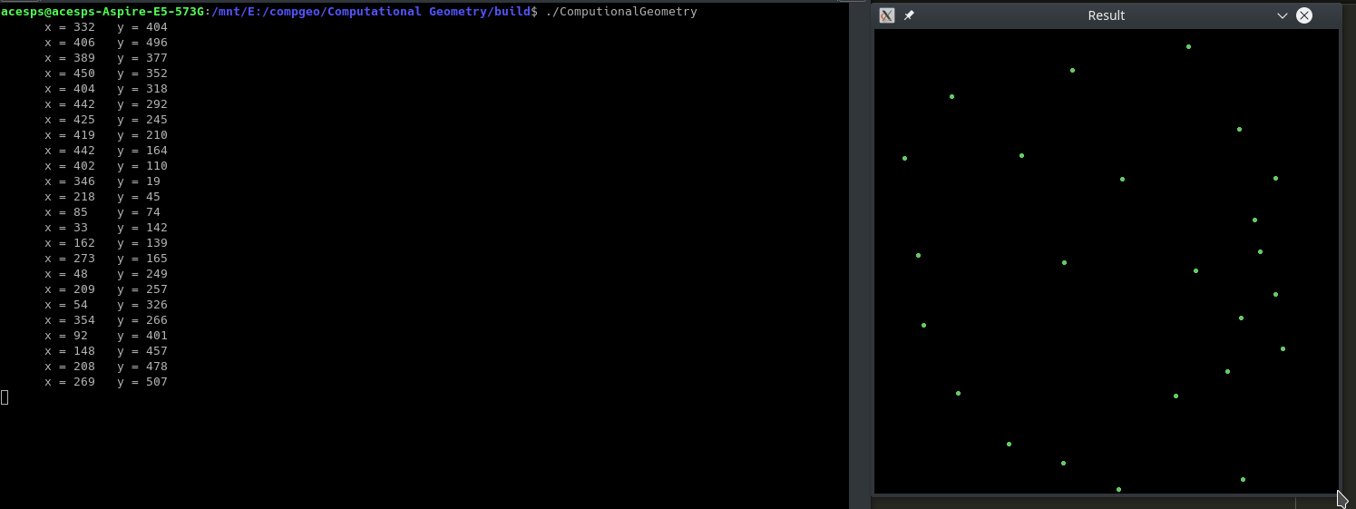
OUTPUT:
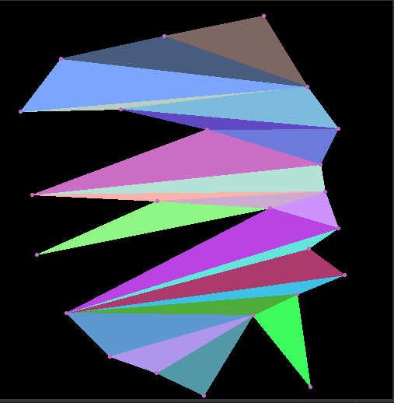

GROUP MEMBERS:
1>Bhavathii Reddy
2>Shubham Singal
Dependencies:
1.cmake
2.openCV
To install dependecies:
sudo apt-get install libopencv-dev
sudo apt-get install cmake
Build instructions:
To build, execute the following commands from the project root directory:
mkdir build
cd build
cmake ../
make
To Run:
From the build directory:
./ComputationalGeometry

