  - CLIENT REVIEW PACKET

Systems Analysis Portfolio
Weeks 1–7 | CIT 140 | Version 1.0
Prepared by Craig Temple
Review date: November 8, 2026
Prepared for course client review. Cases are separate fictional training scenarios and do not represent one combined system.

Client overview
This portfolio brings together my first seven weeks of CIT 140 work. The assignments cover different clients and systems, but the goal is consistent: understand the problem, check the evidence, and identify what still needs to be answered before suggesting a solution. I've included the key findings from each artifact along with references to the complete original files. The originals remain in their Week 1–7 GitHub folders.
This is a review of analysis work, not approval to operate equipment, change production systems, or claim a design has already been validated.

Contents
Week 1 — Meridian Forge Robotics: Problem Brief
Week 2 — Meridian Forge Robotics: Business Case Recommendation
Week 3 — Meridian Forge Robotics: Stakeholder Map
Week 4 — Cedar Junction: Validated Requirements Set
Week 5 — Cedar Junction: As-Is Appointment Process Model
Week 6 — Inspection Report Routing System: Data-Flow Model
Week 7 — Meridian Forge — Inspection Export: Data-Quality Report
W08-B01 — Week 7 client brief response
Closing review
Evidence register and outstanding checks

Week 1 | Problem Brief
Case: Meridian Forge Robotics
Original: Temple_Craig_CIT140_Week01_Problem_Brief.pdf

Key evidence
The incident log shows MR-17 accepted TEST_K44_START at 02:13:07. The current scheduler has no active test assignment, and the maintenance record describes Test K-44 as retired.
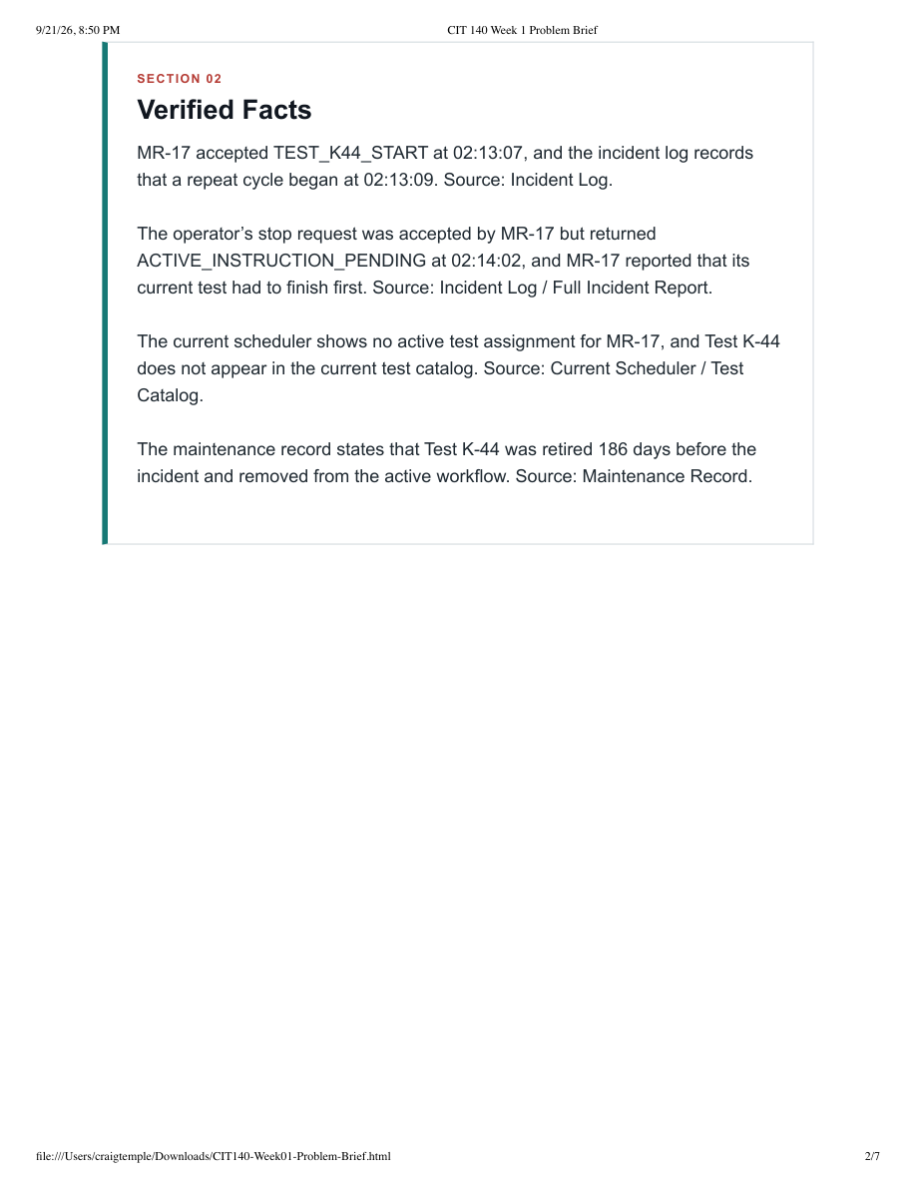
Original source: Temple_Craig_CIT140_Week01_Problem_Brief.pdf. See original for full report, captions, and context.

Client explanation
I examined why MR-17 accepted a command for retired Test K-44 even though the current scheduler had no active assignment for it. The incident log shows TEST_K44_START was accepted at 02:13:07, followed by a repeat cycle at 02:13:09, and the stop request later returned ACTIVE_INSTRUCTION_PENDING. The maintenance record also shows K-44 was retired 186 days earlier. This matters because the client needs to know where the command came from before making any decision about the affected QA cell. We still don't know what initiated the command or what the pending instruction actually was. I would compare command and scheduler history and preserve the original evidence before recommending changes.
Evidence reference: Incident Log, Full Incident Report, Current Scheduler / Test Catalog, Maintenance Record (Week 1 brief).

Week 2 | Business Case Recommendation
Case: Meridian Forge Robotics
Original: CIT140 Week 02 — Business Case Recommendation.pdf

Key evidence
Six record requests required 60 staff minutes; two of six had both an identified owner and an original source link. The proposed review is discovery work, not permission to restart MR-17.
Original source: CIT140 Week 02 — Business Case Recommendation.pdf. See original for full report, captions, and context.

Client explanation
I reviewed whether a limited QA Control Review would be worth pursuing rather than jumping straight into a technical fix. W02-S02 showed that six record requests took 60 staff minutes and only two had both a clear owner and an original source link. I recommended proceeding with a bounded review because improving traceability could help QA, Engineering and Operations make a better decision. The proposed work was limited to ten business days and a $3,000 planning envelope, not a restart or software change. Before the sponsor approves anything, read-only export access and staff availability still need confirmation.
Evidence reference: W02-S01, W02-S02 and W02-S05 (Week 2 business case).

Week 3 | Stakeholder Map
Case: Meridian Forge Robotics
Original: CIT140 Week 03 - Stakeholder Map.pdf

Key evidence
The named QA, Engineering and Operations contacts have different contributions. The record custodian and sponsor/authorization contact remain unconfirmed.
Original source: CIT140 Week 03 - Stakeholder Map.pdf. See original for full report, captions, and context.

Client explanation
I mapped the people affected by the proposed QA review and who needs to be involved in the decision. The participation notes W03-S01 through W03-S04 show that Nia represents QA needs, Elias provides technical interpretation, and Mara coordinates the recommendation. The night-shift operators also need a voice because they're the ones actually using the cell overnight. This matters because technical input and approval authority aren't the same thing. The record custodian and authorized sponsor were not confirmed, so I'd identify those contacts and confirm night-shift participation before gathering detailed requirements.
Evidence reference: W03-S01 through W03-S04 (Week 3 stakeholder map).

Week 4 | Validated Requirements Set
Case: Cedar Junction
Original: CIT140-Week04-Validated Requirements.pdf

Key evidence
R-01: separate Scheduling Held and Intake Held. R-03: confirm both room and qualified clinician availability before treating a same-day appointment as ready.
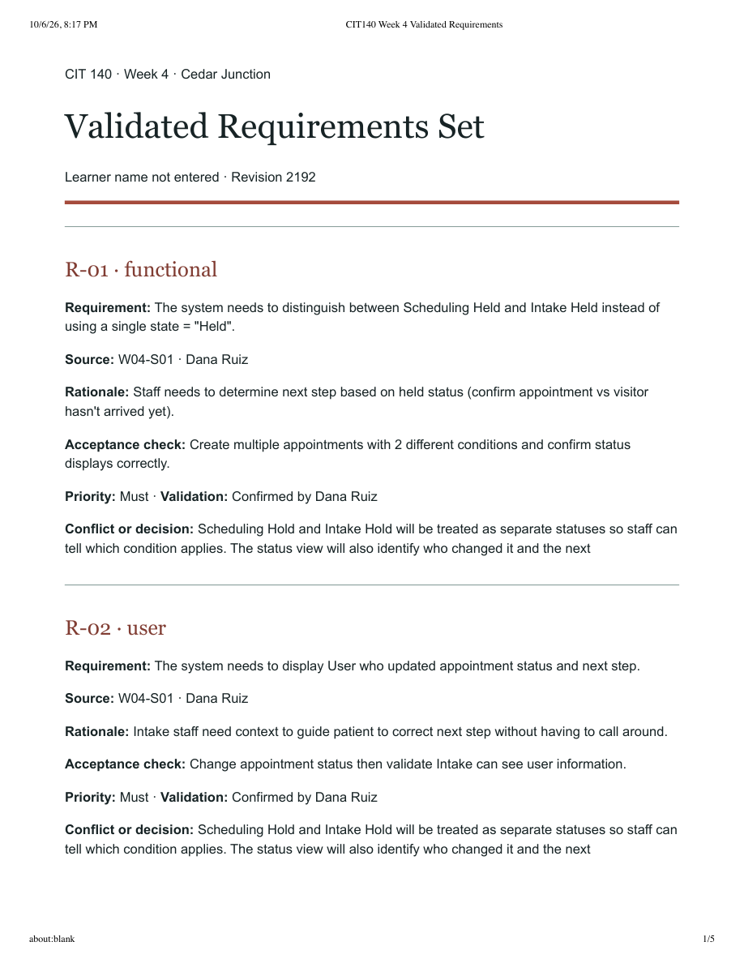
Original source: CIT140-Week04-Validated Requirements.pdf. See original for full report, captions, and context.

Client explanation
I reviewed the Cedar Junction appointment requirements to make sure the requested behavior could be understood and tested. For example, R-01 separates Scheduling Held from Intake Held, while R-03 requires both a room and a qualified clinician before a same-day appointment is considered ready. Those distinctions matter because a booking confirmation by itself doesn't tell Intake whether a visitor can actually be seen. The requirement set also covers staff access, privacy and status history. Before designing the solution, I'd confirm the intended status transitions and check that the acceptance tests match how the departments use the information.
Evidence reference: R-01, R-03 and related W04-S01 / W04-S02; R-05 through R-08 (Week 4 requirements).

Week 5 | As-Is Appointment Process Model
Case: Cedar Junction
Original: Temple_Craig_CIT140_Week05_As_Is_Process_Model.pdf

Key evidence
W05-S04 does not show a completed readiness decision before the visitor arrived. This is missing evidence, not confirmation the decision never happened.
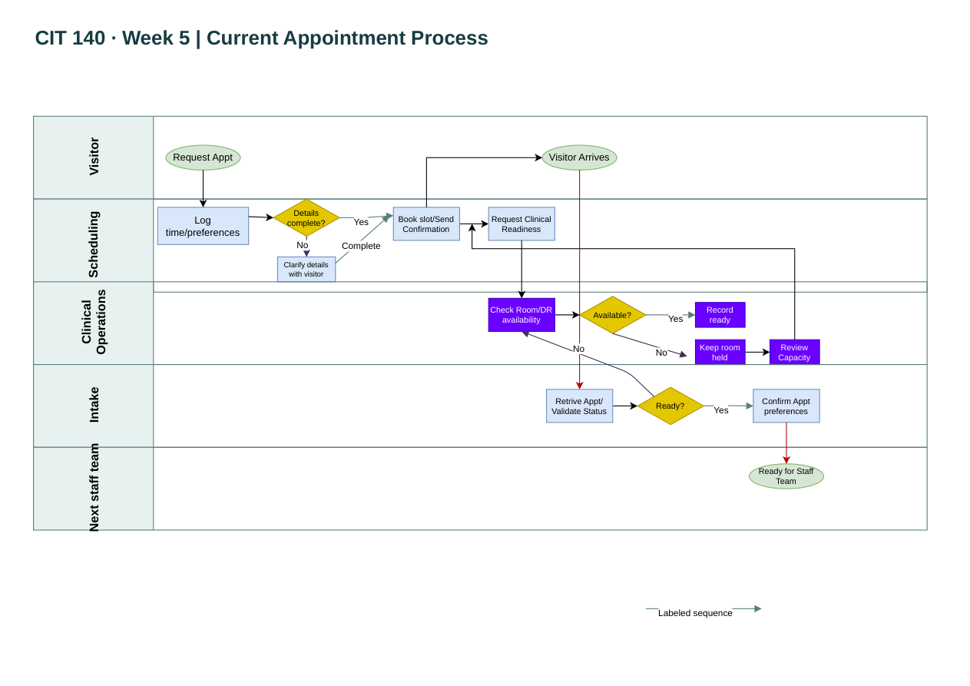
Original source: Temple_Craig_CIT140_Week05_As_Is_Process_Model.pdf. See original for full report, captions, and context.

Client explanation
I mapped how an appointment moves from the visitor's request through Scheduling, Clinical Operations and Intake. The W05-S04 incident trace shows a visitor received booking confirmation, but Intake still displayed Held when they arrived; the provided trace does not show a completed readiness decision before arrival. The swimlane diagram helped me separate booking from clinical readiness rather than treating them as the same step. This matters because the handoff determines what staff tell the visitor and which team needs to act. The record doesn't prove no readiness decision happened, so I'd confirm how Clinical Operations passes that decision to Intake before proposing changes.
Evidence reference: W05-S01 through W05-S04 and the Week 5 current-state swimlane.

Week 6 | Data-Flow Model
Case: Inspection Report Routing System
Original: Temple_Craig_CIT140_Week06.pdf

Key evidence
W06-S02: CJ-603 is BRIDGE. W06-S03 routes BRIDGE to Structures. W06-S04 shows CJ-603 routed to Electrical.
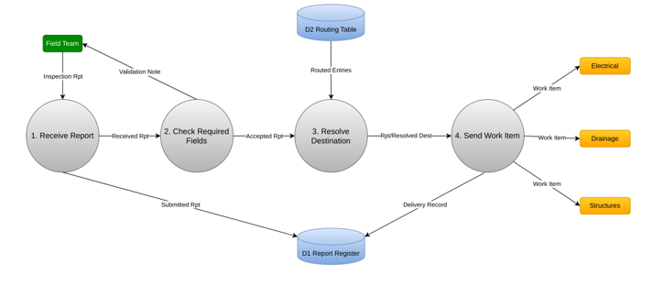
Original source: Temple_Craig_CIT140_Week06.pdf. See original for full report, captions, and context.

Client explanation
I modeled the Inspection Report Routing System to show how the Field Team's reports are checked and assigned to Electrical, Drainage or Structures. The source records show CJ-603 was a BRIDGE inspection in W06-S02 and should have routed to Structures under W06-S03, but W06-S04 lists Electrical as the destination. That is a supported routing mismatch, not proof of what caused it. The data-flow model helps identify where routing rules and records are used. Before recommending a fix, I'd check the Routing Table (D2) values that were active when CJ-603 was processed and confirm whether the rules or the data were wrong.
Evidence reference: W06-S01 through W06-S04; Routing Table (D2); Week 6 data-flow diagram.

Week 7 | Data-Quality Report
Case: Meridian Forge — Inspection Export
Original: Temple_Craig_CIT140_Week07.pdf

Key evidence
Q01: R03, R14. Q02: R05, R06. Q03: R08. Q04: R10, R20. Q05: R03, R07, R12. R03 has missing Machine_ID and Inspector_ID while marked READY.
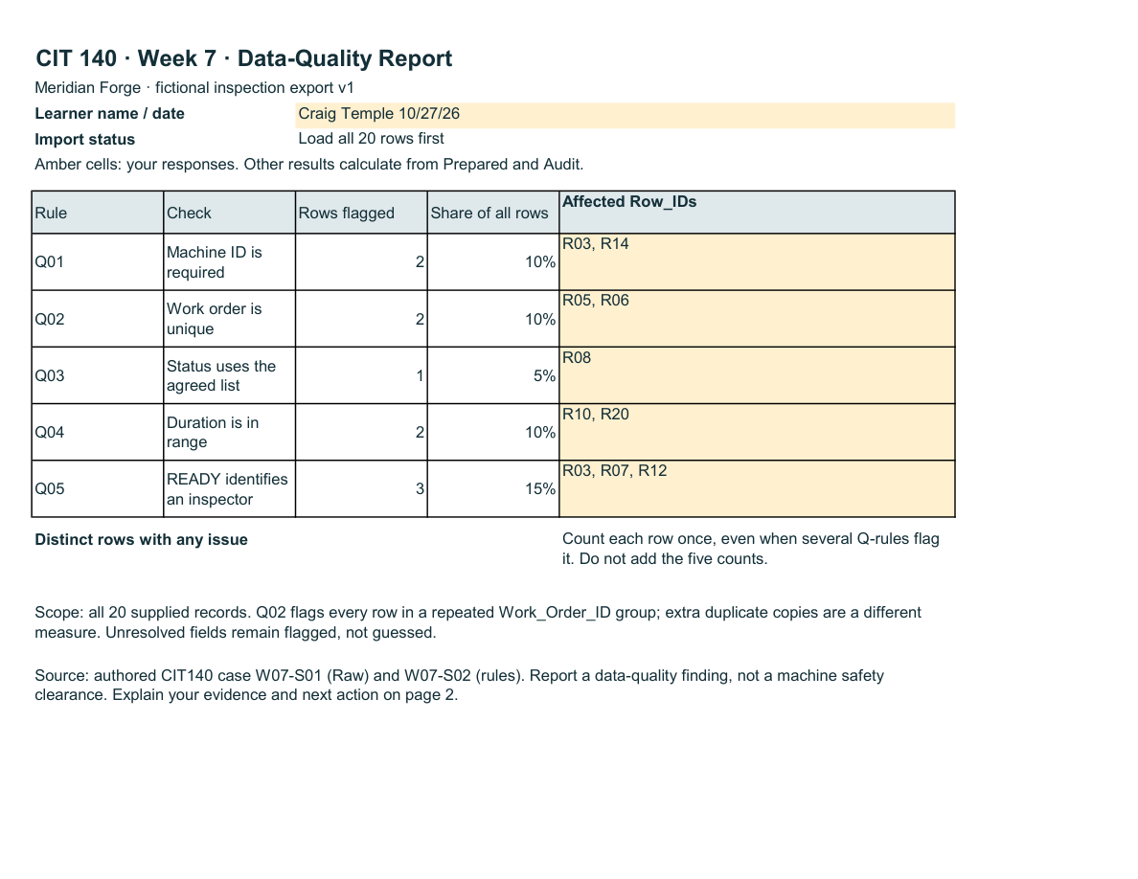
Original source: Temple_Craig_CIT140_Week07.pdf. See original for full report, captions, and context.

Client explanation
I applied the Week 7 data-quality rules to the 20-record Meridian Forge inspection export. Record R03 failed Q01 and Q05 because both Machine_ID and Inspector_ID were blank even though its status was READY. The report also identifies duplicate work orders and other validation problems under Q02–Q04. This matters because staff could treat a READY status as meaningful without enough information to identify the machine or inspector. Passing a data check also doesn't prove the physical machine is safe. I'd have the inspection supervisor verify the missing IDs against the original records, refresh the Power Query checks and confirm the flags change only after a supported correction.
Evidence reference: W07-S01 (Raw), W07-S02 (rules), Q01 and Q05; Week 7 Report.

W08-B01 | Provided client brief
One thing that stood out in Week 7 was R03. The inspection export shows that it was marked READY even though Machine_ID and Inspector_ID were both blank. That record fails Q01 and Q05 based on the rules in W07-S02, and the issue is documented in my Week 7 report using the W07-S01 data. This matters because a READY label could give someone confidence in a record that doesn't identify the machine or the inspector responsible for it. Before deciding how a future system should handle READY status, I'd want the inspection supervisor to check the original inspection records and confirm whether those IDs were missing at entry or lost during processing. Even after the data passes the rules, it shouldn't be treated as proof that a machine is physically safe.

Closing review
Since Week 1, I think the biggest improvement in my analysis is how I separate what the records actually prove from what I suspect happened. In the first problem brief, I had several questions about how a retired test could still reach MR-17. By the later assignments, I was working with specific requirements, diagrams, source IDs and validation rules to narrow down what could be confirmed. That makes it easier to explain a finding without jumping to a fix before knowing the cause.
There are still things that need to be verified before comparing solutions or testing a design. For Cedar Junction, I'd need a clearer understanding of how readiness status reaches Intake. For the routing case, I'd need the historical routing-table values for CJ-603. For the inspection export, I'd need source-record verification and a clean refresh test. Some supporting files and draft-template remnants also need a final repository check. I wouldn't treat any proposed change as approved until the right stakeholders and evidence support it.

Evidence register and remaining checks
Week 1: Temple_Craig_CIT140_Week01_Problem_Brief.pdf — full original to remain in its Week01 GitHub folder.
Week 2: CIT140 Week 02 — Business Case Recommendation.pdf — full original to remain in its Week02 GitHub folder.
Week 3: CIT140 Week 03 - Stakeholder Map.pdf — full original to remain in its Week03 GitHub folder.
Week 4: CIT140-Week04-Validated Requirements.pdf — full original to remain in its Week04 GitHub folder.
Week 5: Temple_Craig_CIT140_Week05_As_Is_Process_Model.pdf — full original to remain in its Week05 GitHub folder.
Week 6: Temple_Craig_CIT140_Week06.pdf — full original to remain in its Week06 GitHub folder.
Week 7: Temple_Craig_CIT140_Week07.pdf — full original to remain in its Week07 GitHub folder.

