Assignment 2
The output of the Assignment can be seen in the screenshot below
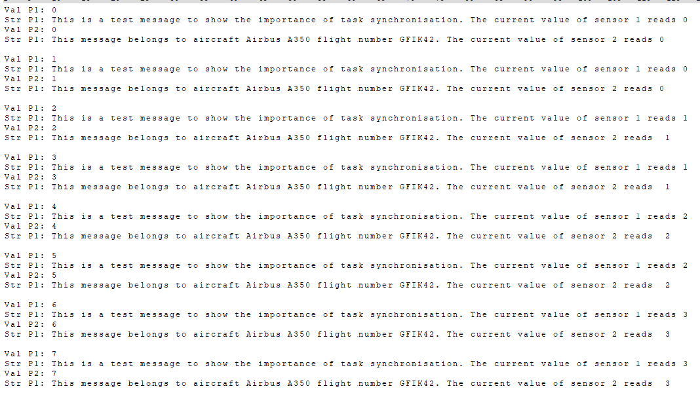
Here the Semaphores are already in use. I could not observe any change in the UART output with and without the Semaphores. I assume that when the resources are not protected the consumer task may check if a value is even and while writing it out the producer task may modify it. This behavior has not occurred once during my testing though.
Defining PROTECTED to use the protected version.

