# Exercise: Introduction to jQuery

Problems for exercises and homework for the ["JavaScript For Front-End Course@SoftUni"](https://softuni.bg/trainings/2032/javascript-for-front-end-july-2018" \l "lesson-8965). Submit your solutions in the SoftUni judge system at <https://judge.softuni.bg/Contests/1099/>.

## Increment Counter

You are tasked with creating a piece of **HTML** dynamically using JavaScript and **appending** it to a given element using a passed in **selector**.

### HTML and JavaScript Code

You are given the following **HTML** and **CSS**.

|  |
| --- |
| incrementCounter.html |
| <!DOCTYPE **html**> <**html lang="en"**> <**head**>  <**meta charset="UTF-8"**>  <**title**>Increment Counter</**title**>  <**script src="https://code.jquery.com/jquery-3.1.0.min.js"  integrity="sha256-cCueBR6CsyA4/9szpPfrX3s49M9vUU5BgtiJj06wt/s="  crossorigin="anonymous"**></**script**> </**head**> <**body**>  <**div id="wrapper"**>  </**div**>  <**script src="incrementCounter.js"**></**script**> </**body**> </**html**> |

It comes together with the following **JavaScript** code:

|  |
| --- |
| incrementCounter.js |
| **function** *increment*() {  *//* ***TODO*** } |

Your function will receive a **string** value representing a **selector** (for example "#wrapper" or ".root"), all elements created should be appended to the **selector**.

The HTML you create should contain 4 elements:

* <textarea> with class="counter", value="0" and the disabled attribute.
* <button> with class="btn", id="incrementBtn" and text "**Increment**".
* <button> with class="btn", id="addBtn" and text "**Add**".
* Unordered list <ul> with class="results".

When the [Increment] is clicked the value of the **textarea** should go up by **one** (if it was 0 it should become 1 e.t.c.). When the [Add] is clicked a new list item (<li>) with text equal to the current value of the textarea should be added to the unordered list.

### Screenshots

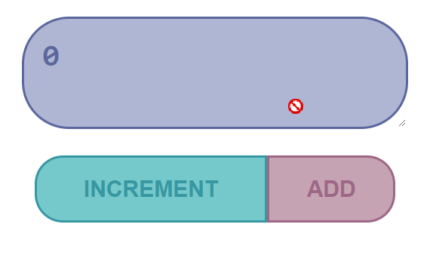 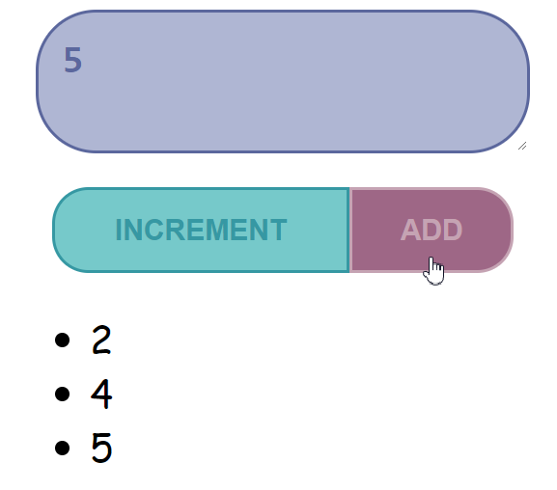

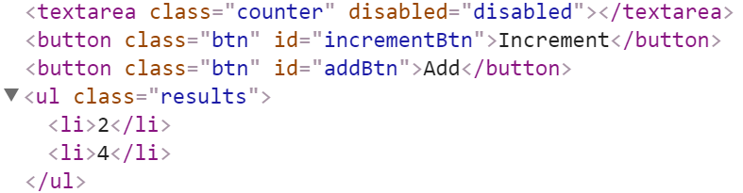

### Hints

We’ll start off by creating the needed elements and parsing the **selector**, we can do it easily with **jQuery** like this:

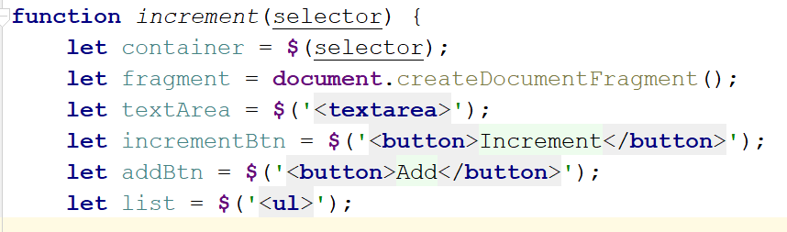

Adding multiple elements to the DOM can be expensive, instead of repeatedly adding to the DOM we can create a DocumentFragment and **add** the elements to it instead. When we have built our hierarchy we can **append the** DocumentFragment to the DOM, which will add all of the fragment’s elements to the specified selector.  
  
The next step is to **add values**, and **attributes** to the **elements** and **events** to the **buttons**:

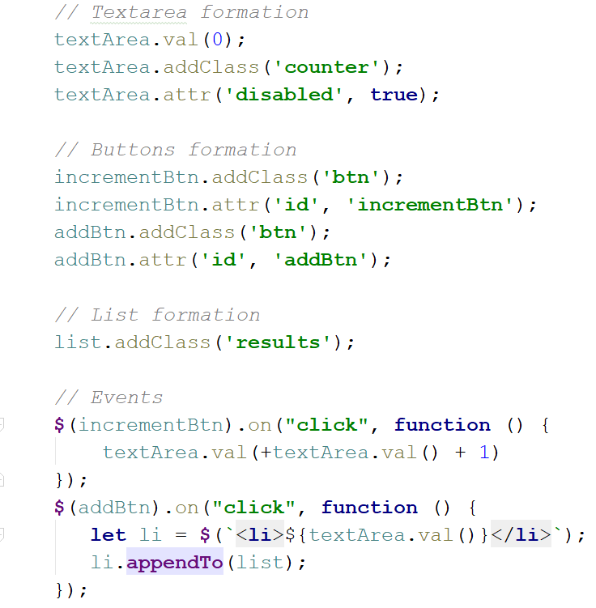

The last step is to **add** our elements to the DOM:

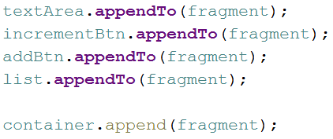

Our code is now ready.

## Timer

You will be given an **HTML** file, containing the markup of a **timer** with spans for **seconds**, **minutes** and **hours** and buttons to [Start] and [Pause] the timer. Your task is to create a JavaScript application that **starts** the timer whenever the [Start] button is pressed and **pauses** it when the [Pause] button is pressed.

### HTML and JavaScript Code

You are given the following **HTML** code:

|  |
| --- |
| timer.html |
| <**body**> <**div id="timer"**>  <**span id="hours" class="timer"**>00</**span**>:  <**span id="minutes" class="timer"**>00</**span**>:  <**span id="seconds" class="timer"**>00</**span**>  <**button id="start-timer"**>Start</**button**>  <**button id="stop-timer"**>Stop</**button**> </**div**> <**script src="timer.js"**></**script**> <**script**>  **window**.onload=**function**(){  *timer*();  } </**script**> </**body**> |

It comes together with the following **JavaScript** code:

|  |
| --- |
| timer.js |
| **function** *timer*() {  *//* ***TODO*** } |

Submit in the judge the **JS** code (implementation) of the above function. It may hold other functions in its body.

### Constraints

* The initial value of the timer must always be **00:00:00**

### Screenshots

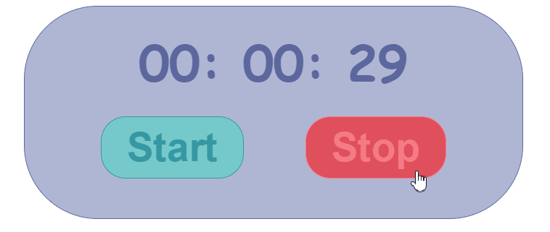

### Hints

Note the spans have unique id values – we can use these to select and modify the elements with **jQuery**.

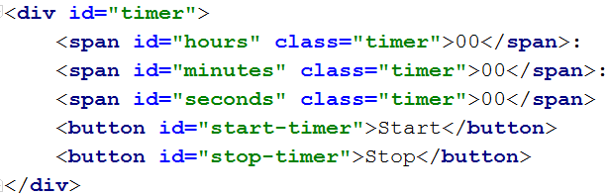

JavaScript has a built-in function setInterval() for executing and repeating an action after a set period of time. It returns an object which can later be used to stop the execution with clearInterval().

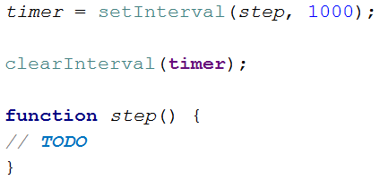

The **first argument** can be an inline declaration or a **named function**. The **second argument** is the **time interval**, specified in **milliseconds**. We can easily attach these two functions to the click event of a button.

To get and set the text of a markup element you can either use its textContent property, or jQuery’s text() function.

Keep in mind that that you should only have one setInterval() function active when the the timer is working, multiple presses of the [Start] button should not attach more setInterval() functions as that would break the correct operation of the timer.

## Form Validation

You are given the task to write **validation** for the fields of a simple form.

### HTML and JavaScript Code

You are provided a **skeleton** containing the necessary files for your program.

The validations should be as follows:

* The username needs to be between **3** and **20** symbols **inclusively** and only **letters** and **numbers** are allowed.
* The password and confirm-password must be between **5** and **15** **inclusively** symbols
* The **inputs** of the password and confirm-password field **must match**.
* The email field must contain the “**@**” symbol and **at least one** "**.**"(**dot**) after it.

If the "Is company?" checkbox is checked, the CompanyInfo fieldset should become **visible** and the Company Number field must also be **validated**, if it isn’t checked the Company fieldset should have the style "display: none;" and the **value** of the Company Number field shouldn’t matter.

* The Company Number field must be a number between **1000** and **9999**.

Every field with an **incorrect** value when the [Submit] button is **pressed** should have the following style applied border-color: red;, alternatively if it’s correct it should have style border: none;. If there are **required fields** with an incorrect value when the [Submit] button is pressed, the div with id="valid" should become **hidden** (**"**display: none;"), **alternatively** if all fields are correct the div should become **visible**.

### Constraints

* **You are NOT allowed to change the HTML or CSS files provided.**

### Screenshots

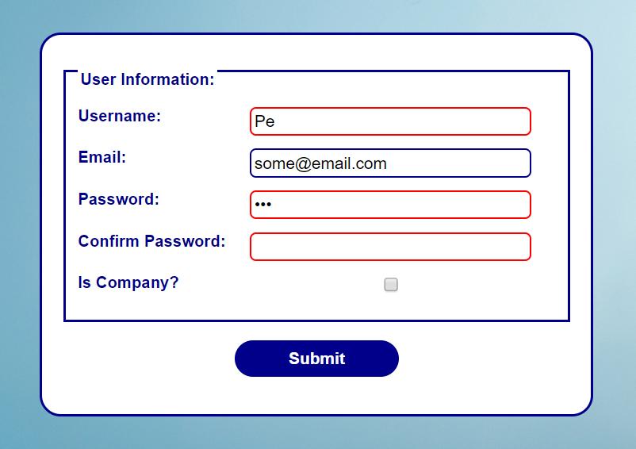

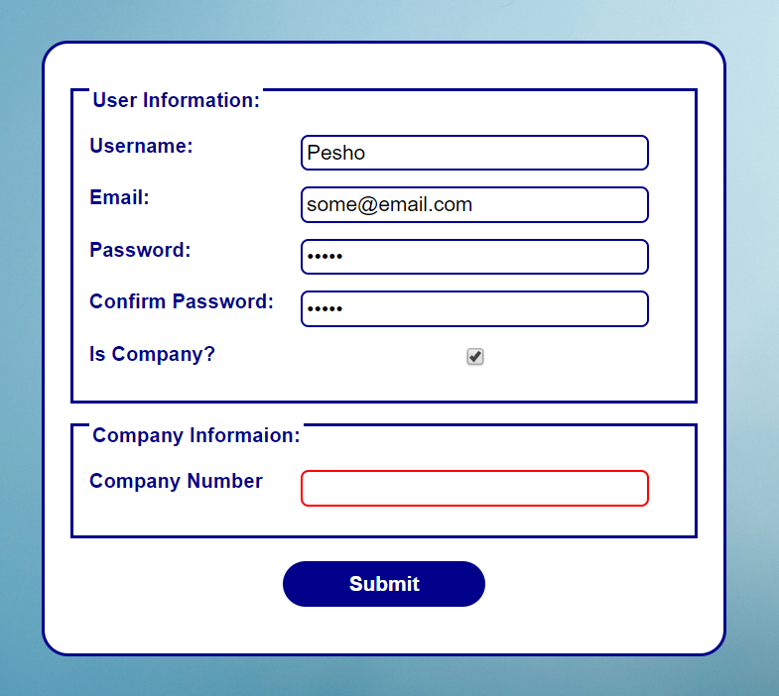

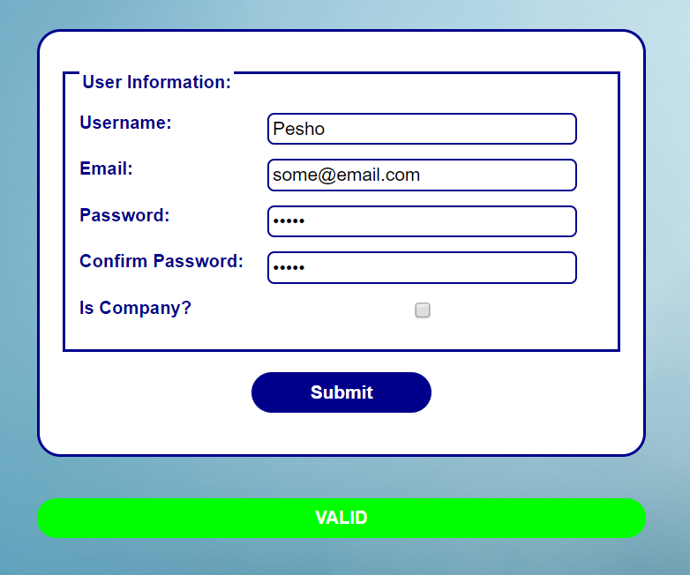

### Hints

* Use addEventListener() or jQuery’s on() function to **attach** an **event listener** for the "change" event to the **checkbox**.
* All buttons within a <form> automatically work as **submit** buttons, unless their type is **manually** **assigned** to something else, in order to avoid **reloading** **the page** upon **clicking** the [Submit] button you can add the following code in the function that handles the on click event:



* The validation for the separate fields can be done using **regex**.