PyQt Tutorial

Getting the code :
The demo widget is avalaible at the HRAA svn repository (you need a valid account to access it).
It is located in /codes/lib/PyQt/Demo/ .

If you don’t want the entire HRAA repo in your computer you can just download the PyQt demo by checking out the PyQt folder:
> svn co https://version-lesia.obspm.fr/repos/HRAA/trunk/codes/lib/PyQt

A brief description of the code:
- PyQtDemo.py is the main executable Python file and must be executable. Basically it loads all the PyQt librairies and uses the demo.ui to build the interface.
- demo.ui is an XML file, modifiable/editable in a friendly user manner with - Qt Designer or Qt creator (comes with Qt installation - see below).
- demo_ui.py is an auto generated pyqt file generated with the terminal command :
> pyuic4 demo.ui -o demo_ui.py (pyuic4 translates the xml file in python objects with PyQt package).
This command has to be typed every time the GUI is modified (i.e the demo.ui file is changed) to take into account the changes in PyQt.
Note: Once generated DO NOT EDIT the demo_ui.py file. Only PyQtDemo.py (the main executable) can be edited safely since we mmanipulate in PyQtDemo.py objetcs created automatically in demo_ui.py.

Required packages :

Python :
We use in this tutorial Python version 2.7.6

If not already installed, download and install python from your favorite package manager (aptitude in ubuntu, yum on fedora or macport under macOSX).

Matplotlib (standard plot library for python) :
http://matplotlib.org/users/installing.html

In ubuntu :
> sudo apt-get install python-matplotlib

PIP
PIP is needed for an easy install of some required packages for the PyQt demo to work.
In a terminal under ubuntu :
> sudo apt-get install python-pip

Pyfits (standard FITS files library for python)
Check install instructions here :
http://www.stsci.edu/institute/software_hardware/pyfits/Download

Here we use PIP to install pyfits easily :
> sudo pip install pyfits

QT :
Go to the Qt official webpage and install Qt for your environment :
Get Qt version 5 (retro compatible with Qt version 4 that we will use in this tutorial).
http://qt-project.org/downloads

Choose the Qt online installer for your OS and download it.
Open it and install it.
Note a .run file on linux can be opened by changing permissions on it and execute the file on a terminal go the downloaded folder and type (check filename):
> chmod 755 qt-opensource-linux-x64-1.6.0-5-online.run
> sudo ./qt-opensource-linux-x64-1.6.0-5-online.run

Then the Qt setup will open :
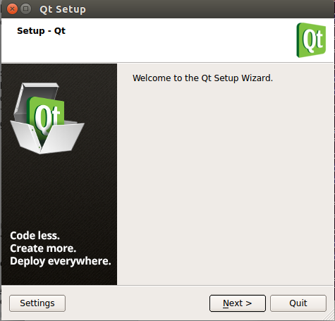

Click next, check and install Qt5.x libraries (you can uncheck ios and android libraries☺). It may take some time as it downloads it from the internet. CHECK and NOTE THE INSTALLATION DIRECTORY.

QtCreator is the specific tool to help editing the GUI. It can be launched from the installation directory (for me the installation directory is : /otp/Qt/) . In Ubuntu it is:
> sudo /opt/Qt/Tools/QtCreator/bin/qtcreator

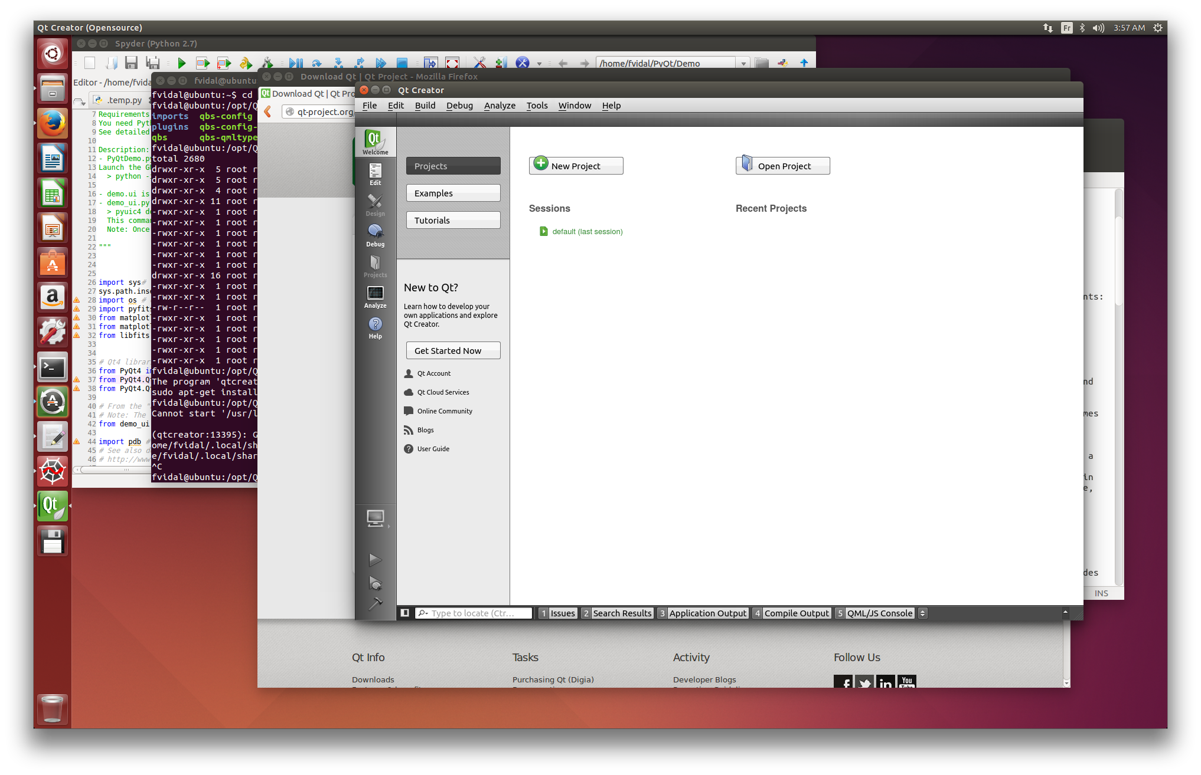

To open the file that contains the Interface using the menu bar : ‘File’ > ‘Open File or Project’ and select the demo.ui file in ~/PyQt/Demo/ directory.

View of the demo.ui file in Qt Creator :

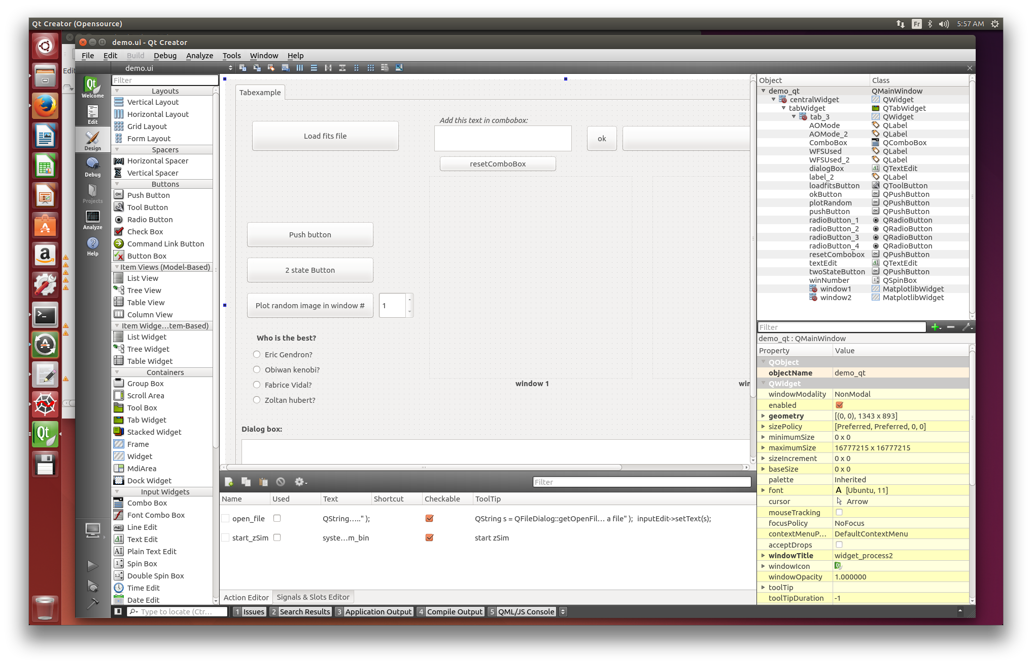

PyQt :
Before installling pyqt you need SIP:
http://www.riverbankcomputing.co.uk/software/sip/download

Download the version for your os and type in the terminal (in the downloaded directory):
> python configure.py
> make
> sudo make install

Now we start the pyqt4 installation. Go to this webpage and download pyQt4 :
http://www.riverbankcomputing.com/software/pyqt/download

In the Download directory :
> python configure.py

---------------------------------------------------------------------------------------------------------

Note for users who have this error :
fvidal@ubuntu:~/Downloads/PyQt-x11-gpl-4.11.2$ python configure.py
Determining the layout of your Qt installation...
Error: /usr/bin/qmake failed to create a makefile. Make sure you have a working
Qt qmake on your PATH or use the -q argument to explicitly specify a working Qt
qmake.

You need to check the qmake path :

> qtchooser -print-env
QT_SELECT="default"
QTTOOLDIR="/usr/lib/x86_64-linux-gnu/qt4/bin"
QTLIBDIR="/usr/lib/x86_64-linux-gnu"

Here QTTOOLDIR and QTLIBDIR do not point towards the installed Qt direcory (i.e /opt/Qt/…) .

Open and edit the file : /usr/lib/x86_64-linux-gnu/qt-default/qtchooser/default.conf

And change the 2 lines to :
/opt/Qt/5.3/gcc_64/bin/
/opt/Qt/5.3/gcc_64/lib/

(Personally I had to remove and recreate /usr/lib/x86_64-linux-gnu/qt-default/qtchooser/default.conf file since it was a symbolic link poiting to nothing (go figure...). Be carefull with permissions too…

Check with the command :
fvidal@ubuntu:~/Downloads$ qtchooser -print-env
QT_SELECT="default"
QTTOOLDIR="/opt/Qt/5.3/gcc_64/bin/"
QTLIBDIR="/opt/Qt/5.3/gcc_64/lib"

Finally re-try a python configure.py in PyQt Directory.

---------------------------------------------------------------------------------------------------------

Usefull but not required: Spyder (python/ipython environment)
https://code.google.com/p/spyderlib/
> sudo apt-get install spyder

Launching the demo
Launch the GUI using the command (in a terminal):
> python -i PyQtDemo.py

And play with it !

