VLTI

GRAVITY

Phase C

Wavefront Sensor
Real Time Computer
User Requirements

Doc. No.: VLT-SPE-GRA-15881-5104

Issue: 5.4

Date: 19.12.2014

Author(s): C. Deen …………………………………………………..
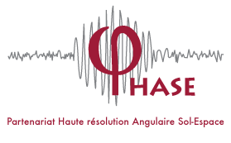





Name Date Signature
E. Gendron, Y. Clénet ……………………………………………
Name Date Signature
S. Hippler, W. Brandner…………………………………….........
Name Date Signature
Proj. Manager: E. Sturm …………………………………………………….
Name Date Signature
Proj. Responsible F. Eisenhauer ……………………………………………………..
Name Date Signature
CHANGE RECORD
ISSUE | DATE | WHO | SECTION  AFFECTED | REASON/INITIATION  DOCUMENTS/REMARKS
1.0 | 30.10.09 |  | All | Initial issue
1.5 | 31.03.10 |  | All | Update after PDR. Released.
2.0 | 30.07.2010 |  | All | Delta PDR release. Title changed from “functional specifications” to “user requirements”
2.5 | 01.12.2010 |  |  | Release 2.5, revised according to action items listed in the delta PDR board report (RD12)
3.0 | 15.01.2011 |  | All | More revisions. As SPARTA Light is now the baseline for Gravity RTC, all SPARTA Light specs should apply. This doc has been revised in order to point out only the minor differences that could occur between the initial gravity specs and the Sparta Light specs.  Most of the paragraphs have been replaced by "SPARTA Light implementation" in order to refer now to only a single document (=the Sparta light ones).
4.0 | 30.11.2011 |  | All | Final design release.
4.1 | 27.07.2012 |  | All | Corrections after FDR according to RIX actions
5.0 | 17.11.2014 |  | All | Complete rework
5.1 | ? |  | All ? | ?
5.2 | 9.12.2014 | Gendron | 9. | Rework section 9 (modal basis+cntrl mat) to be able to start coding
5.3 | 16.12.2014 | gendron | 11.2 becomes 12 | Rework old section 11.2 (pupil tracking) and make it a new section 12. , with all specs + pseudo code to be able to start coding.
5.4 | 19.12.14 | gendron | 11.1 | Section of reference slopes reworked, updated, etc.
TABLE OF CONTENTS
1. Scope 6
2. References 7
2.1. Applicable documents 7
2.2. Reference documents 7
2.3. Acronyms 9
3. Overview 10
4. High-level requirements 11
5. Detector read-out 12
5.1. Detector frame rate 12
5.2. Real-time windows, or pixel selection 12
6. Guide star acquisition 12
7. Image calibration 12
7.1. Dark 13
7.1.1. Taking the Dark 13
7.1.2. Storing the Dark Erreur ! Signet non défini.
7.1.3. Querying the Dark file currently used by the system 13
7.2. Flat 13
7.2.1. Querying the Flat file currently used by the system 14
7.3. Background 14
7.4. Bad pixel handling 15
8. Slopes in sub-aperture computation 15
8.1. Flat thresholding Erreur ! Signet non défini.
8.2. N-brightest pixels 15
8.3. Weighted center of gravity Erreur ! Signet non défini.
9. Control matrix computation 15
9.1. Interaction matrix acquisition 15
9.1.1. Zonal calibration 15
9.1.2. Hadamard calibration 16
9.2. Inversion & modal base handling Erreur ! Signet non défini.
9.3. Loading of M_{C} into RTC 21
10. Computing Commands for DM 23
10.1. Setting Gains 19
10.2. Saturation management 23
10.3. Piston removal 23
10.4. Offsets 24
10.4.1. NCPA 25
10.4.2. Static Abberations introduced by the derotator 24
10.5. Vibration control 23
11. Online update of parameters 24
11.1. Tip-tilt offloading 27
11.2. Pupil Tracking 28
11.2.1. M8 Pupil Tracking 28
11.3. Offsets 25
12. Telemetry & Archiving 33
12.1. Data analysis purposes 34
12.2. Real-time display Erreur ! Signet non défini.
12.3. Archive data 35
12.4. SPARTA-Light RTDFL 35
13. GUI 35
13.1. Observations 35
13.1.1. DM HO/TT actuator positions 36
13.1.2. Gradients 36
13.1.3. Pupil Tracking 36
13.1.4. Subaperture Illumination 36
13.2. Engineering 36
13.2.1. Data Viewing 36
13.2.2. Data Recording 36
13.3. Status panel and performance estimations (R0, L0, SR, wind speed, etc.) 37
13.3.1. Turbulence Parameters 37
13.3.2. System Parameters 37
13.3.3. Performance Estimator 37
14. Alarms 37
14.1. Conditions 37
14.1.1. Loop Crash 38
14.1.2. Insufficient/non-Uniform Illumination 38
14.1.3. Pupil Tracking error 38
14.1.4. Mirror Saturation 38
14.1.5. Strehl degredation 38
14.2. Handling 38

LIST OF TABLES
Table 1: Applicable documents 6
Table 2: Reference documents 6
Table 3 Main hardware specifications of the GRAVITY WFS 8
Table 4 RTC functionality 13
LIST OF FIGURES
Figure 1: The graph shows, in terms of sampling frequency, the maximum latency required to achieve a system bandwidth of 24 Hz (graph taken from RD4). Erreur ! Signet non défini.
Figure 2: Individual components of the latency budget for a frame rate of 200 Hz (top) and 500 Hz (bottom). Erreur ! Signet non défini.

- Scope
This document describes the user requirements for the wavefront sensor real time computer (RTC) and related CIAO instrument software of the GRAVITY instrument at the VLTI.
For practical reasons, the ESO-developed “SPARTA Light” architecture will be used. This provides a set of standard AO real-time features, some of which will be used, and some extra CIAO-specific functionalities need to be independently developed.
This document describes all AO-RTC related functionalities of the CIAO system, and the references for their implementation.
- References
  - Applicable documents
The following applicable documents (AD) of the exact issue form part of the present document to the extent specified herein.
AD # | Document number | Document title | Issue | Date
AD1 | VLT-SPE-ESO-16100-4856 | SPARTA-Light Reference Implementation Technical Specifications | 1 | 26.07.2010
AD2 | VLT-TRE-ESO-16100-4827 | SPARTA-Light Architecture | 1 | 11.07.2010
AD3 | VLT-SPE-ESO-16100-4829 | SPARTA-Light System Requirements | 1 | 11.07.2010

Table 1: Applicable documents.
  - Reference documents
The following reference documents (RD) contain useful information relevant to the subject of the present document.

RD # | Document number | Document title |  | Issue | Date
RD1 | VLT-TRE-GRA-15881-5101 | GRAVITY Wavefront Sensor - System Design |  | 4.0 | 30.11.2011
RD4 | VLT-TRE-GRA-15882-5201 | GRAVITY Wavefront Sensor – Adaptive Optics Performance |  | 4.1 | 03.07.2012
RD5 | VLT-TRE-GRA-15881-5401 | GRAVITY Wavefront Sensor - Control Software |  | 4.0 | 30.11.2011
RD6 | VLT-TRE-GRA-15881-5501 | GRAVITY Wavefront Sensor – Detector and Read-out Electronics |  | 4.0 | 30.11.2011
RD7 | VLT-SPE-ESO-15600-2062 | MACAO-VLTI REAL-TIME-COMPUTER Software Functional Specifications RTC |  | 1.2 | 14.03.2001
RD8 | VLT-SPE-ESO-15600-4027 | MACAO RTC Software Upgrade Technical Specifications |  | 2 | 12.09.2006
RD9 | ESO Messenger 126, pp 37. | Enabling Fringe Tracking at the VLTI |  |  | December 2006
RD10 | VLT-TRE-GRA-15886-4362 | GRAVITY Phase A Adaptive Optics Design |  | 1.6 | 18.09.2007
RD11 | Fedrigo, E., Kasper, M., Muradore, R., "Compensating nonlinear effects in AO control loops", in Adaptive optics: analysis and methods, proceedings of the OSA meetings, paper AWB2, 2007 |  |  |  | 2007
RD12 | VLT-TRE-ESO-15880-49xx |  | GRAVITY delta PDR Board Report | 1.0 | 15.10.2010
RD13 | Email by Gert Finger, ESO |  | Latest Selex, Selex NGC, NGC/SPARTA infos |  | 19.10.2011

Table 2: Reference documents.
  - Acronyms
AO Adaptive Optics
DM Deformable Mirror
ESO European Southern Observatory
Fowler Fowler sampling
IGC (Task/software will be) IMPLEMENTED by GRAVITY CONSORTIUM.
LQG Linear Quadratic Gaussian
MACAO Multi Application Curvature Adaptive Optics, the UT adaptive optics system
MVM Matrix-Vector-Multiplication
NIR Near-Infrared
PDR Preliminary Design Review
RON Read-out noise
RTC Real Time Computer
RTDFL Low-Level Real-Time Data Flow
SH Shack-Hartmann
SHWFS Shack-Hartmann Wavefront Sensor
SLL (Task/software is assumed to be included in) SPARTA LIGHT
LIBRARY/APPLICATION.
SPARTA Standard Platform for Adaptive optics Real Time Applications
TBD To Be Defined
TBC To Be Confirmed
UT Unit Telescope
VLT Very Large Telescope
VLTI Very Large Telescope Interferometer
WFS Wavefront Sensor
- Overview
The wavefront sensor (WFS) subsystem of GRAVITY consists of 4 WFS, one for each UT at the VLT (see RD1 for details of the design). The WFS unit’s main purpose is to analyse wavefront distortions originating in Earth’s atmosphere. The wavefront sensor (WFS) subsystem of GRAVITY consists of 4 WFS, one for each UT at the VLT (see RD1 for details of the design). The WFS unit’s main purpose is to analyse wavefront distortions originating in Earth’s atmosphere, and to provide correction signals to the MACAO tip-tilt and bimorph deformable mirrors. In addition, the correction signals include corrections for non-common path static and quasi-static aberrations originating in the VLTI optics between the Coudé room and the VLTI lab. The WFS itself is of Shack-Hartmann type with 9x9 sub-apertures and 8x8 detector pixel per sub-aperture. The maximum frame rate to be processed by the Real Time Computer (RTC) is 500 Hz. The GRAVITY RTC will be based on the SPARTA-Light architecture, which has been developed by ESO (see AD1, AD2, AD3).
- High-level requirements
The Gravity WFS RTC software type is the ESO SPARTA-Light System. The following table describes the interface between the RTC system and the Gravity WFS detector system:
SPARTA Light Detector Spec | GRAVITY WFS detector system
Nb. of Sub-apertures | 9 x 9 or an array of 68 sub-apertures located on a pupil-shaped area.
Optical pixels per sub-aperture | 8 x 8 pixel
Pixels per sub-aperture used for slopes computation | 4x4 (nominal), 6x6 (extended objects or very bad seeing>1.5’’) 8x8 (full field for acquisition) pixel modes
Frame Rate/Loop Rate | The maximum frame rate for Gravity is 500 Hz.  The “frame rate” is the rate of the images after Fowler (after processing samples). The “frame rate” is also the rate at which the wavefront slope calculation is to take place.  The RTC of Gravity should be able to handle frame rates of 500 Hz, 200 Hz, 100 Hz and 50 Hz (goal, TBC).
Shortest Integration Time | 1 ms
Readout Time | Less than 50µs per 96x72px sub-window frame
Detector read-out modes | The RTC receives usable full frame photometric images (RTC doesn’t do Fowler sampling, this is done by the NGC)

The CIAO system uses the deformable mirror (DM) from the MACAO system at the VLTI. The DM specifications have to be known to the SPARTA Light system:
DM type | Bimorph
Number of Actuators | 60
Tip/Tilt Mirror | Separate (DM mount)
DM control | the interface from the RTC to the DM is a sFPDP link to the HVA

The AO control system has the following characteristics:
Supported modes | Single Conjugate Adaptive Optics (SCAO)
Controller type of AO loop | Integrator with gain + vibration tracking on tip-tilt
Latency | Defined as the time between the end of the detector integration, and the application of the computed commands to the DM (i.e.: the full AO loop):  3.8 ms for the 500 Hz case

- Detector read-out
The Real Time Computer receives the signals from an IR detector (SELEX) operating in the FOWLER-N readout-mode.
  - Detector frame rate
The frame rate defines the number of IMAGES per second.
An IMAGE is made by a list of values that can be interpreted as a usable, photometric signal from the detector. The intermediate, raw signal samples provided by the Fowler samples are data that are NOT considered as an image.
The “frame rate” is the rate of the images after Fowler processing. The “frame rate” is also the rate at which calculation of a given sub-aperture is to take place.

  - Image processing
Because of its particular architecture, the NGC sends 96x72 pixels coded as 32-bit integers to the SPARTA-light RTC. The pixel-processing pipeline is then the following:
- Reception of raw 96x72 pixel frame
- Conversion from 32-bit integer to single precision floating-point
- SW windowing to extract a 72x72 region of interest

  - Real-time windows, or pixel selection
This 72x72 pixel image is split in 8x8 pixel windows corresponding to the sub-apertures. The slopes are calculated as centre-of-gravity on the inner 4x4 or 6x6 pixels of the 8x8 windows during observations, but also possibly on the entire 8x8 pixel windows during AIT and maintenance.
The 6x6 mode may not comply with latency requirements: it is a mode used for possibly degraded conditions.

- Guide star acquisition
The guide star acquisition will need a real-time display, which CIAO has to provide.

- Image calibration
The RTC will perform rudimentary image calibration (dark, flat and background) before passing the 72x72 pixel images to the reconstructor.
The image processing implemented in SPARTA is
Calibrated = (raw-dark)*flat - background
We plan to load the measure/calibrate the sky+instrument+detector emission, and load all this in the SPARTA variable called “dark”. The SPARTA variable called “background” will always be set to 0, except (maybe) by the background follower.
  - Dark
CIAO shall provide the functionality to take and store a Dark image.
    - Taking the Dark
The best way to do it would be to have the possibility to just get RAW images, then average them, and then store the result as the SPARTA variable called “dark”. Unfortunately, it seems (to be confirmed by ESO), this is not possible because changing the tap point from “calibrated images” to “raw images” is not possible on the fly.
So, the following procedure will be used if the tap point is set to “calibrated pixels”
The built-in SPARTA-light module AcqOptimiser will be used:
- Set dark and background maps to all 0s
- Set flat map to all 1s
- Measure a map by collecting pixel frames after dark, background and flat processing, and average
Now, if the top point is set to “raw pixels” then the algorithm becomes:
- Measure a map by collecting raw pixels, and average.

The resulting map will be loaded in SPARTA in the SPARTA variable called “dark”. Notice that the measured map can either be a real dark (filter wheel closed), a sky/instrument background (filter wheel open), or else: in any case it will be loaded in the SPARTA variable called “dark”.
    - Querying the Dark file currently used by the system
CIAO will allow the user to query the system and display the currently used composite dark.
  - Flat
As taking a new flat is impossible while the lenslet array is installed, It is nor foreseen for CIAO to take new flats. The Flat file will be computed in the AIV and commissioning process.
Note: the flat will also be used to set to 0 dead pixels, unless there is a special map dedicated to dead pixels.
Dead pixel map allows to set pixels to 0 at the beginning of the processing
    - Querying the Flat file currently used by the system
CIAO will allow the user to query the system and display the currently used flat file
  - Background
For operation, the background follower algorithm of CIAO needs to load something in the SPARTA variable called “background”.
Note that if CIAO is using the N-brightest pixel algorithm for the slope calculation of the sub-aperture (thresholding), see Section 8.1, one does not need to care about the background follower.

During observations, the sky+instrument background may vary because of conditions (temperature, water vapour, …), on a timescale in the order of 1 minute. A background follower algorithm will periodically calculate the background level in each sub-aperture by measuring the average flux level in the four corner pixels of the raw image.
The aim of the algorithm is to monitor the average value of all the “corner pixels”, at the 4 corners of all the sub-apertures, and adjust the value of the image by adding/subtracting a constant to the image in order to keep this average value equal to 0 after image calibration.
The algorithm is the following:
- The component listens continuously to circulating RAW pixel frames, and DARK is subtracted
- The component is configured with a mask of pixels to be monitored in each pixel frame received
- The pixels to be monitored are supposed to be non-illuminated, such that any variation present on them is due to the evolution of the detector dark current or sky+instrument evolution
- Each processing cycle of the component is conceptually composed of the following steps:
  - Skip a configurable number N of consecutive pixel frames
  - Accumulate separately the pixel values corresponding to each detector channel over a configurable number M of consecutive pixel frames
  - Compute the median pixel value for each detector amplifier frame from the accumulated pixel frame
  - Calculate an offset for each amplifier and apply/store this offset to the Background map for all pixels which are not marked as dark
  - Generate a new map in a configurable CDMS location
  - The CDMS slot for the map generated above can be set to the ACQ supervisor BACKGROUND map and DYNAMIC update enabled for it, such that it will be automatically downloaded to the HW as soon as it is generated
The implementation as described above is a slightly modified version of the algorithm implemented by the AOF Dark Follower.
  - Bad pixel handling
If dead pixel map is not available is Sparta:
Bad pixels handling will be done using the flat-field. The dead pixels will be set to 0 using the flat.

If a dead pixel map is available : the dead pixel map will be used.

- Slopes in sub-aperture computation
  - N-brightest pixels
The N-brightest pixel algorithm computes the center of gravity keeping only the N brightest pixels in each sub-aperture window.
Of course the thresholding operation is not required any more with this centroiding algorithm, and can be skipped.
Note that although both wCoG and N-brightest pixel strategies are implemented by SPARTA-Light, they cannot be selected dynamically. The selection is made at compile time. This means that, at a minimum, the RTC has to be rebooted to load a new binary in order to switch strategy.
  - Other centroiding methods
They will not be used in the gravity baseline. Gravity will comply with SPARTA-Light specs in any case.

- Control matrix computation
A control matrix is a vital component of any adaptive optics system. CIAO will provide the following functionality regarding the calculation and analysis of the control matrix.
  - Interaction matrix acquisition
The CIAO system needs to provide the following methods for measuring the interaction matrix of the system.
    - Zonal calibration
The zonal calibration will be performed by pushing/poking individual actuators on the DM and recording the effect on the gradients measured by the WFS.
As a baseline, the Interaction Matrix for Gravity shall be calculated using zonal calibration. While slower than the Hadamard calibration, there are only 62 actuators, and it will not be necessary to re-measure the Interaction Matrix more than once a month (TBC ... ?).
Anyway, there's no need to proceed in a different way than MACAO. We should use the same procedure as MACAO for compatibility reasons + sparing development time. Should be fully compatible with SPARTA procedures.
Two interaction matrices, for the DM (HO) and the tip-tilt mount (TT) are computed separately with Sparta. In the paragraphs below, the ensemble of these 2 interaction matrices will sometimes be called “the interaction matrix” for the sake of brevity.
    - Hadamard calibration
The Hadamard scheme should only be implemented in the framework of gravity if AITs show that the zonal calibration fails or is not sufficient.
The Hadamard calibration will be performed by sending a sequence of patterns to the DM and recording the effect on the gradients measured by the WFS. Gravity will comply with SPARTA-Light specs in any case.
  - Modal basis computation
The choice of the basis is done considering the following scheme, taken from document VLT-SPE-ESO-16100-4856, issue 1, SPARTA-Light Reference Implementation Technical Specifications.
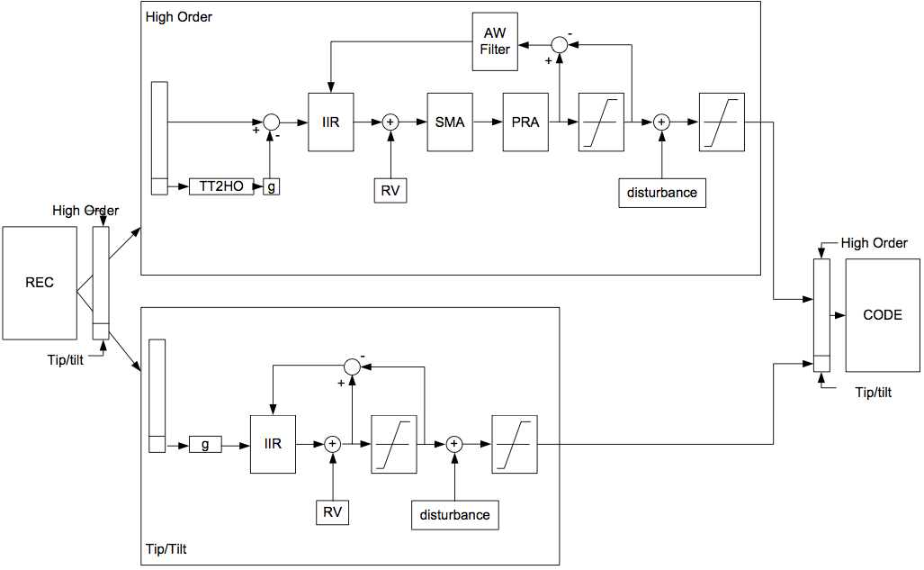

So, as far as we understand it, the REC stage consists of a reconstruction matrix, that handles the tip-tilt both on the dedicated tip-tilt mount (TT), and also on the DM higher orders (HO). The CTR stage (above scheme) will take care to subtract from the HO part the tilt already achieved by TT.

The generation of the modal basis is done as follows :
- based on the interaction matrices of HO and TT, identification of the vector TT2HO (i.e. the DM mode that is producing a wavefront as close as possible to the tip & tilt on the TT mount, taking care of having the right units). We know that previous procedures in MACAO were computing/measuring this TT2HO mode by measuring the closed-loop voltages of HO DM with the loop engaged on a tip & tilt generated by poking the TT mount. We choose to simplify the procedure and trust matrix algebra and DM linearity to deduce them. We will (possibly) revise this during AITs if we show something goes wrong with this.
- creation of a modal basis of the HO DM containing a) the 2 modes TT2HO, and b) other modes. The basis is designed so that the ‘other modes’ produce measurements that are orthogonal to the measurements of tip and tilt (in the measurement space)
- then, piston mode. It can either be :
  - provided as an input to the function,
  - or determined using a SVD of the modal interaction matrix of this new basis, (taking care of some management of the TT2HO modes)
  - in any case, this piston mode will be filtered out from the modal basis. Warning : here, the piston should be orthogonal to the other modes but the scalar product in this case should be the integral of phase products over the pupil. Indeed, we don’t want any piston in the phase. Having the command orthogonal is not sufficient. For doing this, in principle, the knowledge of the influence functions is needed ; looking at the equations more closely teaches us that in reality only the terms Δ_{ij}=∫f_{i}(x,y).f_{j}(x,y) dx dy are required ; this is why the procedure takes in input a matrix Δ (matrix 60x60) and not the influence functions.
- finally some « well-seen » modes will be extracted from this (piston+tiptilt)-free modal basis, that will form the commanded space of the DM.
- The modes produced are not othogonal (in the sense of scalar product of integral of product of phases). The orthogonality of modes is a requirement which is sufficient, but not strictly necessary. A modal basis which cross-projections form a diagonal-dominant matrix is usually fine. If, for some reason, the AIT would reveal that this is not sufficient, then we would add a re-orthonormalisation of the modes, using the matrix Δ (we would diagonalize the matrix (modes.Δ.modes^{t})).

The creation of the modal basis is described in pseudo code in the function
gral_createModalBasis()
This pseudo-code is actually Yorick (https://github.com/dhmunro/yorick) interpreted langage (syn-tax close to C), vector oriented (as IDL, python ..), however with a main difference with C : indexes in arrays start to 1, and not 0.
Input parameters :
- The measured interaction matrices for HO and TT (120x60, 120x2 i.e. 120 lines, 60 columns and 120 lines 2 columns)
- A matrix called Δ (delta) which is pre-computed, to be found somewhere on the disk. The matrix Δ will be computed only once during AITs, and there should be 4 matrices : one per MACAO DM. Those matrices should remain the same during all the life of the MACAO DM.
Output parameters :
- TT2HO : the matrix of the tip and tilt produced by the DM, and used in the CTR component of sparta
- M2V : the matrix of the system modes, to be used lated in the modal control optimiza-tion and the computation of command matrices.
- piston : this is the piston vector to be used in Sparta for PRA.
- S2M : the modal control matrix, a control matrix that multiplies to slopes vectors and pro-duces the modes coefficients.
TT2HO, M2V, piston and S2M should be archived together with the input interaction matrix, they form a coherent set of data. They are used to compute the standard non-optimized control matrix of the system (that can be used to close the loop during AIT or onsky), they are also used to compute the optimum gains using the modal control optimization procedure, and from that derive an optimized control matrix.

  - Command matrix computation
A command matrix computed from the interaction matrix is a vital part of any adaptive optics system. The computation of the command matrix will be done as follows:
CM = M2V*G*S2M
CM(1:60,) = CM(1:60,) + TT2HO*G(61:62)*CM(61:62,)
Where:
- CM = command matrix
- M2V = mode-to-voltage matrix
- S2M = sensor-to-modes matrix
- G = matrix containing the modal gains in its main diagonal
Matrices M2V and S2M are produced during the system calibration using the procedure gral_createModalBasis(), whereas matrix G can be updated at any time from a vector of modal gains, or from the user’ input.
There are SPARTA components that can be used as examples in order to compute matrices M2V and S2M from newly calibrated HO and TT IM. The same component typically re-computes the modal basis making use of the same IMs and the pre-calibrated IFs. This functionality is invoked during a system calibration and produces the M2V and S2M matrices that will be archived and remain unchanged until a new calibration takes place.
An detailed example of pseudo code doing these operations is given in the function called
computeSystemOptimizedControlMatrix()
Input parameters :
- the modal control matrix S2M as computed by function computeModalControlMatrix()
- a 1D vector of modal gains G, either provided by function modalControlOptimization(), or alternatively provided by the user.
- the matrix of the modes M2V computed by the function createModalBasis()
- the matrix of the DM-tilt modes TT2HO (60,2)
Returned parameter :
- the command matrix CM of the system.
The vector G is the vector of the gains, and the following paragraph describes where it is coming from.
  - Setting Gains
    - OMGI Gains
The CIAO RTC will use an Optimized Modal Gain Integrator algorithm to set the modal gains in response to variable observing conditions.
The typical sequence will be:
- New modal gains are estimated by a dedicated RTC component which uploads the resulting modal gain vector into a particular location in CDMS
- This triggers an automatic reaction from a second RTC component that re-computes the CM and stores the result into a particular CDMS location
- This triggers an automatic reaction from a third RTC component that downloads the new CM to the control HW and applies it in closed-loop
    - Non-OMGI Gains
The user may find it quite handy to be able to set the loop gain manually (instead of automatically using OMGI) during the AITs. Those manual gains are used :
- During integrations, tests, AITs, etc.
- During calibration procedures
- On-sky, when closing the loop for the very first time on an object before any OMGI process has ever been calculated
Usually on most of the AO systems the user can set 3 gains,
- one for the DM (gDM)
- another for tip (gTX)
- a third one for tilt (gTY)
However, due to the particular case of SPARTA used with MACAO DM, this cannot be done as in other AO systems. Indeed, the tilt is treated in a different way than others AO systems. That’s why in CIAO one will have to ‘emulate’ this behaviour.
The sequence will be:
- Any new manual gain (gDM, gTX, gTY) will generate a modal gain vector [gDM, gDM, gDM…,dDM, gTX, gTY] containing as many “gDM” elements as there are modes in M2V.
- This triggers an automatic reaction from a second RTC component that re-computes the CM and stores the result into a particular CDMS location
- This triggers an automatic reaction from a third RTC component that downloads the new CM to the control HW and applies it in closed-loop

  - Loading of CM into RTC
CIAO needs to provide the ability to load newly (or previously) computed command matrices into the RTC on the fly.
  - Query the CM in use
CIAO needs to provide a reference (through a FITS file name for example) to the currently in-use CM matrix.
  - GUI : interaction and control matrices
The GUI for calibrating the interaction matrix and compute the control matrices, modal basis, etc., should be one single panel.
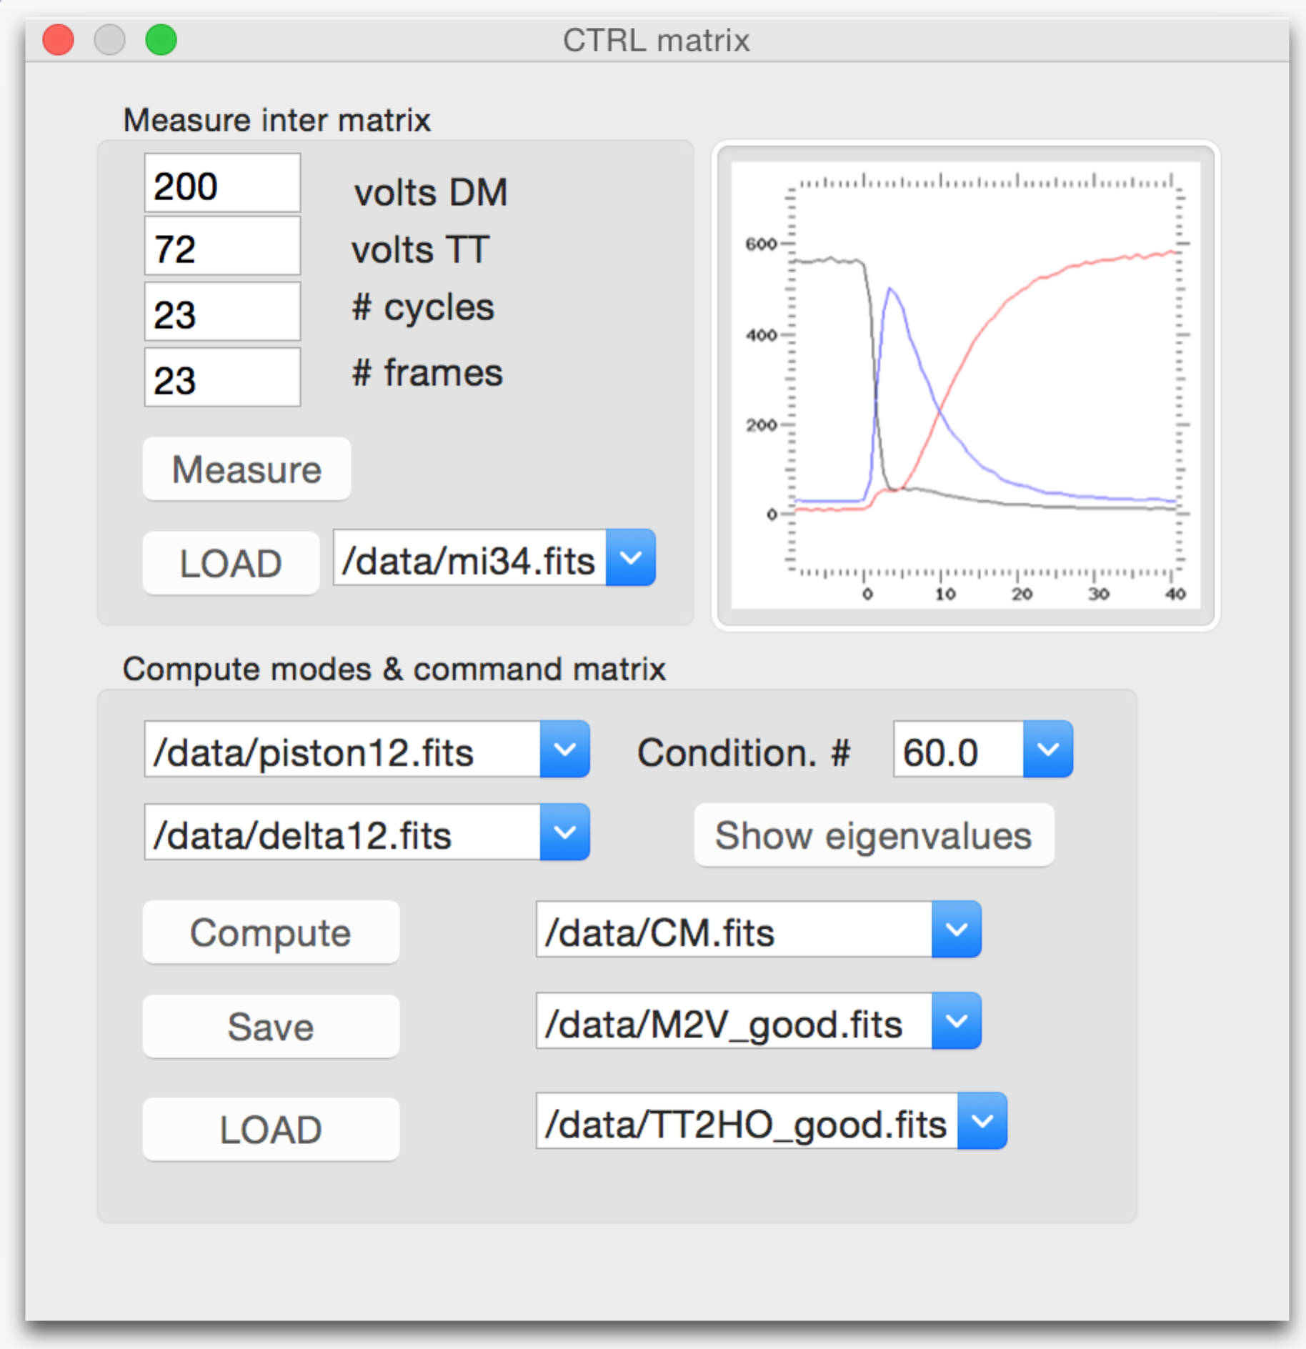
    - GUI : Interaction matrix
[[Measure]] this button triggers the measurement of an interaction matrix (both the HO inter matrix and the TT inter matrix), taking into account the parameters in the boxes above. The present interface does not show the complete set of parameters, it should be adapted accordingly (ask to Casey). The result should be saved in the file shown in the box (or, alternatively, there could be a “save” button opening something to parse a folder tree … as you like, Udo). When finished, the inter matrix is displayed somewhere in a graphic window.

[[LOAD]] this button reloads an interaction matrix (HO and TT), the name of the matrix is written in the file box. When reloaded, the inter matrix is displayed somewhere in a graphics window.

    - GUI : Control matrix, modes, etc.
[[Compute]] this button will trigger the use of the function gral_createModalBasis() and gral_computeSystemCommandMatrix(). Those 2 functions will generate:
- a modal basis, to be saved in a FITS file which name is given in a box
- a piston mode, to be saved in a FITS file which name is given in a box
- a standard system command matrix, to be saved in a FITS file which name is given in a box
- a modal control matrix, to be saved in a FITS file which name is given in a box
- a matrix TT2HO (that I have forgotten in the interface), to be saved in a FITS file which name is given in a box
[[save]] this should allow the user to save all the matrices above in the files which name are given in the text boxes
[[LOAD]] this allows the user to reload all the matrices above, using names in the text boxes.

[[Show eigenvalues]]
this button performs a SVD (singular value decomposition) of the HO matrix and plots the eigenvalues. These eigenvalues should be plotted in a log scale. These eigenvalues should be normalized to the largest eigenvalue. They should be sorted in decreasing order. The vertical scale of the graph should range from max(smallest eigenvalue, 0.001) to 1.00. A horizontal line should be drawn across the graph at the level of (1/conditioning_number), taken in the text box.

  - OMGI
The CIAO RTC will use an Optimized Modal Gain Integrator algorithm to set the modal gains in response to variable observing conditions. Optimizing the correction requires first to get data acquired in closed loop. Some DM voltages and WFS slopes should be acquired (typically N≈2048 frames).
The algorithm is described as pseudo-code in function:
gral_modalControlOptimization()

Those slopes are projected onto the modal basis, as well as DM voltages, and added up together (possibly time shifted to account for the latency) in order to retrieve pseudo-open loop data in modes space.
TBC : Noise level should be derived from the temporal sequence of data (done by autocorrelation). However, I will skip this stage for the time being. Even without the noise estimation, the procedure should be accurate enough. The
Temporal spectra of all mode temporal record are computed, and the system transfer functions are then applied to them, and the minimum error is searched versus gain.
This process should be run every 5 to 10 mn on the WS.
The typical sequence will be:
- New modal gains are estimated by a dedicated RTC component which uploads the resulting modal gain vector into a particular location in CDMS
- This triggers an automatic reaction from a second RTC component that re-computes the CM and stores the result into a particular CDMS location
- This triggers an automatic reaction from a third RTC component that downloads the new CM to the control HW and applies it in closed-loop

    - GUI for the OMGI
The GUI for the OMGI should be used
- to trigger manually (click !) an optimization of the gains and the generation of a new optimized matrix
- during AIT, to check the values on the optimized gains
- as an engineering panel to configure the following parameters (that should be part of the system configuration):
  - the period of re-optimization,
  - the number of slopes to acquire for OMGI,
  - the maximum value allowed of the gain (gmax)

[[Get optimized gains]] this button triggers the acquisition of a number (written in the text box) of slopes and DM voltages, and runs the function gral_modalControlOptimization() that will compute the array of gains, and plot them in a graphic window. Notice that the pseudo-code function only describes the algorithm, and does not describe the acquisition of slopes+volts data.
[[Compute matrix]] this button will trigger the function gral_computeSystemOptimizedControlMatrix() that will generate and load a new control matrix in the RTC.

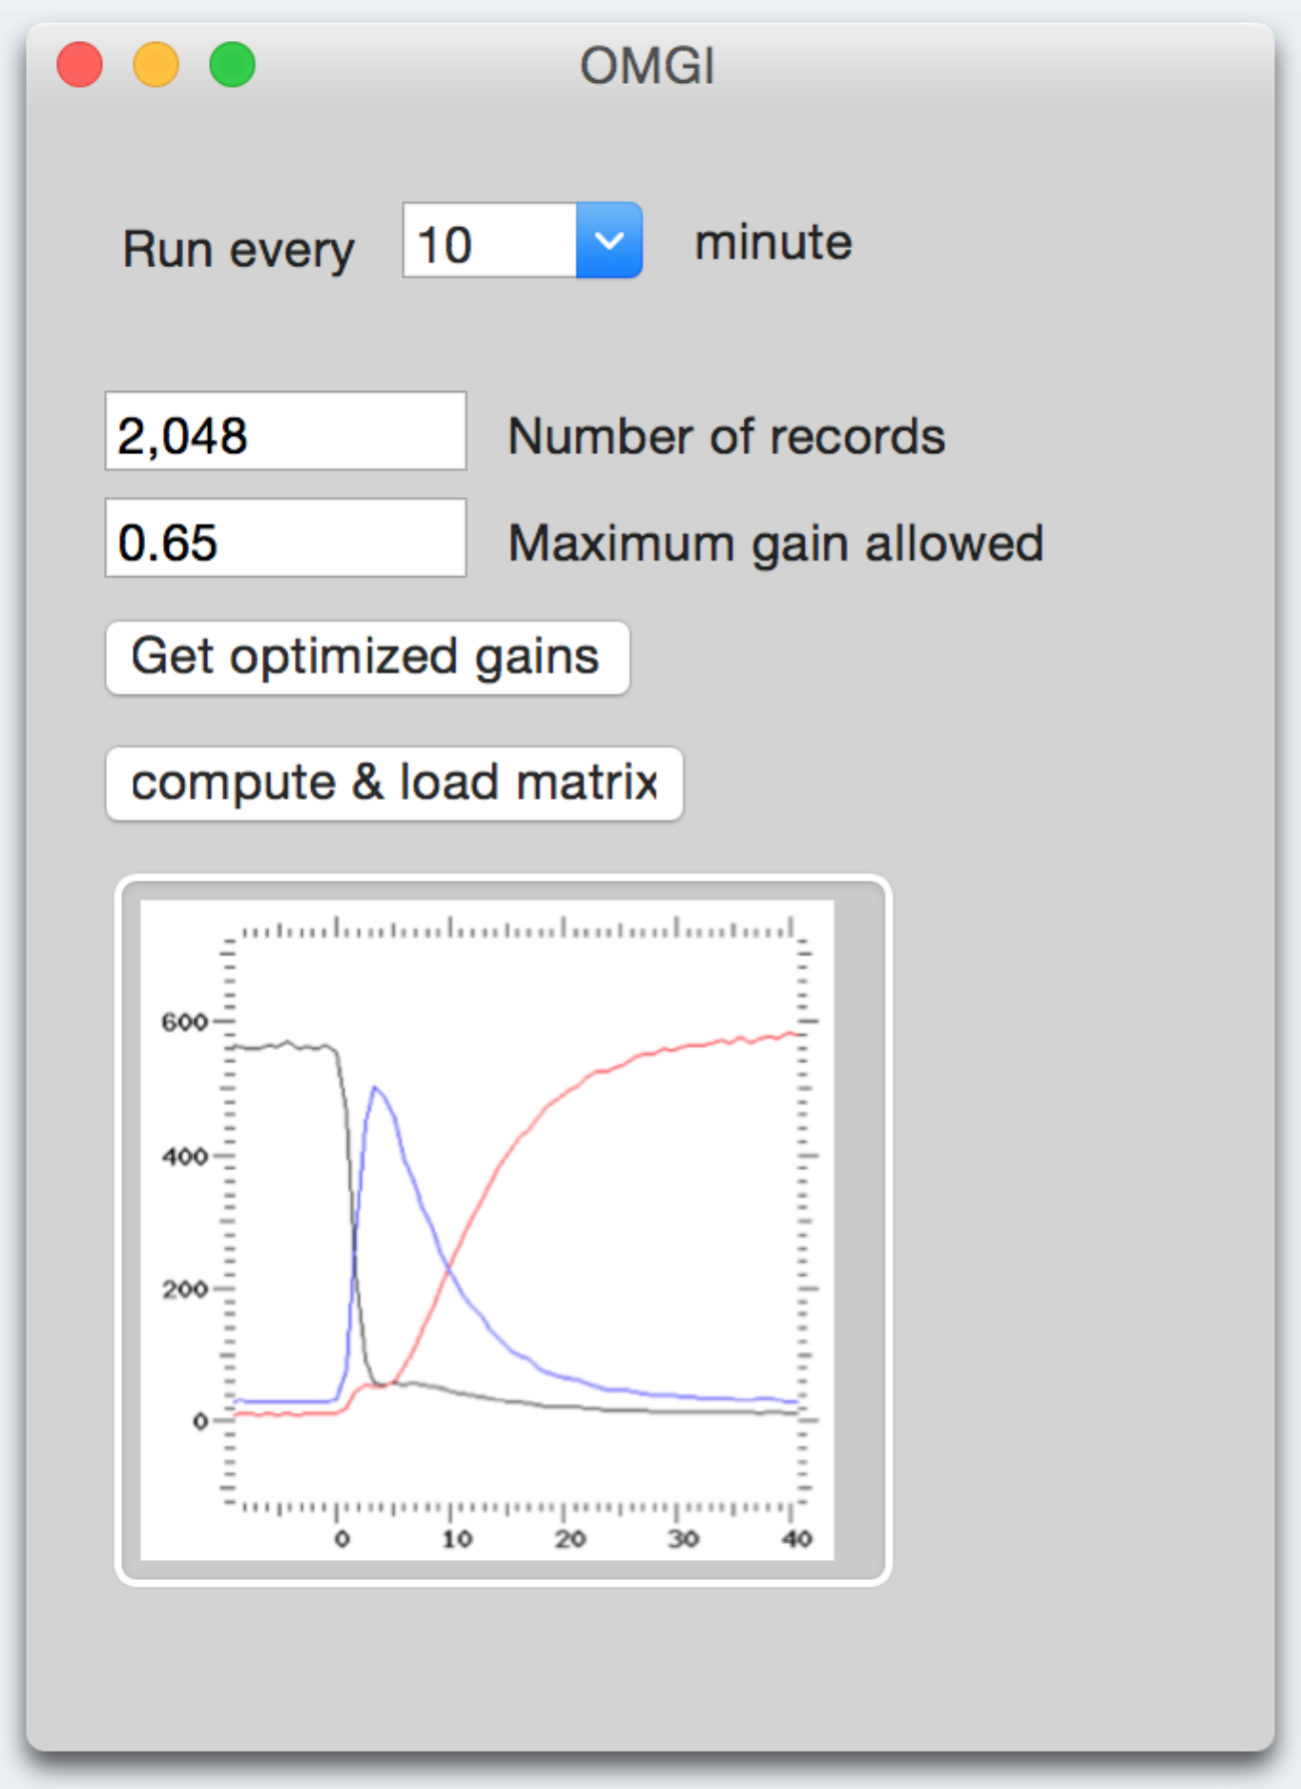

- Computing Commands for DM

  - Saturation management
In order to keep the mirror from saturating and degrading the delivered Strehl in extreme observing conditions, CIAO will implement a saturation-management algorithm which will minimize the number of saturated actuators, trading off a slight degradation of loop performance.
The baseline is to use the SMA algorithm from SPARTA.
  - Piston removal
Because GRAVITY is an interferometric instrument, the WFS will have to take care not to introduce piston into the correction, as this will affect the signal sent to the interferometer. CIAO will operate in a piston-less modal basis and implement a piston-removal algorithm.
The baseline is to use the PRMA algorithm from SPARTA.
  - Vibration control
CIAO must be able to measure and reject vibrations due to the telescope and other environmental elements. CIAO will comply with SPARTA standard of vibration control.
The vibration control will only be applied to tip-tilt. Vibration control should only be active for sampling frequencies greater than 50 Hz.
Question: Are the vibrations to be corrected with the TTM or with the DM? The vibrations will be compensated using the same active element as already foreseen by SPARTA Light.

- Online update of parameters
  - Reference slopes
As the optics of the wave-front sensor path and of the VLTI train are not perfect, they introduce some aberrations into the beam delivered to the VLTI tunnel. CIAO must be able to account for these aberrations.
A reference source will be located at the level of the star separator (where beams separate between WFS, and science imaging). This source will be able to calibrate for the aberrations contained in the WFS path (between STS and WFS): indeed, the loop should not attempt to compensate any of these aberrations at any time, since the science channel does not see them at all.
    - Simple reference slopes
When the de-rotator is fixed, absent, switched off, not initialized or inactive (e.g. in the lab, during AITs), reference slopes will be made by averaging slopes. One of these 2 equivalent algorithms should be applied (the choice will be made by the programmer (personally, I like #2 better..)):
Algorithm #1:
- load reference slopes equal to 0.00 in SPARTA
- get slopes from SPARTA, and time-average them: this will be the new calibrated reference slopes
- load the new calibrated reference slopes in SPARTA
Algorithm #2:
- get slopes from SPARTA, and time-average them,
- add the currently applied reference slopes to the previous average,
- load the result as the new calibrated reference slopes in SPARTA
See python pseudo-code function:
calibrateRefSlopesSimple(nframes)
Input parameters:
<nframes> : scalar integer, number of frames to grab at each acquisition. Recommended default value (if ever required for whatever reason): 200
Output parameters:
The 1D array of new reference slopes values.
    - Reference slopes using the de-rotator
If the de-rotator is not 100% perfectly aligned, motion of the de-rotator will induce a rotation of the aberrations contained in the optical path between the reference source and the de-rotator. This motion will be manifest in slight variations in the reference slopes as a function of rotation angle.
If the best possible alignment of the de-rotator is unable to make the effects of these variations negligible, CIAO must have the ability to calculate corrections to the reference slopes as a function of de-rotator position, and to apply these corrections as the telescope tracks across the sky. This will be done using a look-up-table scheme based on measurements of reference slopes done for a given set of angle values of the rotation. Precise pitch between angles will be determined during commissioning.
The detailed algorithm is given in the python function
calibrateRefSlopesUsingDerotator(nframes, nsteps)

Input parameters:
<nframes> : scalar integer, number of frames to grab at each acquisition. Recommended default value (if ever required for whatever reason): 200
<nsteps> : number of position angles the rotator needs to do. Recommended default value (if ever required for whatever reason): 12
    - NCPA
The user will provide the NCPA to CIAO as Zernike coefficients, expressed in nanometres rms. CIAO will “rotate” the demanded wave-front according to the WFS de-rotator angle, and will convert it to reference slopes (taking care of units), and add it to the current reference slopes: this will be done in the instrument software.
Then, these reference slopes will be loaded into SPARTA.
This NCPA data file should be part of the system configuration.
During commissioning, the non-common path aberrations (NCPA) will be measured by examining the beam delivered to the VLTI tunnel (using the GRAVITY acquisition camera) and adjusting the DM pattern until the Strehl ratio is maximized.
The detailed algorithm has been coded in python pseudo-code in the function:
transformZernikeIntoSlopes(z, i0, flip, angledeg, scalingFactor, pixelSizeArcsec, DiamVLT)
Input parameters:
<z> : 1D array of floating-point zernike coefficients. Zernike coefficients are expected in "nanometers rms".
<i0> : scalar integer, Zernike standard index of the first element of the array <z> (see section 11.1.6)
<flip> : Boolean, to be adjusted during AITs
<angledeg> : scalar, floating point. Angle of rotation in degrees of CIAO de-rotator.
<scalingFactor> : scalar floating point, nominally equal to 1.000
<pixelSizeArcsec> : scalar floating point = pixel size of WFS in arcsec = 0.51 (Pixel size of WFS is 0.51'')
<DiamVLT> : scalar floating point = VLT diameter in meters = 8.0 (VLT is 8m diameter)

Output parameters:
1D array of slopes, to be added to the reference slopes.
    - Offsets (TBC, low priority!)
CIAO will possibly (TBC) need to accommodate tiny offsets (Focus, Tip/Tilt, etc.) sent by any of the other systems (Telescope (?), Beam Combiner, etc.). This will impact the reference slopes of the system. These offsets should be provided as a list of Zernike coefficients, expressed in nanometres rms. They will be treated exactly as NCPA, and they will need to be added to the reference slopes too, just as NCPAs.
    - Global scheme, overview
At Paranal:
on the left (green background) the calibration phase produces the LUT for reference slopes using the de-rotator, and produces NCPA. On the right, during on-sky observation (pink background) the angle of the de-rotator determines the reference slopes from the LUT, and the NCPAs received either from the CIAO user or from external source (cloud) are rotated according to the de-rotator angle and summed all together and loaded to Sparta.
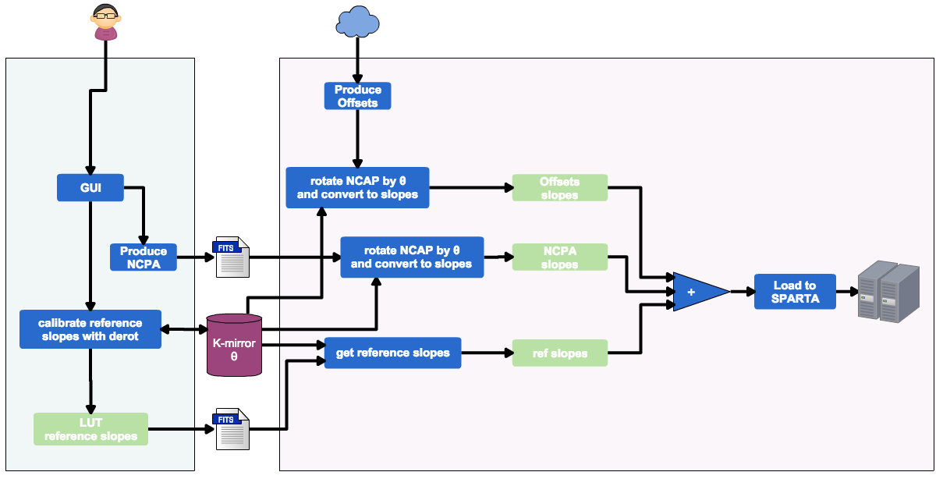

During AITs in Heidelberg:
The procedure is simplified because the de-rotator is inactive. We do not have to “rotate” the wave-front (i.e. we rotate it by an angle of 0°). We cannot easily calibrate the LUT neither, so that we will need to compute the reference slopes using a simpler scheme.
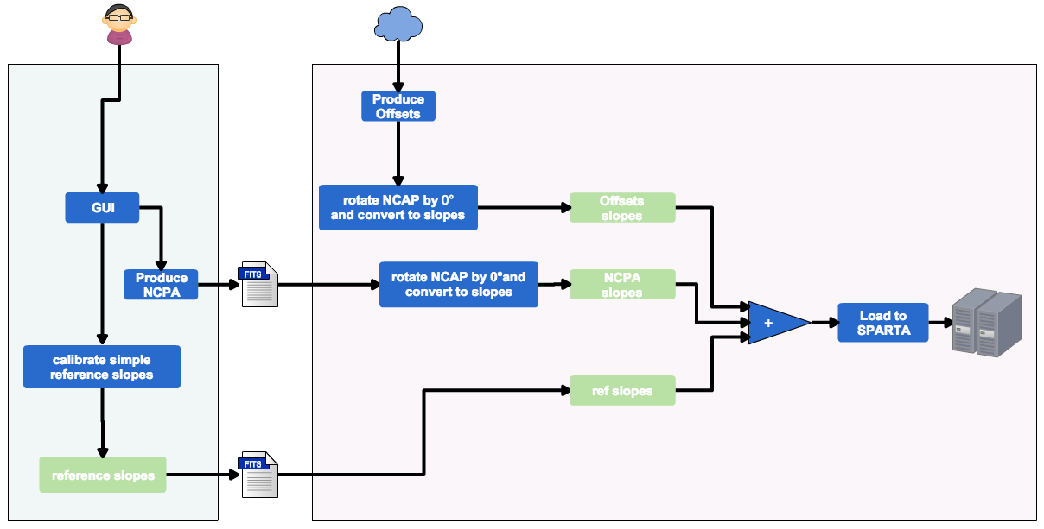

    - GUI for reference slopes

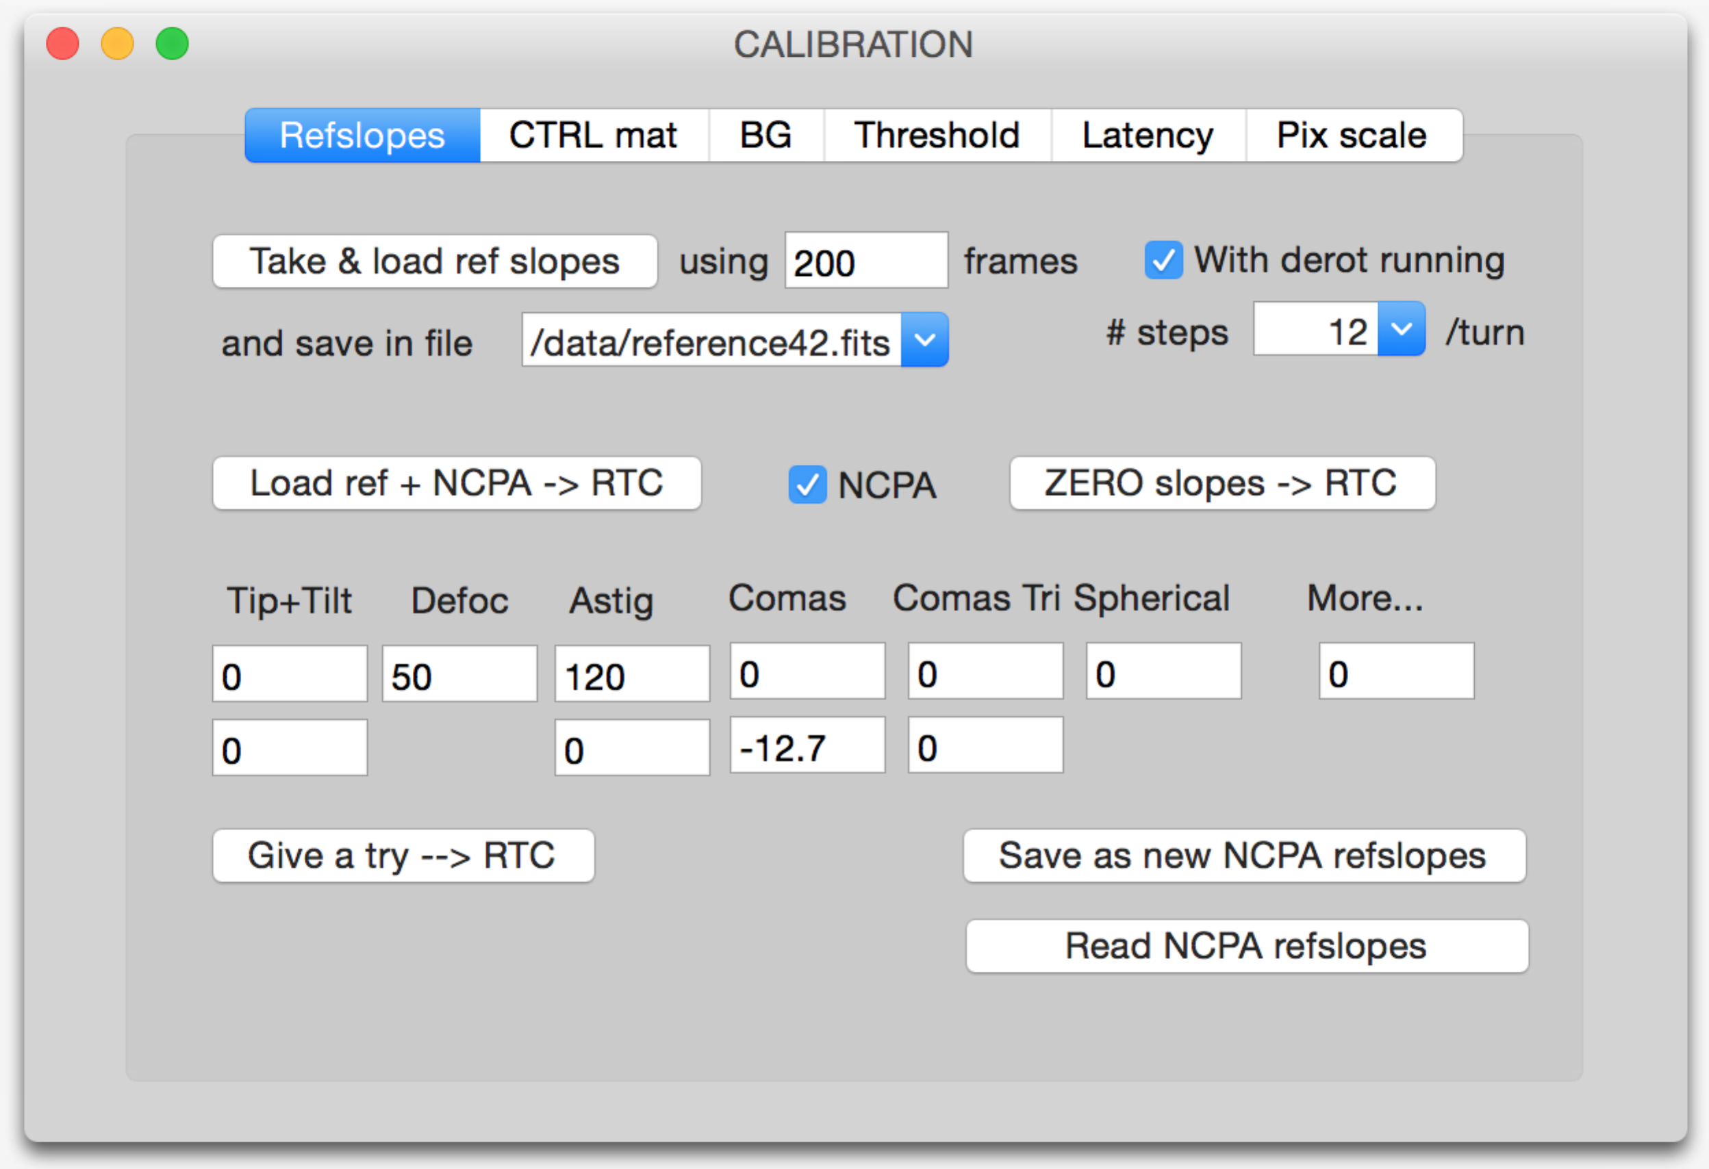
The GUI of the reference slopes should be one of the tabs of a larger “Calibration” Panel.

[[Take & load ref slopes]] will either:
- calibrate the reference slopes by calling the “simple ref slopes scheme” as described in section 11.1.1, if the checkbox “☑ With de-rotator running” is OFF (=’unchecked’) (in this case a fits file containing the reference slopes will be saved). The file will be saved, and the reference slopes will be loaded into SPARTA.
- or call the “ref slopes with de-rotator” function as in 11.1.2, if the checkbox “☑ With de-rotator running” is ON (in this case a LUT containing reference slopes for all de-rotator angles will be saved). The number of steps the de-rotator will do is indicated by the box “# steps/turn”. The file will be saved, and the reference slopes will be loaded into SPARTA according to the de-rotator angle.
[[Load ref + NCPA → RTC]] will open a file browser and read a chosen refslopes fits file. If a simple refslopes file is chosen, it will directly load them into SPARTA as is. If a refslope-LUT file is chosen it will look for the de-rotator angle, and load refslopes accordingly. Depending on the status of the checkbox “☑ NCPA”, the NCPA should be added, or not.
[[Zero slopes → RTC]] load reference slopes all equal to 0 in the RTC, with no NCPA. Just 0. No matter the de-rotator position.
Tip-tilt, Defoc, Astig, Comas, Coma Tri, Spherical, More …: those boxes allow the user to enter manually the amplitudes (in nm rms) of the NCPA. When clicking on [[Read NCPA refslopes]] the same boxes are used to print the Zernike coefficients. The numbering (following Zernike standard numbering) of the aberrations is the following:
Aberration name | Zernike standard index | C array index
Tip | 2 | z[0]
Tilt | 3 | z[1]
Defocus | 4 | z[2]
Astig | 5 | z[3]
Astig | 6 | z[4]
Coma | 7 | z[5]
Coma | 8 | z[6]
Coma Tri | 9 | z[7]
Coma Tri | 10 | z[8]
Spherical aberration | 11 | z[9]
The function transformZernikeIntoSlopes(z, i0, flip, angledeg, scalingFactor, pixelSizeArcsec, DiamVLT) should then be called with i0=2.
[[Give a try → RTC]]: This button takes the values given by the user for the NCPA (all the boxes) and applies them (i.e. rotates according to the de-rotator angle, converts to slopes, add to reference slopes, and loads into RTC).
[[Save as new NCPA refslopes]]: Save in a FITS file the NCPA values written in the boxes
[[Read NCPA refslopes: Reloads a FITS file containing Zernike coefficients describing NCPA aberrations, prints the values in the boxes
  - Tip-tilt offloading
While the MACAO DM has an integrated Tip/Tilt mount (and can perform a large amount of Tip/Tilt itself), CIAO should also be able to offload Tip/Tilt to different parts of the system (the STS or the telescope itself).
Of course, CIAO will reuse the current facilities from the RTC –i.e. skip N frames, project M frames individually into TT, average result, enter it into a MAV filter, sub-sample filter output, publish result in OLDB. The periodicity of this offload will be the same as in MACAO. The algorithm will be the same than in MACAO.

- Pupil Tracking
Pupil shifts on the WFS lenslets can reduce the GRAVITY AO performance as shown in RD4; e.g. for the bright reference star case, m_{K}=7 and 7” off-axis, a pupil shift of about 1/10th of the size of a sub-aperture reduces the Strehl number from 0.364 to 0.359.
M8 pupil tracking will be performed on the control workstation through analysis of the uploaded data coming from the RTC. The algorithm is described below. In case a compensation of the pupil shift is required (see section Error Budget in RD1), the correction should be performed within 1 second.

There are 2 possible philosophies:
- either stabilize the position of VLT mirrors (i.e. VLT pupil stop M2, since M1 is not the pupil) on the lenslets. Monitoring the flux balance on the edge sub-apertures is a good algorithm for doing this. On top of that, the algorithm can run pretty fast since it does not need large amounts of data.
- or stabilize the position of the MACAO DM (M8) on the lenslets, and this can be done by monitoring the closed-loop data (slopes and voltages) and search for possible DM shifts into it. However, this algorithm will be slow (<0.1 Hz or 0.05 Hz) because it requires a pretty large amount of data (≈at least 2000 frames) to run properly. TBC during AITs.
- A 3rd possibility would also be to monitor the position of the MACAO DM in open-loop, by poking the DM briefly and recording WFS data to ‘see’ where is the DM. This mode requires a particularly fine coordination at system level and cannot be achieved during observing, that’s why the 2 other methods are preferred.
We received some oral recommendations from ESO people, telling that a stabilization of M8 should be preferred. Indeed, the ultimate goal of stabilizing the pupil is to keep the command matrix up-to-date, i.e. the registration of the DM (rather than M2).

  - M8 Pupil Tracking using slopes+voltages
The M8 (=deformable mirror) centering/registration between the Shack-Hartmann lenslet mask and the M8 deformable mirror - can be extracted from real-time close-loop data. Indeed, computing the difference between 2 successive SHWFS frames gives a quantity, which should be equal to
Δ_{measurement} = D . ( Δ_{command} + Δ_{turbulence} )
where
- D is the interaction matrix (dimensions are 136 x 60 for GRAVITY)
- Δ_{measurement} is the difference between 2 successive SHWFS measurements (slope vector with dimension 136 x 1)
- Δ_{command} is the DM command vector (60 x 1) that has been incremented to the loop integrator
- Δ_{turbulence} is the turbulence increment between the 2 successive frames
We are able to measure a wealth of pairs (Δ_{measurement} , Δ_{command}) by acquiring slopes+voltage data. As the quantity Δ_{turbulence} is nearly uncorrelated/independent from Δ_{command}, it can be considered just like a “noise”. Hence, getting plenty of measurements allows us to solve the equation system in a least-square sense, and to get all the coefficients of the matrix D, namely to retrieve the interaction matrix while the system is working in closed-loop. The algorihm also needs to take into account the latency of the system, in order to know exactly when a given DM command is seen by the WFS (the DM command usually takes place astride on 2 WFS measurements). Then, when the interaction matrix is retrieved, an algorithm needs to compare it to the nominal interaction matrix, and tell what is the shift.
Tests on NAOS during commissioning have demonstrated that the method works fine, provided that at least 2000 to 4000 samples are taken, depending on the seeing and on the SNR on the WFS. Running for example at 200 Hz means that at least 10-20 seconds of real-time data have to be recorded, before being able to get a result. The situation is different in the case that the Star Separator’s pupil actuator is moved by an auxilary device such as DELIRIUM [RD9]. Whether an open loop control system would solve this problem needs to be discussed with ESO.
The detailled algorithm has been coded in python, and is described by the function
pupilTrack_slopesMethod()
with detailled comments.

  - M2 pupil tracking
M2 pupil tracking is preferably used for alignment and diagnostics. The algorithm is described below. M2 pupil shifts can be monitored on the Shack-Hartmann WFS at frequencies of about 33 Hz (for details see end of this chapter). This would allow to correct pupil shifts with a control bandwidth of about 5 Hz. Details of this flux monitoring scheme using 4 outer ring sub-apertures can be found in RD10. A slightly modified excerpt of this scheme is included below. This method works with and without running the AO system in closed-loop.
The algorithm is based on flux measurement by the edge sub-apertures. The flux difference will be computed between “left and right” edge sub-apertures to derive the shift in X, and between “top and bottom” ones to get the shift in Y.
The algorithm initially planned (and described in the early versions on the document) aimed to use only 4 sub-apertures. The final algorithm is described in pseudo-code (python) in the function
pupilTrack_fluxMethod()
and is making use of all the edge sub-apertures, both at the outer periphery of the pupil and around the central obscuration. See below: useful sub-apertures are shown in yellow. The algorithm determines the edge sub-apertures (in green), and associates a radial unitary vector to each of these sub-apertures. The global shift will be determined by summing all the vectors for each sub-apertures, weighted by their respective flux, and normalized by the total flux.

Flux monitoring scheme
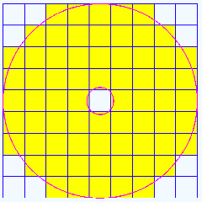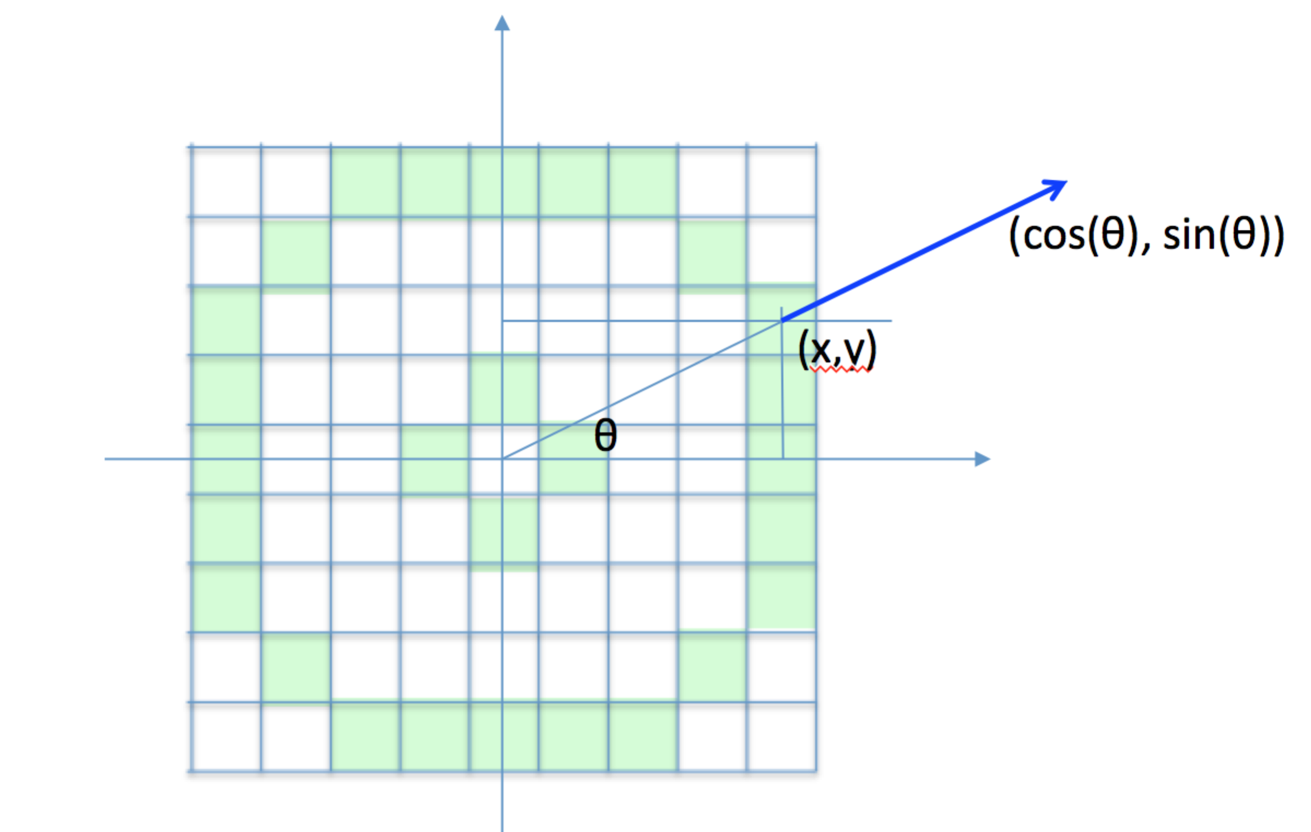
This algorithm is preferred to the initial algorithm, because it is making use of all the edges sub-apertures, and not only 4 of them: this should contribute to increase the signal-to-noise ratio.
    - Initial algorithm (obsolete)
The figure shows a square micro-lens array in a 9x9 configuration with 68 illuminated (>50% illuminated) micro-lenses. To first measure the pupil position using the Shack-Hartmann WFS we propose to use 4 sub-apertures (e.g. top center (TC), bottom center (BC), left center (LC), right center (RC)) and use their integrated flux to calculate the normalized pupil centroid position PX and PY:
PX = (LC-RC)/(LC+RC) (1)
PY=(TC-BC)/(TC-BC) (2)
This is similar to a dual axis lateral effect detector [see for example: A. Mäkynen, Ph.D. Thesis, Position-sensitive devices and sensor systems for optical tracking and displacement sensing applications, OULU, OULU University Library, Finland, 2000, ISBN 951-42-5779-0].
The correction element for pupil misalignment is inside the GRAVITY WFS cryostat. Calling x the shift of the pupil, expressed as a fraction of a sub-aperture, we have
if -1<x<0:
LC(x) = LC(0) * (1+x) (3)
RC(x) = RC(0) (4)
if 0<x<1:
RC(x) = RC(0) * (1-x) (5)
LC(x) = LC(0) (6)
For x<0 we have according to EQ. 1:
PX(x) = (LC-RC)/(LC+RC) = (LC(0)*(1+x)-RC(0)) / (LC(0) * (1+x) + RC(0))
= x*LC(0)/( LC(0) * (1+x) + RC(0)) (7)
and for x>0:
PX(x) = (LC-RC)/(LC+RC) = x*RC(0)/( RC(0) * (1-x) + LC(0)) (8)
Assuming that x is small we can rewrite EQ. 7
(LC-RC)/(LC+RC) = PX(x) = x*LC(0) / (LC(0) + RC(0)) (9)
We know we have LC(0) = N electrons on average. However, at each frame we measure a quantity LC(0)=N+e, with e a zero-mean (<e>=0), random variable. When photon-noise limited, e has a variance equal to N. If we take into account readout-noise RON on n pixels, the variance of the measured flux will be <e²> = (N+n*RON²).
The expression of PX(x) (EQ. 9) can then be written as (RC(0)=N+e’):
PX(x) = x * (1+e/N) / (2 * (1+e/2N+e'/2N))
= (x/2) * (1+e/N) / (1+e/2N+e'/2N)
= (x/2) * (1+e/N) / (1+e/2N+e'/2N) * (1-e/2N-e'/2N) / (1-e/2N-e'/2N)
= (x/2) * (1+e/N) * (1-e/2N-e'/2N) *
1 / ((1+e/2N+e'/2N) * (1-e/2N-e'/2N))
= (x/2) * (1+e/N) * (1-e/2N-e'/2N) * 1 / (1-1/4N² * (e+e’)²)
= (x/2) * (1 + e/2N - e'/2N) (10)
The random variable (e/2N-e'/2N) has a zero-mean, and a variance of
V² = (N+n*RON²) / 4N² (11)
So, if we want x to be accurate enough ( (x_measured-x_true)/x_true < 1.01 ), we should have something like sqrt(V²)<<0.01, or V²<<1E-4.
At 200Hz, with mK=6.5, we have about N=800e⁻/frame
with RON=6.5 electrons/pixel rms and n=16 pixels, we have
V² = (800+16*42.25)/(4*800²) = 6E-4.
This means we have to average at least 6 frames to reduce the variance down to a reasonable level. In other word, the time constant of the pupil tracking cannot be higher than τ = 6/200 = 0.03 seconds. The bandwidth BW of the pupil loop will be 1/τ = 2π.BW, or BW < 5.3 Hz. A bandwidth of 5.3 Hz is sufficient to get a good accuracy, and fast enough to follow any pupil drift.
  - Field lens motion
The pupil-tracking algorithm by itself is useless: it requires to be coupled to an action on the field lens, which will re-centre the pupil after the shifts have been determined. The command of the motors of the field lens will be done using some specific units (called motor units here), while the pupil-tracking algorithm returns the pupil shift in other units. A link needs to be established between the pupil tracking units, and motor units:
motor_units_X = pupil_shift_unit_X * Ax + Bx
motor_units_Y = pupil_shift_unit_Y * Ay + By
The numbers Ax, Ay, Bx, By need to be part of the system configuration.
They also need to be calibrated. For that, we need a special function that will translate the field lens from motor_units (x₀, y_{C}) to (x_{N}, y_{C}) in N steps and will measure the pupil shifts (u_{k}, v_{k}) at each step k, and will do the same in Y (motor_units (x_{C}, y₀) to (x_{C}, y_{N}) in N steps). Then a linear regression of the [x₀, x₁, … x_{N}] in terms of the [u₀, u₁, … u_{N}] will allow us to determine Ax and Bx. Same for Y. The values of (x_{C}, y_{C}) will be a user input. The amplitude range (x_{N}-x₀)/2 = (y_{N}-y₀)/2 = R will also be provided by the user. The x_{k} can be computed using x_{k} = x_{c} – R + 2.k.R/(N-1) (and same for Y).
  - On-sky operation of pupil tracking algorithm
A procedure running in background should periodically measure the pupil shift on-sky every T seconds, each time based on the acquisition of N frames of data. The pupil shifts (u, v) will be measured each time.
The motors of the field lens should be updated at each step using the formula:
new_motor_position_X = old_motor_position_X + G*Ax*u
new_motor_position_Y = old_motor_position_Y + G*Ay*u
where G is a scalar factor provided by the user (and stored in the system configuration). Those 2 equations lead to a closed-loop pupil tracking scheme, and G is the gain of this closed-loop.
  - System configuration for pupil tracking
The system configuration should remember the following parameters:
- number of data frames to be acquired for the estimation of pupil shifts
- period (in seconds) for re-estimating the pupil shifts when observing on-sky
- Bx, By (motor coordinates of field lens for having the pupil centered)
- Ax, Ay (coefficients for translating pupil shifts into motor coordinates)
- pupil-tracking loop gain

  - GUI for pupil tracking

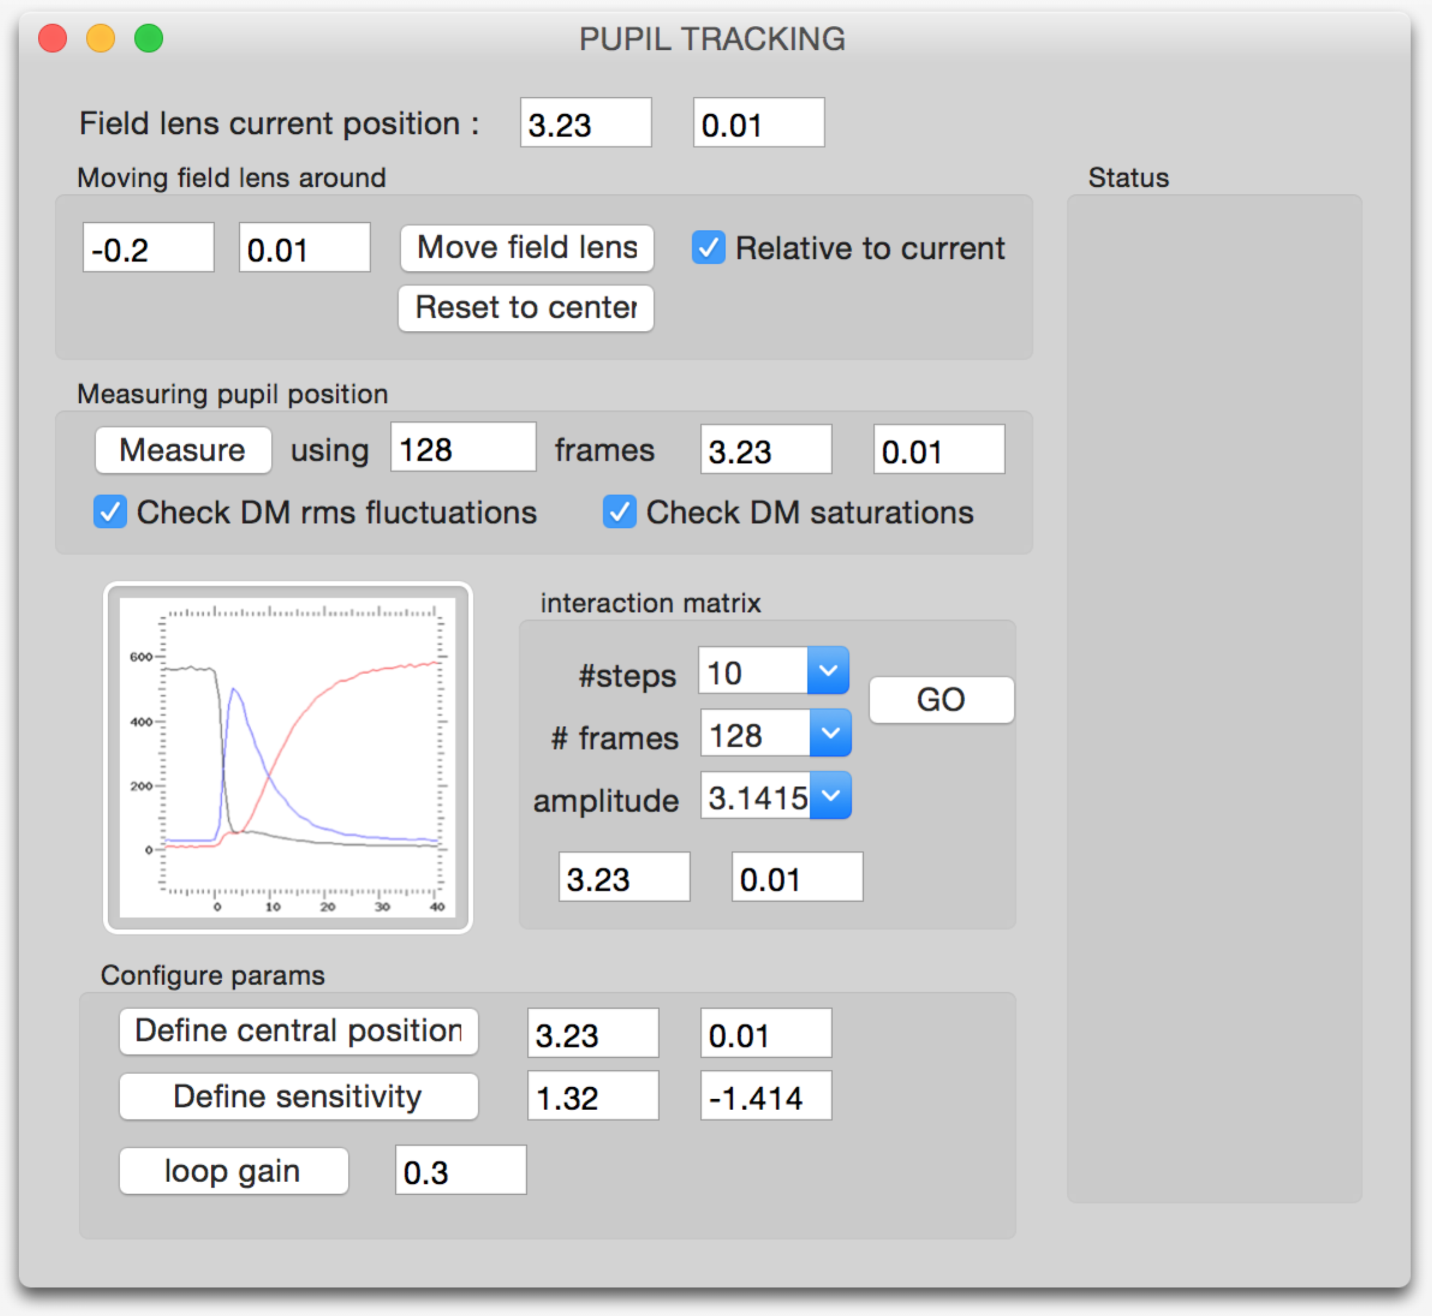

    - Moving the field lens
This sub-box should be used in AIT to move the field lens around, either from its current position, on to an absolute position. The [[Reset to centre]] button allows the user to bring the lens to the default coordinates (Bx, By).
    - Measuring pupil position
This sub-box should be used during AIT to run (just once) the algorithm of pupil shift estimation and print the shift estimates in the text boxes.
    - Interaction matrices
This sub-box should be used during AIT and maintenance phases to compute the coefficients Ax, Ay, Bx, By described in section 12.3.
    - Configure params
This sub-box should be used during AITs and maintenance phases to define the default parameters to be stored in the system configuration Ax, Ay, Bx, By, loop gain.

- Telemetry & Archiving
Data acquisition is important during observing modes, and even more important and demanding during the manufacturing process of the RTC (debugging), AIT phase, commissioning.
RTC Phase | Purpose of data acquisition
RTC manufacturing | Data acquisition for debugging software and interfaces
Manufacturing of SELEX readout electronics and testing of interfaces, data flow, synchronization, between NGC and RTC | Characterization, synchronization issues, debugging interfaces (the real ones) and time-related issues.  Here strong requirements on 100% data logging capabilities (99.9% not sufficient).
AIT | Being able to debug the system.  Real-time displays (many of them opened at same time).
Observing | Real-time display (flow rate adequate for eye-looking), in order to check things, possibly center the object, etc.
Observing | Data analysis for loop optimization, special computations, performance analysis
Maintenance | Get specific data obtained in a specific mode and process them (in a specific way)
The data acquisition can be split into 3 categories:
1 – getting data for data analysis purpose
2 – getting data for real-time display
3 – archive data
  - Data analysis purposes
The list of the things that require data acquisition is the following:
What | What kind of data is needed | temporal aspect  sub-sampling % authorized
Sky/dark background acquisition | block of data on request  raw images | > 10%
Flat-field acquisition | block of data on request  raw and calibrated images | > 10 %
Threshold optimization | block of data on request  calibration images | > 20 %
Reference slopes | block of data on request  slopes | > 50 %
Interaction matrix | block of data on request  slopes | =100%
Modal control optimization | block of data on request  slopes + volts | =100%
Vibration tracking optimization | block of data on request  slopes + volts | =100%
Performance estimation | block of data on request  slopes + volts | > 99%
pupil centring | block of data on request  flux + slopes | > 70%
telescope offload (tilt, focus) | block of data on request  volts | >10%

  - Archive data
High-level data products like all control matrices shall be saved for trend analysis and long-term health monitoring of the WFS. In case, the low-level data should be useful for the GRAVITY astrometric data analysis, implementation of data archived has to be discussed.
Archived data should include:
- Interaction matrices
- Command matrices
- Statistical parameters (r0, L0, tau0, noise, average flux, SR, % DM saturations)
- Reference slopes
- NCPA
- backgrounds
  - SPARTA-Light RTDFL
We understand that the upload of samples from the RTC to the INS-WS is done continuously through RTDFL links. That is, the RTC does not send periodically blocks of N samples, but each vector of slopes/intensities/command as they are generated every loop cycle.
It means that there is no local storage facility in the LCU, and the only buffers are those provided by the RTDFL links.
- GUI
  - Observations
The observing interface to CIAO must provide the observer easy access to frequently used information
    - DM HO/TT actuator positions
CIAO will provide a graphical display of the High Order/Tip-Tilt actuator positions. The graphical display should be updated at a frequency of ~10 Hz.
    - Gradients
CIAO will provide a graphical display to show the gradients calculated from the subaperture positions. The display should be updated at a frequency of ~10 Hz.
    - Pupil Tracking
CIAO will provide the observer/operator with a display (either graphical or numerical) of the position of the pupil.
    - Sub-aperture Illumination
CIAO will provide a display showing the integrated intensity of each sub aperture, to be used in diagnosing loop performance.
  - Engineering
CIAO will provide the following functionalities for engineering and maintenance operations
    - Data Viewing
      - Interaction/Command Matrix
CIAO will allow visual and numerical inspection of the measured/calculated interaction/command matrices.
      - OMGI
CIAO will allow the user to inspect the modal gains currently in use by the system, as well as comparing to historical values.
      - Modal basis
CIAO will provide the ability to generate graphical images of the modal basis (will this be useful?)
    - Data Recording
CIAO will allow the commissioning/maintenance crew to record all pertinent loop information for off-line diagnosis. The pertinent information is summarized in the table in Error: Reference source not found.
  - Status panel and performance estimations (R0, L0, SR, wind speed, etc.)
CIAO will monitor via the RTC circular buffer voltages, slopes, and intensities. The length of the buffer monitored by CIAO will be 2048 (goal 4096) elements long. Together with the open loop modal coefficients, the following parameters will be computed each 30 (goal 15) seconds and displayed on a Status Panel. The goal is to acquire data for the next computation while the current data are reduced and. If this is not feasible, the current data will be skipped in favour of the next, most current set of parameters. A moving boxcar average of each parameter will be performed, whose result will be sent to the OS and displayed on the RTC panel every 30 (goal 15) seconds
    - Turbulence Parameters
- r0, L0 and wind speed V (together with 0)
    - System Parameters
- Temporal average value of the average DM voltage (computed over the actuators)
- <v>, Temporal average value of the rms voltage value (computed over the actuators):
- Temporal average value of number of saturated actuators per frame
- Temporal average value of the number of voltage values larger than ± 3 <v>i-1 (i-1 meaning rms of the previous step)
- Temporal average value of the tip tilt voltages
- Temporal rms value of the tip tilt voltages
- Temporal average of the spatial average flux over all the subapertures
- Tip tilt offload values
- Vibration management coefficients
- Piston estimation
    - Performance Estimator
- Strehl ratio
- Alarms
  - Conditions
CIAO must be able to raise alarms during the following conditions:
    - Loop Crash
If the loop is closed and suddenly becomes open, CIAO must raise an error/warning to the user
    - Insufficient/non-Uniform Illumination
If there is insufficient flux to close the loop, CIAO must raise an error/warning to the user
    - Pupil Tracking error
If the pupil becomes misaligned by more than 10% of a sub-aperture, CIAO must raise a warning to the user.
    - Mirror Saturation
If more than a certain number of actuators (TBD during commissioning) are consistently saturated, CIAO must raise a warning to the user.
    - Strehl degradation
If the Strehl ratio degrades past a certain point (configurable by the user, default TBD), CIAO must inform the user (possibly raising a flag to be monitored by the VLTI instruments?).
  - Handling
How should each of these errors be handled? Which software needs to be informed about which error?
Integrations into OS and ISS ???

