**Exercise 1**

 Шинэ project үүсгэх.

Хийх гэж буй хавтасандаа нэр өгөх

A screenshot of a computer

Achit

Судалгааны кейс засварлах

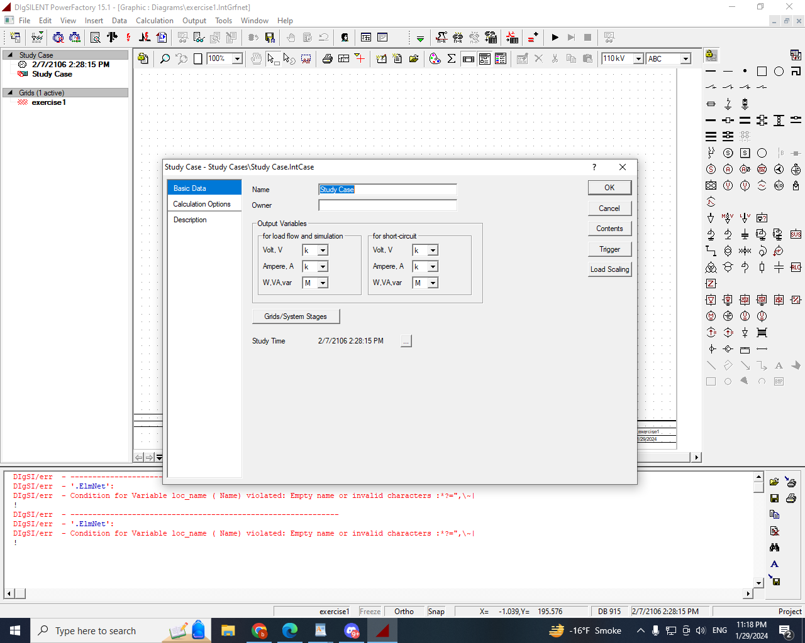

Үүсгэсэн project-oo хадгалах

