交易所对接流程

1. 钱包使用
   1. Linux钱包

第一步，下载安装包：

Centos系统：

wget https://github.com/Achain-Dev/Achain2.0/releases/download/v1.1.0/achain-1.1.0-1.x86_64.rpm

安装：

sudo yum install ./achain-1.1.0-1.x86_64.rpm

Ubuntu系统：

wget <https://github.com/Achain-Dev/Achain2.0/releases/download/v1.1.0/achain_1.1.0-1_amd64.deb>

安装：

sudo apt install ./achain_1.1.0-1_amd64.deb

第二步：启动

安装成功后，开始启动

先启动钱包进程：keosd --http-server-address *< wallet-http-server >* --unlock-timeout <time(s)>

钱包启动成功后，开始启动主链进程：

nodeos --max-irreversible-block-age -1 \

--contracts-console \

--config-dir *<config-dir>* \

--data-dir *<data-dir>* \

--http-server-address *<chain-http-server>* \

--p2p-listen-endpoint *<p2p-server>* \

--p2p-max-nodes-per-host 5 \

--agent-name *"my Agent"* \

--filter-on "*" \

--plugin eosio::http_plugin \

--plugin eosio::http_client_plugin \

--plugin eosio::chain_api_plugin \

--plugin eosio::chain_plugin \

--plugin eosio::net_api_plugin \

--plugin eosio::net_plugin \

--plugin eosio::producer_plugin \

--plugin eosio::history_plugin \

--plugin eosio::history_api_plugin \

--p2p-peer-address 52.199.222.137:9700

**注：**

1. http-server-address 如果只在内网内访问，建议设置为内网IP:PORT
2. agent-name 可以指定一个有代表性的名字，只是一个名字而已。比如：my agent
3. Achain2.0基于eosio改造升级，名空间继续沿用eosio的名空间，所以会出现eosio的字样
4. 52.199.222.137:9700是Achain官方的p2p监听服务
5. config-dir和data-dir建议同一个目录，方便管理
6. 钱包进程的*wallet-http-server*与链进程的*chain-http-server*不是一个*server，*注意区分开
   1. 同步区块

在链节点启动之后，会自动连接上节点，开始同步区块信息。

可通过cleos --url <http://xxxx:port> get info查看同步情况

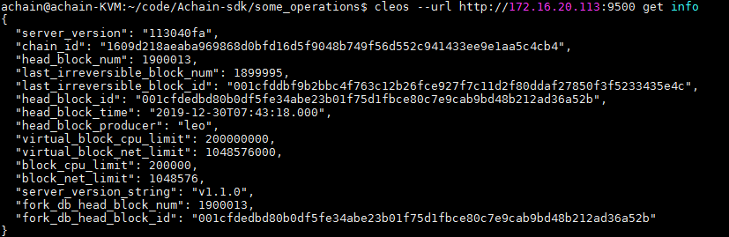

主要关注几个字段：

head_block_num：当前同步到的最新的块号

head_block_time：当前块对应的系统时间

需要检查head_block_time与当前系统时间的差值

通过date –R查看当前系统时间（注意需要减掉时区），比如：Thu, 13 Jun 2019 17:11:48 +0800对应的区块链时间为Thu, 13 Jun 2019 09:11:48

**注意：钱包在同步的过程中，调用命令会有延迟或者报错情况。请在钱包同步完之后再进行命令调用。**

* 1. 钱包操作
* 创建钱包：

cleos --wallet-url <http://wallet-http-server> –url http://chain-http-server wallet crate –n <wallet-name> --to-console

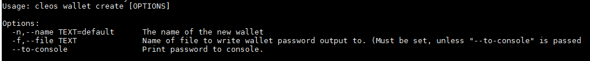

例如：cleos wallet create -n achain --to-console 创建名为achain的钱包

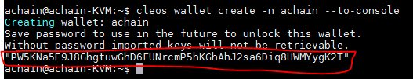

上面红线框出的是钱包的密码，要妥善保存，在解锁钱包时需要用到。

* 解锁钱包：

cleos --wallet-url <http://wallet-http-server> –url http://chain-http-server wallet unlock -n achain --password *<password>;*这个password就是上面创建钱包时返回的所生成的钱包密码。

* 打开钱包：

cleos --wallet-url <http://wallet-http-server> –url http://chain-http-server wallet open –n <wallet-name>

* 钱包导入私钥：

cleos --wallet-url <http://wallet-http-server> –url http://chain-http-server wallet import -n <wallet-name> --private-key <private-key>

* 查看钱包的公钥信息（需要在钱包解锁的情况下）：

cleos --wallet-url <http://wallet-http-server> –url http://chain-http-server wallet keys

* 1. 创建账户

依赖2.0钱包

1. 获取交易数据
2. 查看当前最新块：cleos --url *<http-server-address>* get info

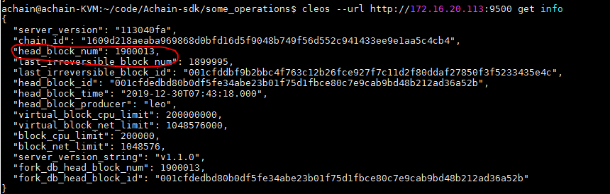

1. 根据块号，查看块打包的交易：

cleos --url *<http-server-address>* get block *<block-num>*

例如：

achain@achain-KVM:~/code/Achainplus$ cleos get block 316

{

"timestamp": "2019-03-27T08:19:42.000",

"producer": "act",

"confirmed": 0,

"previous": "0000013bb26014359dbb1c490280f9fb4526c966dbc831c1e5b5013488b12a3a",

"transaction_mroot": "505a6fdbbd17f48b1f5aba9fc179eb16c36eda135e223b1ae9a02ea9a0e5d123",

"action_mroot": "b5069994595e03b3be1dca1d0e164ee5aee47741ff7a6ef9e337de97811b158d",

"schedule_version": 0,

"new_producers": null,

"header_extensions": [],

"producer_signature": "SIG_K1_KcBM6ajPVAeVsyNvB6e9fUraCTgCbjhT2JNJZRJisJbzbSAdN8oTQzmGsSR2K3oHMG483ip5WpHKxee4xRNdnycUeb4c5E",

**"transactions": [{**

**"status": "executed",**

"cpu_usage_us": 708,

"net_usage_words": 16,

**"trx": {**

**"id": "1aa3ab5e3f2515c1f0f5b5b7a0d8aca5c0d9284809cca24a289bcb3a963e3650",**

**"signatures": [**

**"SIG_K1_KXA1CMNVZ51yKB4zUqMSeNtDeVZ9fuFEw1HBXhjgqZ4NTbHzGgVowLsDYq2xdkUzXQeTLVS8NiMHyvdDKfz5XmFRsihHEi"**

**],**

"compression": "none",

"packed_context_free_data": "",

"context_free_data": [],

"packed_trx": "39329b5c3a015e198f40000000000100c0549066d03332000000572d3ccdcd0100c0549066d0333200000000a8ed32322100c0549066d033320000000000d03332a08601000000000004414354580000000000",

"transaction": {

"expiration": "2019-03-27T08:20:09",

"ref_block_num": 314,

"ref_block_prefix": 1083119966,

"max_net_usage_words": 0,

"max_cpu_usage_ms": 0,

"delay_sec": 0,

"context_free_actions": [],

"actions": [{ //需要重点解析关注的action数据，后面的转账会详细说明

"account": "act.token",

"name": "transfer",

"authorization": [{

"actor": "act.token",

"permission": "active"

}

],

"data": {

"from": "act.token",

"to": "act",

"quantity": "10.0000 ACT",

"memo": ""

},

"hex_data": "00c0549066d033320000000000d03332a086010000000000044143545800000000"

}

],

"transaction_extensions": []

}

}

},{

"status": "executed",

"cpu_usage_us": 470,

"net_usage_words": 16,

"trx": {

"id": "6189883dfe48290422f3fccf5442aa1ffe79e26ecf92e6ffad03fc46dea9883a",

"signatures": [

"SIG_K1_JuwNuNGfxu2Ffnn9VL7gUFd4QWbb8oPo1vtertfeJY54LVaRsv5U6TJmdhztMBBvJqdjCxUwu9zJWrB6TPqrCjp886Dgv7"

],

"compression": "none",

"packed_context_free_data": "",

"context_free_data": [],

"packed_trx": "39329b5c3a015e198f40000000000100c0549066d03332000000572d3ccdcd0100c0549066d0333200000000a8ed32322100c0549066d0333200000000000072ce400d03000000000004414354580000000000",

"transaction": {

"expiration": "2019-03-27T08:20:09",

"ref_block_num": 314,

"ref_block_prefix": 1083119966,

"max_net_usage_words": 0,

"max_cpu_usage_ms": 0,

"delay_sec": 0,

"context_free_actions": [],

"actions": [{

"account": "act.token",

"name": "transfer",

"authorization": [{

"actor": "act.token",

"permission": "active"

}

],

"data": {

"from": "act.token",

"to": "ttt",

"quantity": "20.0000 ACT",

"memo": ""

},

"hex_data": "00c0549066d0333200000000000072ce400d030000000000044143545800000000"

}

],

"transaction_extensions": []

}

}

}

],

"block_extensions": [],

"id": "0000013cb36a8729e11b8817f23f47fb118f9ec8d49e246081832e24ea7c97ce",

"block_num": 316,

"ref_block_prefix": 394796001

}

扫块，就能直接获取块打包的交易信息；

或者通过上述命令解析出trx-id（一个块打包的交易数量>=0），然后再循环通过cleos --url *<http-server-address>* get transaction *<trx-id>* [-b *<block-num>*]

例如：

achain@achain-KVM:~$ cleos --url http://172.16.20.120:9000 get transaction 13d71a5b46d88d97d0cea9dc259e3cf384929846575512d5e2cc16cd3c0bfe56 -b 1009236

{

**"id": "13d71a5b46d88d97d0cea9dc259e3cf384929846575512d5e2cc16cd3c0bfe56",**

"trx": {

"receipt": {

**"status": "executed",**

"cpu_usage_us": 2658,

"net_usage_words": 17,

"trx": [

1,{

"signatures": [

"SIG_K1_KfuvraAaBLmj9TKJWdmjiUMrV5hEY5UFTqGeR9uUNAWcFv2wGrnZHrApwxcTYmQfKUwVtPSpAJVzqPEYZnxhufsQU8Daiz"

],

"compression": "none",

"packed_context_free_data": "",

"packed_trx": "b13b075d53669323fa70000000000100c0549066d03332000000572d3ccdcd01000000000060a69900000000a8ed323226000000000060a699000000009868a2891027000000000000044143545800000005544b57495a00"

}

]

},

"trx": {

"expiration": "2019-06-17T07:05:21",

"ref_block_num": 26195,

"ref_block_prefix": 1895441299,

"max_net_usage_words": 0,

"max_cpu_usage_ms": 0,

"delay_sec": 0,

"context_free_actions": [],

"actions": [{

**"account": "act.token",**

**"name": "transfer",**

**"authorization": [{**

**"actor": "nana",**

**"permission": "active"**

**}**

**],**

**"data": {**

**"from": "nana",**

**"to": "lalala",**

**"quantity": "1.0000 ACT",**

**"memo": "TKWIZ"**

**},**

"hex_data": "000000000060a699000000009868a2891027000000000000044143545800000005544b57495a"

}

],

"transaction_extensions": [],

"signatures": [

"SIG_K1_KfuvraAaBLmj9TKJWdmjiUMrV5hEY5UFTqGeR9uUNAWcFv2wGrnZHrApwxcTYmQfKUwVtPSpAJVzqPEYZnxhufsQU8Daiz"

],

"context_free_data": []

}

},

"block_time": "2019-06-17T06:45:24.000",

"block_num": 1009236,

"last_irreversible_block": 1009467,

"traces": []

}

1. 转账操作
   1. 查询区块上转账交易

先获取当前最新块：

cleos --url *<http-server-address>* get info

通过块号获取块中的交易：

cleos --url *<http-server-address>* get block *<block-num>*

然后，解析出区块打包的各个trx-id（一个块打包的交易数量>=0），然后再循环通过cleos --url *<http-server-address>* get transaction *<trx-id>* [-b *<block-num>*] 获取交易详细信息：

例如：

achain@achain-KVM:~$ cleos --url http://172.16.20.120:9000 get transaction 13d71a5b46d88d97d0cea9dc259e3cf384929846575512d5e2cc16cd3c0bfe56 -b 1009236

{

**"id": "13d71a5b46d88d97d0cea9dc259e3cf384929846575512d5e2cc16cd3c0bfe56",**

"trx": {

"receipt": {

**"status": "executed",**

"cpu_usage_us": 2658,

"net_usage_words": 17,

"trx": [

1,{

"signatures": [

"SIG_K1_KfuvraAaBLmj9TKJWdmjiUMrV5hEY5UFTqGeR9uUNAWcFv2wGrnZHrApwxcTYmQfKUwVtPSpAJVzqPEYZnxhufsQU8Daiz"

],

"compression": "none",

"packed_context_free_data": "",

"packed_trx": "b13b075d53669323fa70000000000100c0549066d03332000000572d3ccdcd01000000000060a69900000000a8ed323226000000000060a699000000009868a2891027000000000000044143545800000005544b57495a00"

}

]

},

"trx": {

"expiration": "2019-06-17T07:05:21",

"ref_block_num": 26195,

"ref_block_prefix": 1895441299,

"max_net_usage_words": 0,

"max_cpu_usage_ms": 0,

"delay_sec": 0,

"context_free_actions": [],

"actions": [{

**"account": "act.token",**

**"name": "transfer",**

**"authorization": [{**

**"actor": "nana",**

**"permission": "active"**

**}**

**],**

**"data": {**

**"from": "nana",**

**"to": "lalala",**

**"quantity": "1.0000 ACT",**

**"memo": "TKWIZ"**

**},**

"hex_data": "000000000060a699000000009868a2891027000000000000044143545800000005544b57495a"

}

],

"transaction_extensions": [],

"signatures": [

"SIG_K1_KfuvraAaBLmj9TKJWdmjiUMrV5hEY5UFTqGeR9uUNAWcFv2wGrnZHrApwxcTYmQfKUwVtPSpAJVzqPEYZnxhufsQU8Daiz"

],

"context_free_data": []

}

},

"block_time": "2019-06-17T06:45:24.000",

"block_num": 1009236,

"last_irreversible_block": 1009467,

"traces": []

}

**注意！！其中，几个重要的字段信息，已经标红加粗：**

**id – 交易的ID**

**status – 交易的执行结果状态，只有executed代表交易成功；其余状态都可以理解失败**

**actions里面的信息：**

**account：必须是act.token，对应的资产为ACT**

**name：必须是transfer，对应的转账操作**

**actor：操作者，也就是转账的发起者**

**permission：权限**

**data里面的系信息：**

**from：转账的from，也就是转账的来源账户，必须和上面的actor一致**

**to：转账的to，也就是转账的目的账户**

**quantity：转账的金额，是一个字符串，必须解析出数量+代币名称，代币名称必须为ACT**

**memo：转账的备注信息，交易所必须需要解析，区分不同的账户；可以是字母，也可以是数字**

* 1. 查询账户余额

cleos --url *<http-server-addr>* get currency balance act.token *<account-name>* ACT

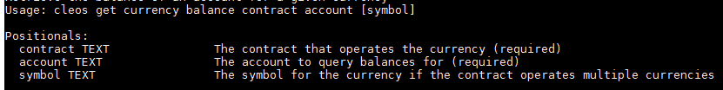

例如：



* 1. 转账操作：

cleos --url *<http-server-addr>* transfer sender recipient amount memo

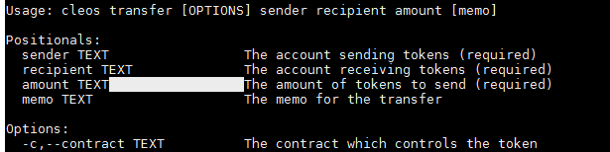

例如：usera给userb转账100个ACT，备注信息为1234567

cleos --url *<http-server-addr>* transfer usera userb ‘100 ACT’ “1234567”

注意！！

1. **如果转账Achain2.0的代币ACT，不需要执行合约名称，默认是act.token**
2. **memo必须指定，用于区分交易所的不同的账户**
3. **ACT的精度是10000，也就是小数点后四个数字，最小额度0.0001 ACT**

【超级节点】

有资质的用户可以申请超级节点，官方审核通过后，可在社区发起投票。

【投票分红】

用户通过质押ACT获取CPU和NET，同时也具备了投票的票数；可以投给相应的账户。

Achain2.0每年有1%的增发用于出块和投票奖励，其中投票奖励占75%，即0.75%的年通胀率；

投票奖励会根据 投票数/总投票数 来计算分红，由被投票用户手动发放。