AWT
AWT is the acronym of Abstract Window Toolkit.
Introduction:
GUI (Graphical User Interface) is a mediator (translator) between the end user and the program.
Form : It is a collection of GUIs designed for one specific purpose.
* Console is a program, provided by the local OS, which supports only text output.
* In order to display GUI outputs, we have another program (similar to the console) provided by the local os. This program is, window.
* All the java classes, which are used to create GUIs are present in the package java.awt.
* The theory behind the creation of GUIs is as follows.
* The functionality of the constructor of the class, whose GUI is to be created, is to create that particular GUI.
* Strictly speaking, this is not the functionality of the constructor of that class.
* In fact, the constructor has some statements which are nothing but, a call to a specific file in the local os. This particular file will be responsible in creating the corresponding GUI. In the foreground, it seems as if the GUI is created just because of the constructor.
* Whatever language we use to create the GUIs, (for example : java, html, vb e.t.c.) in all these cases, only the files present in the local os will be responsible for creating the corresponding GUIs.
* Because of this, the GUIs created in all these cases will look alike.
* Let us take java in particular.
* When we want to create a GUI, we need to create object of that class which represents the corresponding GUI. Let us assume we need to create a GUI – a button. Then we need to write the following code, i.e.
* Button b1 = new Button ();
* So, to create the button GUI, JVM executes the constructor of the Button class. Inside the constructor we have statements which execute the files present in the local os to create the GUI.
* The means, we are making JVM to execute the files present in the local operating system.
* But remember that, JVM can execute only byte code, which is generated from the .class file and this .class file is results from a .java file.
* The files present in the local operating system need not be in java and definitely they will not be in java.
* They will be in some other native language.
Question : Then, how can JVM execute the files present in the local os to create the GUIs?
Ans: JVM depends upon some classes known as Peer Classes to execute the files present in the local os.
* Thus, every awt component depends upon the files of the local os to create GUIs, making JVM to execute those files which are non-java files. This increases the overhead on the JVM. This is the reason why we call awt classes (components) as heavy-weight components
* From the above discussion, it is clear that each os will have its own files for creating the GUIs.
* Now, if we create a GUI using java on one os, then the look and feel of this GUI will be completely different when we execute the same java program on another OS.
Question: Java is not purely platform independent. Justify.
Ans: Because of the dependency of awt programs on the local os in creating GUIs, the outputs of these programs very from one os to another os. i.e. the outputs of the awt programs are platform dependent. This makes java to be platform-dependent.
This is the reason, why we say that java is not purely platform-independent.
Disadvantages of AWT :
(i) The AWT programs increase the overhead on the JVM.
(ii) The make java to be platform dependent.
* The above disadvantages are over-come in Swings
* Swings is an extension of AWT. The swing components do not depend upon the files of the local os in creating the GUIs and thereby, they decrease the overhead on the JVM.
* Thus, swings are known as Light-Weight Components.
* The following is the class hierarchy of java.awt package.
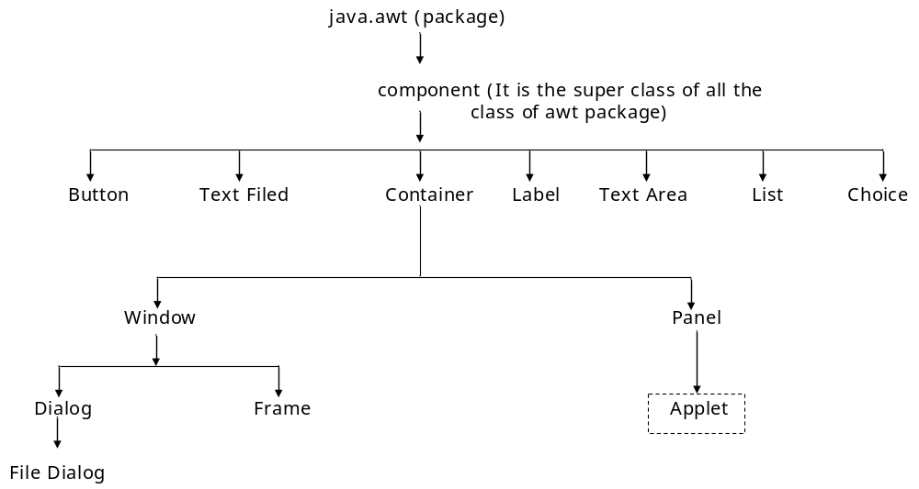
NOTE: Applet class does not belong to java.awt package.
* Applet class belongs to java. applet package.
* We know that window is used for displaying the GUIs.
* A blind rule is that, when we want to add a component to another component then the later component should have the properties of a container.
* Whenever we want to view a GUI output, we add all the required components to the window and then they are displayed that means, window has the properties of a container.
* From the class hierarchy, it is clear that window is the sub class of container class. Hence it has all the properties of a container.
* If we want to add a Button to another button, it is not possible because, button is not a sub class of container and it does not have the properties of a container.
* Same is the case with the other classes present in that level of hierarchy.
* Similarly, we can not think of adding Text Filed to a Label, Text Area to a List e.t.c.
* Thus, any component which has the properties of container is eligible to accommodate other components in it.
* It is clear from the class hierarchy that panel is a sub-class of container and window is at the same level of hierarchy.
* Panel has the properties of container and any no. of components can be added to the panel. To make them visible on the screen, we again need window, but observe that panel does not have the properties of a window.
* Therefore, panel should be added to the window to make the components visible.
* Similarly, we can create a Frame. Frame has the properties of window as well as container
* As Button, Text Area e.t.c. have some properties, window also has some properties.
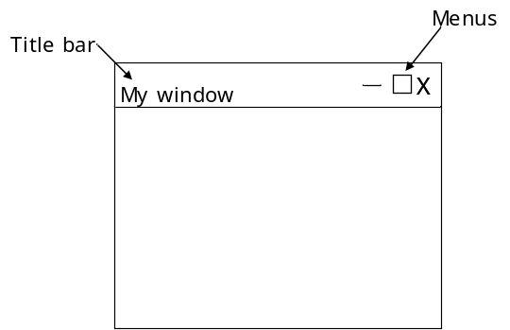
- It has a title-bar
- It has some system Menus
- We should be able to drag it
- We should be able to resize it e.t.c.
* Some of the best examples of the window application are Edit plus Editor, Notepad, IE browser e.t.c.
NOTE: As console cannot display GUIs, window cannot display text directly.
* In order to display text on the window, we need to represent the text in the form of a GUI component and then add it to the window. For this, we make use of the Label class.
* We always prefer to create a window through Frame because window alone has no feature of boundaries. The facility of having boundaries for a window is possible with Frame. This is the reason why we create window through Frame.
* Using the functions of the Frame class we can set the dimensions (size) for the window.
Ex: f.setsize (400, 400);
NOTE: By default, window would always be created in the invisible mode. To make the window visible on the VDU, we should explicitly set the visibility property of the window to the Boolean value ‘true’.
Ex: f = set visible (true);
* A constructor defined in the Frame class takes a string class object as an argument. Thus, whatever the text we want to see in the title bar of the window, we need to pass it as an argument (in the form of a string class object) to the constructor of the Frame class.
Let us develop a simple program which displays a GUI as shown aside.
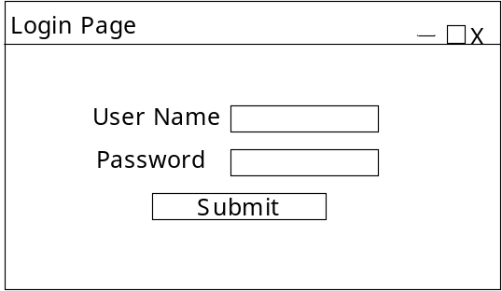
Hint: This GUI consists of six components
two labels + two text fields + one button + one frame (window)
import java.awt.*;
class Form1 Form1.java
{
public static void main (string args [])
{
Frame f1 = new Frame (“Login Page”);
Label l1 = new Label (“User Name”);
Label l2 = new Label (“Password”);
Text Field tf1 = new Text Field ();
Text Field tf2 = new Text Field ();
Button b1 = new Button (“submit”);
f1. add (l1);
f1. add (l2);
f1. add (tf1);
f1. add (tf2);
f1. add (b1);
f1. set size (437, 437);
f1. set visible (true);
}
}
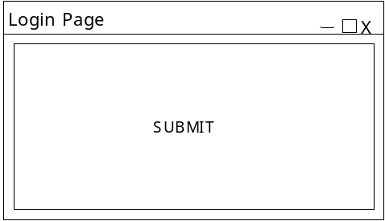
* When we execute the above program, we can see only the button on the window. This is because, all the components have been added, but one upon another. The last component added is the button and hence we see only the button.
* This resulted because we have not mentioned, to which part of the window, the components have to be added. Here they have occupied the entire window.
* So, to make all the components visible we have to align them properly on the window.
* We have some standard procedures using which we can align the components in the frame (container)
* The standard procedures which exactly specify the way in which we align the components on the container are known as Layout Managers.
* We have five Layout Managers in the awt package, where each Layout Manager is the name of a class.
(i) Border Layout (ii) Flow Layout
(iii) Grid Layout (iv) Grid Bag Layout
(v) Card Layout
* Therefore, we should mention the layout according to which the components are to be aligned on the container.
* We can mention the layout (specification or procedure) byusing the set Layout () method of the container class. This method is a non-static method.
* The set Layout () method takes the object of any of the above five layouts as an argument, according to which the components would be aligned (arranged) on the containers.
Border Layout:
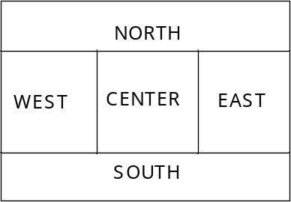
* According to the specifications of the Border Layout, the container area will be divided into five parts as shown in the fig.
* The Border Layout class has some static constants to refer to these areas as Border Layout. SOUTH e.t.c.
* The default layout associated with the Frame class object is Border Layout. The default location associated with the Border Layout is CENTER.
* Therefore, when we call add () method on the Frame class object (i.e. f. add (xxx)), it takes the layout to be Border Layout and adds the component to the centre of it.
* An important property of the Border Layout is, when a component is added to the CENTER, then the component not only occupies the CENTER but also stretches to the other four areas, if there are not components in those areas.
* For example, if we add a button to the center, then it occupies the entire frame.
* If we add two buttons – one to the NORTH and one to the center, then the button which is added to the CENTER also stretches to the EAST, WEST and SOUTH areas.
Flow Layout:
* According to this layout, the container will be divided into rows and columns depending upon the components and their size.
* When we start adding components to the frame according to Flow Layout, then, the components would be added row-wise i.e. first row column-1, column-2, e.t.c. If the row is filled, then the next component would be added to first column of second row and so on.
NOTE: When we specify the layout as Flow Layout, then, initially it assumes the entire space as 1 row & 1 column.
* When we add a component it would be added in the centre at the top (because initially it is 1 row & 1 column).
* Now, when we add another component, control check whether this component can be accommodated to the right of the existing component.
* It yes, it will be added, thus creating a second column.
* If no, the component would be added in the next row.
* Hence, size of the column completely depends upon the size of the component being added.
* Therefore, it is obvious that, when we add components to the container (frame) according to Flow Layout, then the columns will be dynamically generated.
NOTE: The no. of rows and columns may or may not be equal. i.e. the no. of columns may vary from one row to another row, depending upon the size of the components being added.
NOTE: When we resize the frame (on which the components are arranged according to flow layout) then the columns are going to get adjusted accordingly and even the components are going to get adjusted accordingly.
Ex: 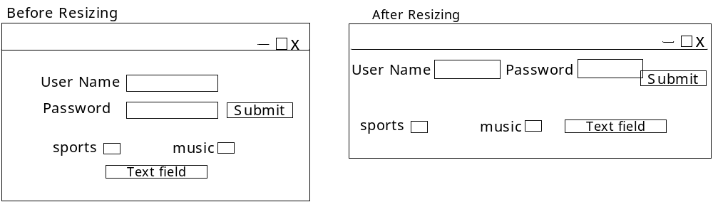
// Modifying the program Form1. java
import java. awt. *;
class Form2 Form2. java
{
Frame f1 = new Frame (“Login Page”);
Label l1 = new Label (“User Name”);
Label l2 = new Label (“Password”);
Text Field tf1 = new Text Field ();
Text Field tf2 = new Text Field ();
Button b1 = new Button (“SUBMIT”);
Form2 ()
{
f1. set Layout (new Flow Layout ());
f1. add (l1); f1. add (l2);
f1. add (tf1); f1. add (tf2);
f1. add (b1);
f1. set size (437, 440);
f1. set visible (true);
}
public static void main (string args [])
{
Form2 f2 = new Form2 ();
}
}
* In the GUI programs which we have written till now, we have been creating objects of the Text Field class wherever necessary. Whether it is for a user name label or a password label, the Text Field is same. So, instead of creating another text field, can’t we add the text field (which was created once) again and again where necessary ?
NOTE: We can not reuse the GUI components once created in a container (frame) i.e. for example, if we have a text field already and if we need one more, then we can’t add the one created earlier. Instead, we should create another text field and add it.
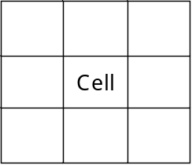
Grid Layout: According to the specifications of Grid Layout, the container will be divided into specific no. of rows and columns of equal size.
* Each division is called a cell or a grid.
* In the Grid Layout, only one component can be added to a grid, and the component occupies entire grid.
* The components will be added to the grids in a serial fashion and we can not skip the grids in between i.e. a component will not be added to grid-3, unless grid-2 is filled provided grid-1 is already occupied.
* It is obvious that the constructor of Grid Layout class takes two integer arguments – row & column.
Ex: f1. set Layout (new Grid Layout(4, 4));
NOTE: When we use the Grid Layout, it is compulsory that all the grids should be occupied with the components. No grid should be left free.
Panel: Panel is a component which has the properties of container. It does not have the properties of a window. So, panel has to be added to the window (frame) to make it visible.
* Since panel has the properties of a container, we can add any no. of components to the panel and now the panel will be treated as a single component.
NOTE: If we want to have more than one component in a grid, then we make use of the panel i.e. add all the required components to the panel and add this panel (which is a single component) to the grid.
* If we want to have an empty grid, then add an empty panel (without any components on the panel) to the grid. This makes the grid look empty.
* We do not have any separate class to create radio buttons. We create radio buttons using checkbox class.
*After creating the checkboxes, if we group them, they will act as radio buttons, else they will act as checkboxes.
Question: Develop a GUI which meets the following requirements.
- It should have four panels.
- Panel-1 should have a drop down list and an ordinary list
and also a text area.
- Panel-2 and panel-3 are empty.
- panel-4 should have two checkboxes and two radio
buttons.
Ans: The GUI would be something as shown below.
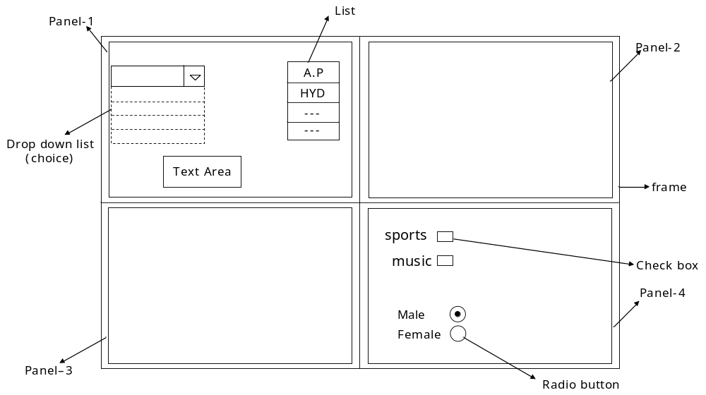
Hint: Here we have altogether 12 components as listed below

Frame-1 Choice-1 Text Area-1
Panels-4 List-1 Check boxes-2
Radio buttons-2

import java. awt. *;
class Grid Demo1
{
Frame f1 = new Frame (“Grid-Demo”);
Panel p1 = new Panel ();
Panel p2 = new Panel ();
Panel p3 = new Panel ();
Panel p4 = new Panel ();
Choice ch = new Choice ();
List lst = new List ();
Text Area ta = new Text Area (9, 40);
Checkbox cb1 = new Checkbox (“sports”);
Checkbox r1, r2;
Grid Demo1
{
f1. set Layout (new Grid Layout (2, 2));
ch. add (“Andhra Pradesh”);
ch. add (“Karnataka”);
ch. add (“Tamilnadu”);
ch. add (“Kerala”);
lst. add (“Hyderabad”);
lst. add (“Bangalore”);
lst. add (“Chennai”);
lst. add (“Trivendrum”);
p1. add (ch);
p1. add (lst);
p1. add (ta);
p4. set Layout (new Grid Layout (4, 1));
p4. add (cb1);
p4. add (cb2);
checkbox Group cbg = new checkbox Group ();
r1 = new checkbox (“Male”, true, cbg);
r2 = new checkbox (“Female”, false, cbg);
p4. add (r1);
p4. add (r2);
f1. add (p1);
f1. add (p2);
f1. add (p3);
f1. add (p4);
f1. set size (437, 437);
f1. set visible (true);
}
public static void main (string args [])
{
Grid Demo1 gd = new Grid Demo1 ();
}
}
NOTE: The constructor of the checkbox class takes three arguments – strings object (i.e. name), Boolean value (to select or deselect the given radio button), the checkbox Group class object.
Grid Bag Layout
* The Grid Bag Layout is similar to the geed Layout, but with some additional features
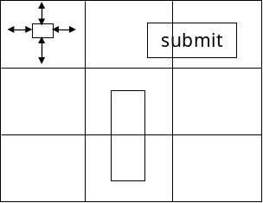
* In the gird layout, we have the facility of adding the components to a specific part of the grid (by mentioning the coordination’s on all the four sides.
* we can stretch the components between the girds either horizontally or vertically
Note:-
Even though grid Bag layout is advantageous it become it increases the complexity of the program
* we have a layout by name box layout in the swings package we use this layout to achieve all that we do using grid Bag Layout and with less complexity
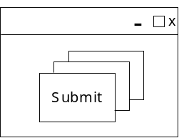
Card Layout:
The card layout specifications help us to add the components to a frame w.r.t z-axis i.e. one component behind the other as shown in the figure
* card lay out is closely related to event handling
Note:-
Actually set layout () method is defined to accept, an object of an interface, as an argument the interface is layout manager
* All the layout classes implements the layout manager interface thus, object of any class, which implements layout manager interface , can be passed as an arguments to the set layout () method
* Obviously, null can also be passed as an argument to the method
Null layout:
Strictly speaking null layout is not a layout when we pass ‘null’ as an argument to the set layout () method , it nullifies all the standard layouts i.e. the default layouts will not be set for the corresponding components
* Now we have the flexibility to add the components according to our specifications
We can add the components to any part of the frame we like consider the following:
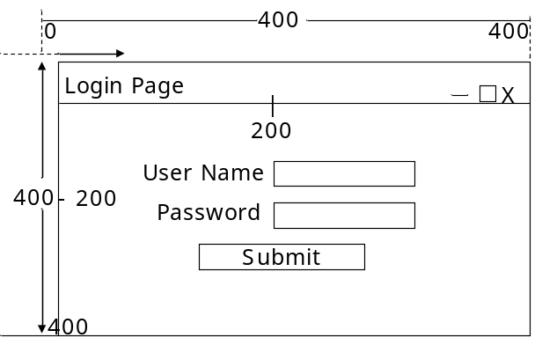
* we need to create a login page as shown in the above figure the components should be placed , as they are shown in the fig first of all we need to calculate the bound properties of the components, as shown below
user name (Label l₁)
x=100, y=125 width =80, height =30
text filed (tf₁)
x=200, y=125 width =110, height =30
Password (label l₂)
x=110, y=170 width =80, height =30
Text field (tf₂)
x=200, y=170 width =110, height =30
Button (b₁)
x=200, y=220 width =200, height =30
* We have a function set bound () in the component class . the set bounds () method takes the bound properties as the arguments and aligns the components on the frame according to the specified bound properties
Following is the program to display the above login page import java.awt
class Login Demo
{
frame f₁ = new frame (“login page”);
Label l₁ = new label (“user name”);
Label l₂ = new label (“Password”);
Text field tf1 = new text field ();
Text field tf₂ = new text field ();
Button b₁ = new button (“SUBMIT”);
Login Demo ()
{
f₁: set layout (null);
l₁.set bounds (110,125,80,30)
l₂.set bounds (110,170,80,30)
tf₁.set bounds (200,125,110,30)
tf₂.set bounds (200,170,110,30)
b₁.set bounds (200,125,110,30)
f₁.add (l₁);
f₁.add (tf₁);
f₁.add (l₂);
f₁.add (tf₂);
f₁.add (b₁);
f₁.set size(400,400);
f₁.set visible (true);
}
public static void main (string args[ ])
{
login demo l_{d}=new login demo ();
}
}
Note:-Till now, we have been directly created object of the frame class but according to coding standards the user defined class extends frame class as shown in the below example not only with frame , but also the same is the case with all other components
import.java.awt*;
class form demo extends frame
{
label l₁=new label (“user name”);
label l₂=new label (“password”);
Text field tf₁ = new text fields ();
Text field tf₂ = new text fields ();
Button b₁=new button (“SUBMIT”)
form Demo ()
{ setlayout (new flow layout ());
add (l₁);
add (tf₁);
add (l₂);
add (tf₂);
add (b₁);
set size (437,400);
set visible (true);
}
public static void main (string args [ ])
{
form demo f=new form demo ();
}
}
Event Handling
Event:
* Event is an object of a predefined class created bv represent the corresponding action performed on the component
* When an action is performed on a component (for example clicking of a button), then in order to represent that action JVM creates an object of the action event class
This is the reason, why events are always created in relation with action
* The list of all the event classes is present in the java.awt.event package
Registration Methods:
*The functions which recognize the events generated in the components are known as registration methods
Event Handling:
* Catching the event class object, which are generated because of an action performed on a component, and assigning them to the corresponding references is known as event handling (i.e. avoiding the event class objects to reach JVM)
* We handle the event using the registration methods
Hint : the event handling concept is very much similar to the exception handling concept
Listeners:
* Listeners are interface which define some function definition these function definition will be executed by the registration methods when ever the registration methods identify event class object being generated in the components because of action performed on the components
* The signature of the registration methods would be some thing like
add <…> listener ()
ex:
add action listener ()
add Text listener (), add item listener () e.t.c
Note: Every registration method is defined to accept object of a listener interface (i.e. object of a class which implement the listener interface)
Ex:
* add action listener (a1) here a1, is an object of a class which impellents action listener interface
* add action listener is a non static method defined in the button class
Note:
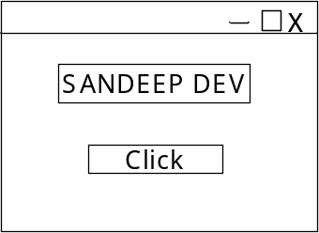
If these is a specific functionality to get executed because of an action performed on a component, then we are supposed to handle the events in the corresponding amponent
Question: Develop a GUI as shown in the figure
Requirement: when ever you like on the button click, then your name should appear in the text field
import java . awt. *;
class event demo1
{
Frame f₁=new frame ();
Button b₁=new button (“click”);
Text field tf₁=new text field ();
Event demo 1 ()
{
f₁.set layout (new flow layout ());
f₁.add (b₁);
f₁.add (tf₁);
A a1 = new A (tf1);
b1.add action Lister (a1);
f₁.setsize (437,440);
f₁.set visible (true);
}
Public static void main (string args [])
{
event demo1 ed =new event Demo 1 ();
}
}
import.java.awt *;
import.java.awt.event *;
class A impement action listener
{
text field tf1;
A (textfield tf1)
{
this .tf₁.tf₁
}
public void action performed (action event e)
{
tf₁.set text (“sandeep devi”);
}
}
Explanation:
* the functionality of the registration method (in this example it is add action listener ()) would be as follows:
* It wails for an event to occur in the component (in our example the component is the button b₁)
* It an event occur (i.e. if the button is clicked), then it catches that event , assigns the event to the corresponding reference now this reference (infact it is the event object )will be sent as an argument to the specific function (in this case it is the action performed ()) and that method will be involved . whatever the functionality or logic we need to get executed when the action performed on the component , should be written in the method
* in the above example our requirement was to print the name in the text field when the button is clicked
* the logic of printing the name in the text filed is written in the action performed () method and this method is incorporated in a user defined class, class a where class a implements the action listener interface.
* In the above example, we have used two classes in accomplishing the task we can achieve it using a single class as shown below
import java.awt.*;
import java.awt.event.*;
class event demo2 implement action listener
{
frame f₁= new frame ();
Button f₁= new button (“click”);
text field tf₁ = new text field ();
event demo2 ()
{
f₁.set layout (new flow layout ());
f₁.add (b1);f₁.add (tf1);
bl.add action listener (this);
f₁.set size (437,440);
f₁.set visible (true);
}
public void action performed (action event e)
{
tf₁.set text (“sandeep devi”);
}
public static void main (“string args [])
{
event demo2 ed = new event demo 2 ();
}
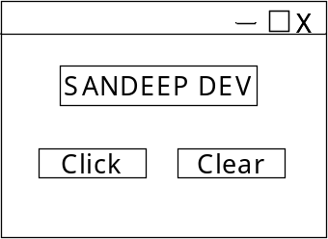
}
Question: display a GUI as shown
Requirement: When ever we click the button click , it your name should be displayed in the text field when CLEAR is clicked, the text filed should be closed
import java .awt *
import java .awt.event.*
class even demo 3 implenmemt action listener
{
Frame f₁=new frame ();
Button b₁ = new button (“CLICK”)
Button b₁ = new button (“CLEAR”)
text field tf1 = new text field ();
event demo3 ()
{
f₁.add (b₁);
f₁.add (b₂);
f₁.add (tf₁);
b₁.add action listener (this);
b₂.add action listener (this);
f₁.set size (437,440);
f₁.set visible (true);
}
public void action performed (action event e)
{
string s1= e. get action command ();
if (s1.equals (“CLICK”))
tf1. set text (“sandeep Devi”);
if (s1.equals (“CLEAR”))
tf1. set text (“sandeep Devi”);
}
Public static void main (string args [ ])
{
event demo3 ed= new event demo 3 ();
}
}
explanations:
* In this example , we have two buttons click and clear an event object will be generated when either of the buttons is clicked based on this object, the action performed () method will be executed
* Now it is our duty to identify, because of which button the event object has been generated and execute the corresponding functionality
* There is a non static function by name
* get action command () in the action event class this method returns a string class object; which is associated with the component that is responsible for generating the object of the action event class
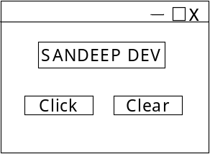
* We have used this method in our program to identify the button on which the action has been performed and generated the corresponding error class object
Question: What is the case if both the buttons have the same name as shown in the fig the requirement is same as that in the above example
* There is a method by name get source () which returns an object of the component (in the form of an object of object class ) which is otherwise responsible in creating the object of action event class
* The object returned by get source () method will be in the form of object class we need to perform the necessary type casting
* the following program illustrates the use of get source () method the program generate a form shown in the above question.
import java . awt *;
import java . awt.event *;
class event demo 4 implement action listener
{
frame f₁ = new frame ();
Button b₁ = new button (CLICK);
Button b₂ = new button (CLICK);
text field tf1 = new text field ();
event demo4 ()
{
f₁. set layout (new flow layout ());
f₁. add (b₁);
f₁. add (b₂);
f₁. add (tf₁);
b₁. add Action listener (this );
b₂. add Action listener (this );
f₁.set size (437,440);
f₁.set visible (true);
}
Public void action performed (action event e)
{
object o= e.get source ();
button b= (button)0;
if (b==b₁) tf₁. set text (“sandeep devi”);
if (b==b₂)tf₁.set text (“”);
}
public static void main (string args [])
{
event demo 4 cd= new event demo4 ();
}
}
Question: create a GUI as shown below
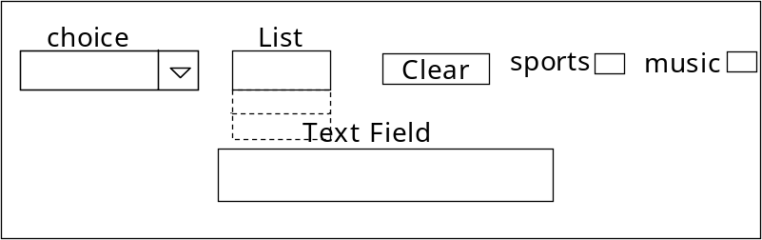
Requirement: Initially the list box should be empty when an item is selected in the choices it should be added to the list box when we click the button CLEAR , the list box should over again become empty when we select a check box, then the corresponding label should appear in the text field
import java.awt.*;
import java . awt.event *;
class event demo5 implements action listener , item listener
{
frame f1 = new frame ();
choice ch1 = new choice ();
button b1= new button (“CLEAR”);
Text field tf1 = new text field ();
list 1st = new list ();
check box sports =new check box (“sports”)
check box sports =new check box (“music”)
event demo5 ()
{
f₁. set layout (new flow layout ());
ch₁.add (“HYDERABAD”);
ch₁.add (“CHENNAI”);
ch₁.add (“BANAGALORE”);
f₁. add (ch₁);
f₁. add (1st );
f₁. add (b₁);
f₁. add (sports);
f₁. add (music);
f₁. add (tf₁);
ch₁.add item listener (this);
b₁.add item listener (this);
sports.add item listener (this);
music.add item listener (this);
f₁. set size (437,440);
f₁.set visible (true);
}
public void item static changed (item event e)
{
object o=e.get source ();
try {
chect boc (b= chect box)0;
if (cd = = sports)
{
Boolean flag 1 = sports .get static ();
if (flag 1 = =true)
tf₁. set text (“sports”)
}
if (cd ==music)
{
Boolean flag 2=music . get static ();
if (flag2==true)
tf₁.set text (“music”)
}
}//try
catch (exeception e)
{
string s₁=ch₁.get selected item ();
if (s₁! = null)
1st . add (s1);
}
}
public void action performed (action event e)
{
1st. remove all ();
}
public static void main (string args [ ])
{
event Demo5 cd = new event demo 5 [ ] ;
}
} // class
Note:
We can use try. Catch as if .else when necessary. In the above program we have done the same in the item state changed () method.
Question: create a GUI as shown below
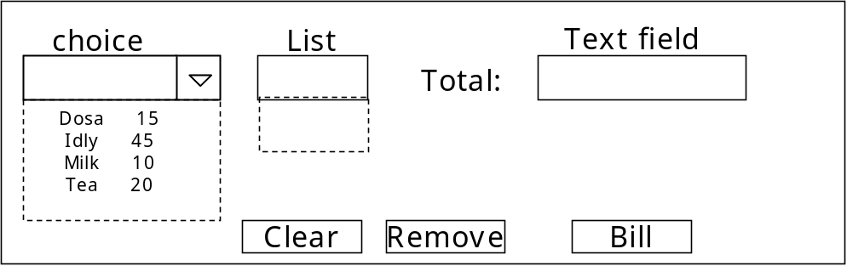
Requirement: Selected items in the choice should be added to the list any unwanted item in the list should be removed when Bill is clicked , the total amount of the items in the list should appear in the text filed. When CLEAR is clicked both, the list and text filed should be cleared
* Till now we have created many windows (frames), but we were not able to close them using the system menu (i.e. by clicking the button on the top. right corner)
* The reason is simple clicking the X button (system menu) is an action on the window (frame) and till now we did not handle the event generated become of the action
* If we handle that event through a registration method, then it would be possible for us to must our requirement
* Dispose () is a non –static function of the window class, using which we can destroy the window object system. exit () is another function of the system class using which we can destroy the window object. But in this case, along with the window, the application will also be terminated
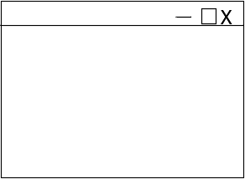
Question: Create a GUI a shown
Requirement:
When ever clicks the X button the windows (frame) should be closed
import java.awt*;
import java.awt.event.*;
Class window event demo1 implements window listener
{
Frame f₁ = new frame ();
Window event Demo1 ()
{
f₁.add window Listener (this);
f₁.set size (437,440);
f₁.set visible (true);
}
public void window activated (window event e) { }
public void window closed (window event e) { }
public void window closing (window event e) { }
{
f1.dispose ();
(or)
system. exist (0);
}
Public void window Deactivated (window event e) { }
Public void window Deaconries (window event e) { }
Public void window I confied(window event e) { }
Public void window opened (window event e) { }
public static void main (string args [ ])
{
Windows event demo1 WD = new windows event demo1 ();
}
} // class
Explanations:
* If the above example, we are required to create a GUI and when we click the X button, the windows (frame) should be closed
* we know that X is a system menu present on the window (frame) when ever we click it, an event object will be generated . we need to handle this event
* That means we should find out the registration method using which we can handle the event object generated in the window (frame)
* We know that every registration method is defined to accept the reference of an interface as an argument
* We should see that our class implements this interface and now we need to private bodies for all the methods present in the interface
* we have done the same in the above program we have identified the registration method in the window class (i.e. add window Listener ()) and we have called it on the
* the add window listener () method takes the reference of window listener interface.
* Inside the window listener interface, many methods are declared for which we need to provide the bodies.
* Out of all those methods, we will use those methods with which we can perform the required functionality. for the other methods, we just provide empty bodies
Question: Create your own text editor, with same properties as shown below
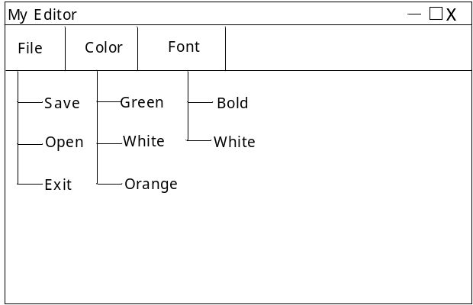
Note: Menu bars would never be added. They can only be set. Menu bars can be placed only at the top of the frame. They can’t be placed any where else on the frame
* We can set the menu bars on the frame using the set menu bar () method
* The set menu bar () is defined to accept object of menu bars.
* It is a non static function present in the frame class
* we know that panel is neither a sub class nor a super class of frame. There fore set menu bar () is not available to the panel class
* This is the reason why we can set menus only to frames but not panel
File Dialog:
It is a component using which we can vies all the contents (files) present in the hard disk
import java.awt.*
import java.awt.event*;
class my editor implements
{
frame f1= new frame (“my editor”);
text area ta1=new text area (18,40);
menu bar mb= new menu bar ( );
menu file =new menu (“file”);
menu colour = new menu (“colour”);
menu font = new menu (“font”);
menu Item save =new Menu Item (“save”);
menu Item open=new Menu Item (“open”);
menu Item exit =new Menu Item (“exit”);
menu Item green =new Menu Item (“green);
menu Item blue =new Menu Item (“blue”);
menu item = new menu item (“Orange”);
menu item bold = new menu item (“Bold”);
menu item italic = new menu item (“Italic”);
My editor ()
{
file. add (save);
file.add (open);
file.add (exit);
colour . add (green);
colour.add (blue);
colour.add (orange);
font.add (bold);
font.add (italic);
md.add (file);
md.add (colour);
md.add (font);
f₁.set menu bar (mb);
f₁.add (ta1);
save.add action listener (this);
open.add action listener (this);
exit.add action listener (this);
green.add action listener (this);
blue.add action listener (this);
orange.add action listener (this);
bold.add action listener (this);
italic.add action listener (this);
f₁.set size (437,440);
f₁.set visible (true);
} // constructor
public void action performed (action event e)
{
string s1 =e.get action command ();
if (s₁. equals (“exit”))
system.exit (0);
if (s₁. equals (“green”))
ta₁.set back ground (colour .Green);
if (s₁. equals (“blue”))
ta₁.set back ground (colour .blue);
if (s₁. equals (“orange”))
ta₁.set back ground (colour .orange);
if (s₁. equals (“blod”))
{
font “fo₁=new font (“serif”, font.BOLD,18);
ta1.set font (f0₁);
}
if (s₁.equals (“Italic”))
{
font fo₂ = new font (“ serif”, font. italic,18);
ta₁.set font (f0₂);
}
if (s₁.equals (“save”))
{
file Dialog fd₁=new file dialog (f₁,”save”, file dialog.save);
fd₁.show ();
string dir = fd₁.get directory ();
string fname =fd₁.get flie ();
string path = dir +”/”+fname;
save file (path);
}
if (s₁.equals (“open”))
{
file dialog fd₂ =new file dialog (f₁, “open”, file dialog.Load)
fd₂.show ();
string dir₁.fd₂.get directory ();
string f_{n} =fd₂.get file ();
string path = dir₁ +”/”+f_{n};
open file (path);
}
}// action performed
public void save file (string path)
{
string data = ta1.get text ();
file output stream fos=new file output stream (path);
byte ba[ ] = data. get bytes ();
for write (ba);
fos.close ();
}
public void open file (string path)
{
file input stream f₃=new file input stream (path);
int size= fis . available ();
byte ba₂ [ ] = new byte [size];
fis.read (ba₂)
string data =new string (ba₂);
ta₁.set text (data);
fis close ();
}
public static void main (string args [ ])
{
my editor med = new my editor ();
}
}// class
Explanation:
* In the above program we have handled the events generated by all the eight menu items which we have considered in the Gui
* Except for the menu item open and save handling the events in the rest of the menu items is same as the process which we followed in the previous examples
* Even for ‘open’ & ‘save’ also the process in same but with some extra functionality which needs additional logic to be written
* dialog is a window
* when ever we need to display a window on another window with a relation between those two windows , them we make use of the dialog
* The relation between the windows as mentioned above is nothing but, as long as the child window is alive, the parent window can not be closed
* Thus of a dialog has to be created, then definitely we need to pass the object of its parent window as an argument to the constructor of the dialog class
* As already mentioned, file dialog is one of the dialog
* A file dialog can be created in two modes as given below:
Load mode – using which we can display the file. Save mode – using which we can save the file to a location. Thus the constructor of file dialog is defined to accept three arguments
* File dialog (f₁,”save”, file dialog. save);
* f₁ The parent window object on which the file dialog has to be displayed
* Save the string which is to be displayed on the title box
* File dialog. Save (or) file dialog .load} the mode in which the file dialog has to be opened
* We use the set visible (true) function to make the window visible on the screen
* In a similar manner, when we “click” ‘save’ or ‘open’ in the menu items, then the file dialog should pop. Up on the existing frame (window) for this purpose we call the show () method on the object of the file dialog.
* The functions save file () and open file () are user defined functions, written to perform the corresponding functionalities which their names suggest
* This is the process of creating a simple test editor, we can make more enhancements to this program to make it an efficient editor

Applets:
Applet: An applet is a java program which can be executed on a java enabled browser
Java applications can be classified as shown below
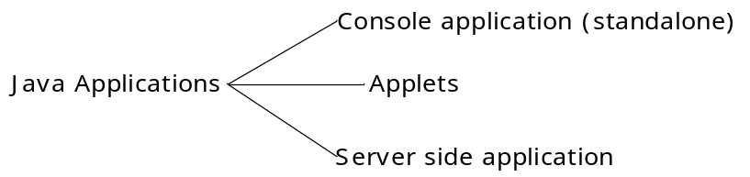
Life cycle: It is the procedure followed by JVM to execute the programs
Note: Life cycle differs from one category to another category of applications
For example:
* In console applications, the life cycle starts in the main () method and also ends in the main () method.
* In applets, the life cycle starts in the init () method and ends in the destroy method
* In this way, it differs from one kind of application to another
* We know that to execute an applet, a java unlabeled browser is needed. Also we know that only JVM can deal with java programs (i.e. class files)
Then new can a browser execute an applet which is in turn a java program?
* This would be possible because, every java enabled browser has an in . built JVM in it which would deal with the applets (.class files)
Browser is a window and it understands only html How can browser understands the java program (applets)?
* Since browser understands only HTML, using HTML we inform the browser about the applet
* There is a tag by name <applet>
* The <applet> tag has three attributes as given below
* Code-Mentions the name of the java file which is to be executed as an applet
* Height width- these two attributes describe the dimensions of the applet
* When ever the browser encounters the <applet> tag. then it hand over the file name process in the code attributes to the in built JVM . Now, this JVM starts executing the program
* Using applets we can display any GUI and the same GUI can be displayed even by using HTML in a more simple way
q) Why should we use applets, when we have an easy alternative (HTML)?
A) When ever it is required to hide the source code, then we prefer applet to display the GUI rather than using html to display the same GUI
* In other words, the disadvantage with Html is that, in the browser, if we click the ‘view source’ option then the entire html code will be visible to the user which the entire html code * * will be visible to the user which would be some times very dangerous
* If we use applets, then this possibility would not be there
* Life cycle of an applet
* As soon as browser encounters the <applet> tag in the html file, the browser hand over the class file to its JVM mentioned in the code attribute
* JVM creates an object of that class and this object would be assigned to a reference of the applet class
* Now JVM calls in it () method and after that it calls start () method on the reference of the Applet class
* If control has to come out of the applet program, then jvm calls stop () method and then the control is relinquished
* Suppose if control comes back to the html page on which the applet program was running, then once again the html code will be encountered and once again then class file would be hand ever to the jvm
* Now JVM will not create another object since the object has already been created earlier
Since the object is not created (for the second time) in it () method will not be executed. Instead, JVM executes the starts () method
Note:
* In it () method would be called only once in the life cycle of an applet
* If the browser is closed, then before deleting the object of the class file, JVM calls the destroy () method on the reference of the applet class
* The four functions (in it (), starts (), stop () destroy ())
* Through which JVM executed the applet program are known as life cycle methods
* these life cycle methods are defined in applet class of java applet package
* Java applet package is one of the smallest package in the entire JDK . If has only class (Applet) and same interfaces
* In the present version, destroy (0 is a deprecated method
Note :
* Paint () is not a life cycle method
* More over point () method is present in the component class.
q) Develop a simple applet program which displays a button “Hello” and a text field when you vclick the button , your name should be displayed in the text field
import java.awt. *;
import java.awt.even *;
import java.applet. *;
public class Hello Applet extends Applet implements action listener
{
button b₁;
text field tf₁;
public void init ()
{
b₁ = new button (“Hello”);
tf₁=new text field ();
}
public void start ()
{
add (b₁);
add (tf₁);
b₁.add action listener (this);
}
public void action performed (action event e)
{
tf₁.set text (“sandeep dev”);
<html>
<body>
<H3> This is my first applet program </H3> <BR> <applet code = “Hello Apple1” width = “437” height = “440”> </applet>
</body>
</html>
q) Can we define a constructor in an applet class?
a) Yes we can define a constructor in an applet class provided , the constructor should be a no-argument constructor
Image class:
*The image class is used to represent the image we can not directly create of the image class because it is an abstract class
* get image () function (a non –static function of applet class) creates obhject of the image class, representing the contents of the gif file that we pass a s an argument to the get image () method
Note:
get image () method takes two arguments,
(ii) name of the gif file – a string class object
(i) the path to the gif file in the form of a URL class object
to display the images on the browser,
(i) create image class object which represents the content of the gif file
(ii) display the image object on the applet
Hint:
(i) get code Base () function which belongs to applet class returns object of the URL class which represents the path /url of the current applet class file
(ii) get document base (0 function returns object of the url class which represents the path/url of the current html file
ex: Image img = get image (get code base (), “tiger.gif”);
to display the image on the applet , we use a function by name draw image () it is a non static function present in graphics class
draw image () method is defined to accept four arguments
- image class object representing the image (gif file)
- x-coordinate values
- y-coordinate values
- the object of the contained on which the image has to be displayed
draw image () method is a non static method of graphics class. so, to call draw image () method we need object of graphics class, but graphics class is an abstract class
q) How can we get the object of graphics class?
* paint () is a method present in the component class and it is defined to accept object of graphics class
* i.e. point (new graphics (){----});
* an anonymous inner class extends the graphic class and this returns the object of the graphics class
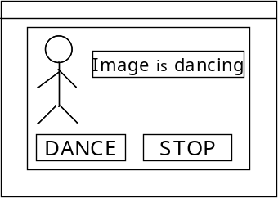
* Now we can call draw image () method on the object of the graphics class
Question: create an applet GUI as shown
Requirement: Just display the image, button and text field, on the applet. Do not handle any events
import java .awt . *;
import java .applet. *;
public class image applet 1 extends applet
{
button b₁,b₂;
Text field tf₁;
image img;
public void in it ()
{
b₁ = new button (“DANCE”);
b₂ = new button (“STOP”);
tf₁= new text field ();
img = get image (get code base (),”tiger.gif”);
}
public void start ()
{
add (b₁);
add (b₂)
add (tf₁);
}
public void point (graphics g)
{
g.draw image (img ,22,40, this);
}
}
<! – image demo . html > image demo. html
<html>
<body>
<H3> my first image application </H3> <BR>
<applet code = “Image Applet1”width=”437” height =”440”>
</applet>
</body?
</html>
* In the above program, we used an image by name tiger.gif we can use any of the image files with.gif extension to be displayed on the applet
Note: Before executing the above example, we should see that, image Applet 1.Java, Image Demo. html, tiger .gif-all tie in the same path
Question: Develop a GUI as shown
Requirement:
* When we click the button “Dance”, then the image should start dancing and in the text field it should display “Image is dancing “on a green back ground
* When we click the button “stop”, then the image should stop dancing and in the text field it should display “Image stopped dancing” on a red back ground
Hints:To meet the above requirement, first we need to have different postures of image i.e. different gif files of the same image with slight differences between them
* we have to make use of a non static function repaint () of the component class
the functionality of the repaint method is to call the paint (0 method of the current object on which we call the repaint () method
Note:
To execute the repaint () method, the paint () method has to be called Atleast once

Myapplet.java:
------------------------
import java.applet.*;
import java.awt.*;
public class Myapplet extends Applet{
String str;
public void init(){
str = "This is my first applet";
}
public void paint(Graphics g){
g.drawString(str, 50,50);
}
}

<HTML>
<BODY>
<applet code="Myapplet",height="200" width="200">
</applet>
</BODY>
</HTML>

public class SampleApplet extends Applet
{
String msg="Checking Applet Life Cycle";
public void init()
{
setBackground(Color.blue);
msg+="Init Called";
}
public void start()
{
msg+="Start Called";
}
public void paint(Graphics g)
{
msg+="Paint Called";
g.drawString(msg,50,50);

}
public void stop()
{
msg+="Stop Called";
}
public void destroy()
{
msg+="Destroy Called";
}

}

UTIL PACKAGE
The collections frame work:
Collections over vies:
The java collections frame work standards the way in which group of object are handled by our programs
Prior to java 2, java provided adhoc classes such as directory, vector, stack and properties to store and manipulate groups of object. Although these classes were quite useful, they lacked a central, unifying theme
The collections frame work was designed to most several goals:
i) the frame work had to be high performances
ii) the frame work had to allow different types of collections to work in a similar manner and with a high degree of interoperability
iii) Extending / Adapting a collection class had to be easy
algorithms are another important part of the collection mechanism . Algorithms operate an collections mechanism. Algorithm operate on collections and are defined as static methods with in the collections class algorithms provide a standard means of manipulating collections
another item created by the collections frame work is the iterator interface. It gives us a general purpose standardized way of accessing the elements with in a collection, one at a time.
* Thus an iterator provides a means of enumerating the contents of a collection because each collection implements iterator , the elements of any collection class can be accessed through the methods defined by interior
* In addition to collections , the frame work defines several map interfaces and classes
maps store key value pairs
Note: Although maps are not “collections” in the proper use of the term, they are fully integrated with collections
Java until defines the following interfaces:
Collection map
Comparator map. Entry
Enumeration observer
Event listener random Access
Iterator set
List Sorted map
List Iterator sorted set
The interfaces that underpin collections are listed below w.r.t to their hierarchy
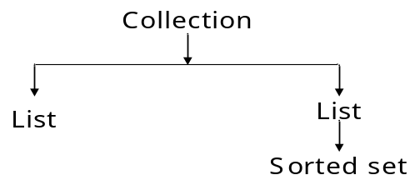
The collection interface is the foundation upon which the collections frame work is built. It declares the core methods that all collections will have
Note:
Most of the methods throw an supported operation exception if a collection cannot modified
* A class cast exception is generated when one object is incompatible with another, such as when an attempt is made to add an incompatible object to a collection
* The following are the methods defined in the collection interface
Boolean add (object obj): Adds obj to the involving collection. Returns true if obj was added to the collection. Returns false if obj is already a member of the collection, or if the collection does not allow duplicates
Boolean add all (collection c):
Adds all the elements of c to the involving collection. Returns true if the elements were added. Otherwise, returns false
Void clear (): Removes all the elements from the involving collection
Boolean contain (object obj):
Return true if obj is an element of the involving collection. Otherwise returns false
Boolean Contains All (Collection c): Returns true if the involving collection contains all elements of c. Other wise returns false
Boolean equals (object obj): Returns true if the involving collection and obj are equal. Otherwise returns false.
int hash code (): Returns the hash code for the involving collection
Boolean is empty ():Return true of the involving collection is empty otherwise, returns false
Iterator iterator (): Returns an iterator for the involving collection
Boolean remove (objective):
Removes one interface of obj from the involving collection and returns true if the element was removed, else returns false
Boolean remove all (Collection c):Removes all elements from the involving collection except those in c. Returns true if the elements were removed. Otherwise returns false
int size (): Returns the no. of elements held in the involving collection
Object [ ] to Array []: Returns an array that contains all the elements stored in the involving collection. The array elements are copies of the collection elements
Object [] to array (object array [ ]): Return an array containing only those collection elements whose type matches that of array of the size of array equals the no. of. Matching elements, these are returned in array
* If the size is less than the no. of matching elements, a new array of the necessary size is allocated and returned. If the size of the array is greater than the no. of .matching elements, the array element following the last collection element is ser to null.
Note: In the above method, an array exception is thrown if any collection element has a types that is not a sub type of array
the list interface : The list interface extends collection and declares the benand for of a collection that stores a sequence of elements
* elements can be inserted or accessed by their position in the list , using a zero based index
Note: A list may contain duplicate elements
* In addition to the methods defined by collection interface the list interface defines some of its own methods as shown below
void add (int index, object obj): Inserts obj into the involving list at the value passed in index. Any pre exciting elements at or beyond the point of insertion are shifted up thus no elements are over writers
Boolean add all (int index, collection c): Inserts all elements of c into the involving list at the location passed in index any pre existing elements at or beyond the point of insertion are shifted up . Thus no elements are over written . Returns true if the involving list changes and returns false other wise
object get (int index): Returns the object stored at the specifies index with in the involving collection
int index of (obj ): Returns the index of the first instance (since list may contain duplicates) of obj in the involving list of obj is not element of the list, then -1 is returned
int last index of (object obj): Returns the index of the last instance of obj in the involving list . If obj is not an element of the list, then -1 is returned
List Iterator List Iterator (): Returns an iterator to the start of the involving list
list Iterator list Iterator (int index): Returns an iterator to the involving list that begins at the specified index
object remove (int index): Removes the elements present at the location specified by index from the involving list and returns the deleted element. The resulting list (after dilation) is compacted i.e. the indexes of the subsequent elements are decremented by one
Object set (int index, object obj): Assigns obj to the location specified by index with in the involving list
List sub list (int start, int end): Returns a list that includes elements from start to end -1 in the involving list. Elements in the returned list are also referenced by the involving object.
The set Interface: the set interface defines a set
it extends collection
Note:
* It declares the behavior of a collection that does not allow duplicate elements
* The add () method returns false if an attempt is mode to add duplicate elements to a set
set interface does not defines any additional methods of its own
The sorted interface:
* Sorted interface extends set interface
* it declares the behavior of a set sorted in ascending order
* In addition to those methods defines by set , the sorted interface declares the following methods
Comparator comparator (): Returns the involving sorted set’s comparator of the natural ordering is used for this set, null is returned
object first (): Return the first element in the involving sorted set
sorted head set (object end): Return a sorted set containing those elements less than ‘end’ that are containing in the involving sorted set. Elements in the returned sorted set are also referenced by the involving sorted set.
object last (): Return the last element in the involving sorted set
Sorted set sub set (object stored, object end): Return a sorted set that includes those elements between start and end -1 elements in the returned collection are also referenced by the involving object
the collection classes: The standard collection classes are listed below
Note:
None of the collection classes is synchroinized
Abstract collection Array List
Abstract List Abstract Set
Abstract Sequencential List Hash Set
Linked List Linked Hash Set
Tree Set
Note: In addition to the collection classes, several legacy classes, such as vector, stack and hash table have been reengineered to support collections
* In the above mentioned list of classes some of them are abstract and other are concrete
The concrete classes are: Array List, Linked List, Hash Set, Linked Hash set, Tree set
The array List class:
* The array list class extends abstract list and implements the list interface
* Array list supports dynamic arrays that can grow as needed
* Array list is a variable –length array of object references i.e. an array list can dynamically increases or decrease in size
* Array lists are created with an initial size . When this size is exceeded , the collection is automatically enlarged when objects are removed , the array may be shrunk
* the array list class has three constructors as shown below
i) array list () : Builds an empty array list
ii) array list (collection c) : Builds an array list that is initialized with the elements of the collection c
iii) Array List (int capacity): Builds an array list that has the specified initial capacity. The capacity grows automatically as more elements are added to the array list
the array list is not synchronized
* to make the array list class synchronized we follow a different approach (discussed later)
The following program demononstrates a simple use of the array list. An array list is created and string objects are added to it. The list is then displayed some modifications are done on the list and again the list is displayed
import java.util.*;
class array list demo
{
public static void main (string args [])
{
array list a₂=new array list ();// creates an empty list
s.o.p (“initial size is :”+a2.size ());
al.add (“IND”);
al.add (“USA”);
al.add (“UK”);
al.add (“CHN”);
al.add (“SA”);
al.add (“SL”);
al.add (“KEN”);
s.o.p (“size after additions :”+al.size ());
s.o.p (“contents of list:”+al);
al.add (2,”AUS”);
s.o.p (“after addition, context are :”+al);
al.remove (“KEN”);
al.remove (3);
s.o.p (“size of list after deletions :”+al.size);
s.o.p(“contents of the list:”+al);
}
}
the output of the above program is as shown below
initial size is :0
size after additions :7
contents of list: IND USA UK CHN SL KEN after addition, contents are:
IND USA UK CHN SL KEN size of list after delations :6
Note: Although the capacity of an array list object increases automatically as object are stores in it , we can increase the capacity of an array list object manually by calling ensure capacity () method
* Conversely if we want to reduce the size of the array that underlies an array list object so that * it is precisely as large as the no.of items that it is currently holding , we call trim to size () method
* the signatures of the above two functions are as shown below
* void ensure capacity (int cap)
* void trim to size
* some times we may need to obtain an actual array that contains the contents of the list. We can achieve this by calling the to array () method
* we may be required to do so in the following situation
* to obtain faster processing times for certain operations
* to pass an array to a method that is not overloading to accept a collection
* to integrate our never , collection based code with legacy code that does not understand collections
* the following program illustrates the concept of converting an array list into an array
consider the array list created in the previous example
import java.util.*;
class array list to array
{
public static void main (string args [])
{
array list al=new array list ();
al.add (“Ind “);
al.add (“ken”);
s.o.p (“contents of the list :”+al);
object sa[] = al.to array ();
for (int i=0; i<sa.length ;i++)
{
string s=(string )sa[i];
s.o.p (s);
}
}
}
* The linked list class
* the linked list class extends abstract sequential list” and implements the list interface
* it provides a linked list data structure
* it has two constructors as shown below
linked list () : It builds an empty linked list
linked list (collection c): This constructors builds a linked list
that is initialized with the elements of the collection c
* In addition to the methods that it inherits, the linked list class defines some useful methods of its own as shown below, for manipulating and accessing lists
void add first (object): Adds elements to the start of the list
void add last (objective)adds elements to the last of the list
object get last (): Retrieves the last element from the list
Object remove first (): Removes or deletes the first elements from the list
object remove last (): Removes the last elements from the list
the following program illustrates several of the methods supported by the linked list
import java.util*;
class linked list demo
{
public static void main (string args [ ])
{
linked list ll =new linked list ();
ll.add (“MSD”);
ll.add (“SSA”);
ll.add (“MGR”);
ll.add (“PV”);
ll.add (“PS”);
ll.add Last (“MSK”);
ll.add First(“MSS”);
ll.add (“MSR”);
s.o.p (“contents of the list :+ll);
ll.remove (“pv”);
ll.remove (4);
s.o.p (“contents of the list, after delations :”+ll);
ll.remove first ();
ll.remove last ();
s.o.p (“After removing first & last elements :”+ll);
object values =ll.get (i);
ll.set (1,(string )value +”MSD”);
s.o.p (“List , after modification:”+ll);
}
}
the output of the above program is as shown below
contents of the list:MSS MSD MSR SSA PS MSK
after removing first & last elements: MSD SSA MSR PS
List after modification: MSD SSA MSD MSR PS
The Hash set class: Hash set extends abstract set and implements the set interface .
* It creartes a collection that uses a hash table for storage
* A hashtable stores information by using a mechanism called hashing
* In hashing, the informational content of a key is used to determine a unique value , called its hash code
* the hash code is then used as the index at which the data associated with the key is stored
the advantage of hashing is that it allows the execution time of basic operations,, such as add (), contains () remove () and size () to remain constant even for large sets
the following constructors are defined in the hash set class
i) Hash set (): It constants a default hash set
ii) Hash set (collection c): This initializes the hash set by using the elements of c
iii) Hash set (int capacity): This constructor initializes the capacity of the hash set to the values specified by capacity
iv) Hash set (int capacity, flat fill ratio): This initializes both the capacity and the fill ratio (also called load capacity) of the hash set from its arguments
* The fill ratio must be between 0.0 and 1.0, and it determines how fill the hash set can be before it is resized upward
specifically, when the no.of.elements is greater than, the capacity of the hash set multiplied by its fill ratio, then the hash set is said to be expended
Note:
* For constructors that do not take a fill ratio , the default value of 0.75 is used
* Hash set does not define any additional methods beyond those provided by its super classes and interfaces
Note:
* Hash set does not guarantee the order of its elements, because the process of having does not usually lend it self to the creation of sorted sets
* if we need a sorted storage , then another collection , such as tree set is a butter choices
the following program demonstrates a Hash set
import java .util.*;
class Hash set Demo
{
public static void main (string args [ ])
{
hashset hs=new hash set ();
hs.add (“B”);
hs.add (“A”);
hs.add (“D”);
hs.add (“E”);
hs.add (“C”);
hs.add (“F”);
s.o.p (“The set is :”+hs);
}
}
A possible output of the above program may be the set is : A F E D C B
Note: As explained, the elements are not stored in sorted order and the precise output may vary after each execution of the program
the linked hash set class:
This class extends hash set , but adds no members of its own. Linked hash set maintains a linked list of the entries in the set, in the order in which they were inserted
* when cycling through a linked hash set using an interior , the elements will be returned in the order in which they were inserted
* In the above program , if we use linked hash set in place hash set then the output will be as follows:
The set is : B A D E C F
The tree set class: Tree set provides an implementation of the set interface that uses a tree for storage
* objects are stores , ascending order
* Access and retrieval times are quite fast, which makes tree set an excellent choices when storing large amounts of sorted information that must be found quickly
* The following are the constructors defined in this class
Tree set (): Constructors an empty tree set that will be sorted in ascending order according to the natural order of its elements
Tree set (collection c): Builds a tree that contains the elements of c
Tree set (comparator comp): Constructs an empty tree set that will be sorted according to the comparator specified by comp
Tree set (sorted set ss): Builds a tree set that contains the elements of ss
The following program demonstrates a tree set
import java.util.*
class Tree set demo
{
public static void main (string args [ ])
{
tree set ts= new tree set ();
ts.add (“C”);
ts.add (“A”);
ts.add (“B”);
ts.add (“E”);
ts.add (“F”);
ts.add (“D”);
s.o.p (ts);
}
}
The output of this program will be: A B C D E F
Note: As explained, because tree set stores its elements in a tree, they are automatically arranged in sorted order, as the outputs confirms
The iterator interface & List Iterator interface: Many a times we may need to cycle through the elements in a collection. For example, we may want to display each element
* The earliest way to do this is to employ an iterator. An iterator is an object that implements either the iterator or the list iterator interface.
* Iterator enables us to cycle through a collection, obtaining or removing elements
* Listinerator extends Iterator to allow bidirectional traversal of a list and modification of the elements
The methods declared by the iterator interface are:
Boolean hash next (): Returns true of these are more elements, other wise returns false
object Next (): Returns the next element. Throws no such element exception of there is not a next element
void remove (): Removes the current elements throws illegal static exception if an attempt is made to call remove () that is not proceeded by a call to next ()
the methods declared by the listenerator interface are:
void add (object ): Inserts obj into the list in front of the elements that will be returned by the next call to next ()
Boolean hash next (): Returns true if there is a next element otherwise returns false
Boolean has previous (): Returns true if there is a previous element. Other wise returns false
Object next (): returns the next element
A no such element exception is thrown if there is not a next element
int next index (): Return the index of the next element if there is not a next element, returns the size of the list
object previous (): Return the previous element no such element exception is thrown if there is not a previous element
int previous index (): Return the index of the previous element returns if there is not a previous element
void remove (): Remove the current element from the list. an illegal state exception is thrown if remove () is called before next () or previous () is involved
* void set (object): Assigns obj to the current element. This is the element last returned by a call to either next () or previous ()
* In general to use an iterator to cycle through the contents of a collection, we follow the below given steps
- Obtain an interior to the start of the collection by calling the collections iterator () method
- Set up a loop that makes a call to hash next () have the loop iterate as long as hash next () returns true
The following program demonstrates iterator and listiterator
import java.util.*;
class iterator demo
{
public static void main (string args [])
{
array list al=new array list ();
al.add (“C”);
al.add (“A”);
al.add (“E”);
al.add (“B”);
al.add (“D”);
al.add (“F”);
s.o.p (“original contents of a₁ :”);
integrator it r= al iterator ();
while (itr . has Next ())
{
object element =itr.next ();
s.o.print (element+””);
}
s.o.p ();
listiterator litr = al.list iterator ();
while (litr.hasnext ())
{
object element = litr.next ();
litr.set (element +”+”);
}
s.o.p (“modified contents of al:”);
itr=al.iterator ();
wile (itr.hash next())
{
object element =itr.next ();
s.o.print (element +” “);
}
s.o.p ();
s.o.p (“modified list backwards:”);
while (itr.has previous ())
{
object element =litr.previous ();
s.o.print (element +” “);
}
s.o.p ();
}// main
} // class
The output of the above program will be:
Original content of al: C A E B D F
Modified contents of al: C+ A+ E+ B+ D+ F+
Modified list back wards: F+ D+ B+ E+ A+ C+
The Random Access interface:
This interface contains no members
By implementing this interface, a collection signals that it supports efficient random access to its elements
Random Access is implemented by Array List and by the legacy vector class
Maps:
A Map is an object that stores associations between keys and values, or key /values pairs
Given a key, we can find its value, Both keys and values are objects
The keys must be unique, but the values may be duplicated
Some maps accept a null key and null values where as others do not
The following interfaces support maps
i) Map ii) Map. Entry iii) Sorted Map
The map interface:
The map interface maps unique keys to values
a key is an object that we use to restive a value at a later date
Given a key and a values, we can store the value in a map object
After the value is stores, we can restive it by using its key
The following are the methods declared in the map interface
void clear ()
Boolean contains key (object k)
Boolean contains value (object v)
set entry set ()
Boolean equals (object obj)
object get (object k)
int hash code ()
Boolean is empty ()
Set key set ()
Object put (object k, object v)
Void put all (map m)
Object remove (object k)
Int size ()
Collection values ( )
Maps revolve around two basic operations
Get () and put ()
To put a values into = map, use put (), specifying the key and the value
To obtain a value call get () passing the key as an argument. The value will be returned
Note: Maps are not collections because they to not implement the collection interface, but we can obtain a collection. View of a map. To do this, we can use the entry set () method it returns a set that contains the elements in a map
* To obtain a collection vies of the keys, use key set ()
* To get a collection –view of the values, use values ()
Collection –view are the means by which maps are integrated into the collections frame work.
The sorted map interface:
* The sorted map interface extends map
* it ensures that the entries are maintained in ascending key order
* Sorted maps allow very efficient manipulations of sub maps (i.e. a sub set of a map)
* To obtain a sub map, use head map (), tail maps () or sub map ()
* to get the first key in the set call first key () and to get the last key call last key ()
* The methods defined by sorted map interface are shown below
Comparator comparator ()
Object first key ()
Sorted map head map (object end)
Object last key ()
Sorted map sub map (object start, object end)
Sorted map tail map (object start)
The map. Entry interface:
The map entry interface enables us to work with a map entry we know that entry set () method declared by the map interface returns a set containing the map entries. Each of these set elements is a map. Entry object
The following are the methods declared by this interface
Boolean equals (object obj)
Object get key ( )
Object get value ( )
Int hash code ( )
Object set value ( )
The map classes: Several classes provide implementations of the map interfaces. The classes that can be used for maps are as shown below
abstract Map, Hash Map, Tree Map, Weak Hash Map, Linked Hash Map, Identify Hash Map
The class hierarchy is,
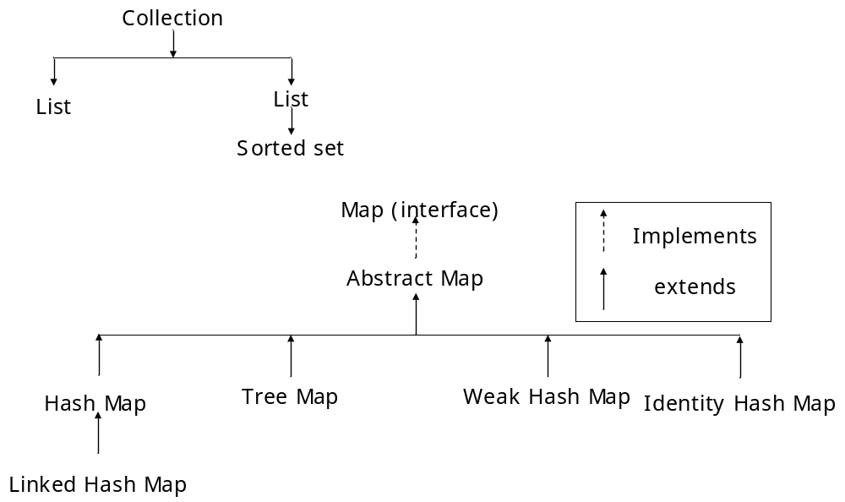
* The hash map class
* The Hash Map class uses a hash table to implement the map interface
This allows the execution time of basic operations, such as get () and put (), to remain constant even for large sets
* The following are the constructor defined in hash map class
Hash Map ()
Hash Map (Map M)
Hash Map (int capacity)
Hash Map (int capacity, float fill Ratio)
Hash Map implement map and extends abstract map. It does not add any methods of its own
Note: A hash map does not guarantee the order of its elements. There fore, the order in which elements are added to a hash map is not necessarily the order in which they are read by an iterator
* the following program illustrates Hash map. It maps names to account balances
import java.util.*;
class hash map demo
{
public static void main (string args [ ] )
{
Hash map hm =new hash map ();
hm.put (“MSD”,new Double (2218.40));
hm.put (“SSA”,new Double (8122.40));
hm.put (“MSS”,new Double (4037.40));
hm.put (“MSR”,new Double (3740.40));
hm.put (“SRK”,new Double (4730.40));
set set = hm entry set ();
iterator i= set. iterator ();
while (i.hash next ())
{
map.entry me =(map.entry)i.next ( );
s.o.print (me.get key ()+”:”);
s.o.p(me. get value ())
}
s.o.p;
// deposit 2218 into account
double balance = ((double) hm.get (“SSA”)) double value ();
hm.put (“SSA”, new Double (balance +2218));
s.o.p (“SSA new balance :”+hm.get (“SSA”));
}
}
Explanation: The program begins by creating a hash map and then adds mapping of names to balances
* Next the contents of the map are displayed by using a set-view obtained by calling entry set ()
* The keys and values are displayed by calling the get key ()
* And get value ( ) methods automatically replaces any preexisting value that is associated with the specific key with the new value. Thus after SSA’s account is updated, the hash map still contain just one “SSA” account
* The tree Map Class
* The tree map class implements the map interface by using a tree
* A tree map provides an efficient means of storing key /value pairs in sorted order and allows rapid retrieval
* A tree map guarantees that its elements will be sorted in ascending key order
*The following constructions are defined in tree map class
tree map ()
tree map (comparator comp)
Tree map (map m)
Tree map (sorted map m)
* Tree map implements sorted map and extends abstract map it does not define any additional methods of its own
* the following program illustrates tree map consider the previous example (hash map demo)
import java.util.*;
class tree map demo
{
public static void main (string args [])
{
tree map tm = new tree map ();
tm.put (“MSD”, new Double (2218.40));
tm.put (“SRK”,new Double (4730.18));
set set =tm.entry set ();
iterator I = set.iterator ();
while (i.hash Next( ))
{
map. entry me =(map.entry)i.next ();
s.o.print (me.get key ()+”:”);
s.o.p (me.get value ());
}
s.o.p ();
}
}
The output of the above program is
MSD: 2218.40
MSR: 3740.18
MSS: 4037.22
SRK: 4730.18
SSA: 8122.40
As mentioned earlier, the elements, the elements are sorted in ascending key order
Note:Tree map sorts the keys. How ever in this case , they are stored by first letter (infact first name) we can even make the tree map to sort the keys by last name (provided the key has first name and last name). This can be done by specifying a comparator when the map is created
The linked hash map class
* Linked hash map maintains a linked list of the entries in the map, in the order in which they were inserted. Thus, when iterating a linked hash map, the elements will be returned in the order in which they were inserted
* We can also create a linked hash map that returns its elements in the order in which they were last accessed
* Linked hash map defines the following constructors
Linked hash map (): Construct a default linked hash map
Linked hash map (map m): Initializes the linked hash map with the elements from m.
The following constructors are defined in tree map class
Tree map ()
Tree map (comparator comp)
Tree map (map m)
Tree map (sorted map m)
Tree Map implements sorted map and extends abstract map. It does not define any additional methods of its own
the following program illustrates tree map
consider the previous example (hash map demo)
import java.util.*;
class tree map demo
{
public static void main (string args [ ])
{
tree map tm = new tree map ();
tm. put (“MSD”, new double (2218.40));
tm. put (“SRK”,new double(4730.18));
set set =tm. entry set ();
iterator i= set.iterator ();
while (i.hash next ())
{
map. entry me =(map. entry)i.next ();
s.o.print (me.get key ()+”:”);
s.o.p (me.get value ());
}
s.o.p ();
}
}
The output of the above program is
MSD: 2218.40
MSR: 3740.18
MSS: 4037.22
SRK: 4730.18
SSA: 8122.40
As mentioned earlier, the elements, the elements are sorted in ascending key order
Note:Tree map sorts the keys. How ever in this case , they are stored by first letter (infact first name) we can even make the tree map to sort the keys by last name (provided the key has first name and last name). This can be done by specifying a comparator when the map is created
* The linked hash map class
* Linked hash map maintains a linked list of the entries in the map, in the order in which they were inserted. Thus, when iterating a linked hash map, the elements will be returned in the order in which they were inserted
* We can also create a linked hash map that returns its elements in the order in which they were last accessed
* Linked hash map defines the following constructors
Linked hash map (): Construct a default linked hash map
Linked hash map (map m): Initializes the linked hash map with the elements from m.
Linked hash map (int capacity): Initialize the linked hash map with the capacity specified
Linked hash map (int capacity; float fill ratio): Initializes with both capacity and fill ratio
Linked hash map (int capacity, float fill ratio, Boolean order);
This form allows us to specify whether the elements will be stored in the linked list by inversion order, or by order of last access. If order is true, then access order is used if order is false, then insertion order is used
* Linked hash map adds only one method to those defined by hash map
Protected Boolean remove eldest entry (map. entry e)
The identify hash map class:
This class extends hash abstract map
It is similar to hash map except that it uses reference equality when comparing elements
Note: The Java 2 documentation explicitly states that identify hash map is not for general use.
Comparators: Both tree set and tree map store elements in sorted order. By default, these classes store their elements by using the natural ordering which we usually expect
* if we want to order the elements in a different way , then specify a comparator object when * * we constant the set or map. Doing so gives us the ability to govern precisely how elements are stored with in sorted collections and maps
The comparator interface defines two methods: Compare () and equals ()
* Int compare (object obj1, object obj 2)
* Obj1 and obj2 are objects to be compared
* this method returns zero if the objects are equal. It returns a positive value if obj 1 is greater than obj 2 otherwise a negative value is returned
* By overriding compare () we can alter the way that objects are ordered
* for example to sort in reverse order, we can create a comparator that reverses the outcome of a comparison Boolean equals (object obj)
* this method tests whether an object equals the involving comparator
note: over riding equals () is unnecessary
* The following demonstrate the use of a comparator it causes a tree set to be stored in reverse order
import java util *;
class my comp implements comparator
{
public int compare (object a,object b)
{
string astr =(string )a;
string bstr=(string )b;
return bstr .compare to (astr);
}
}
class comp demo
{
public static void main (string args [])
{
tree set ts = new tree set ()new my comp ());
ts.add (“c”);
ts.add (“A”);
ts.add (“B”);
ts.add (“E”);
ts.add (“F”);
ts.add (“D”);
Iterator I = ts. iterator ();
while (i.has Next ())
{
object element =i.next ();
s.o.print (element +” ”);
}
s.o.p ();
}
}
Output: F E D C B A
Explanation: In the compare () method the string method compare to () compares the two strings how ever bstr involves compare to () rather than astr. this causes the outcome of the comparison to be reversed
the collection algorithms: the collections frame work defines several algorithms that can be applied to collections and maps these algorithms are defined as static methods with in the collections class
* we know that none of the standard collection implementations are synchronized
* to obtain synchronized (thread –safe) copies of the various collections we use synchronized list () and synchronized set ()
* The set of methods that begins with unmodificable returns views of the various collections that cannot be modifier. These will be useful when we want to grant some process read but not write capabilities on a collection
The legacy classes and interfaces:
* The original version of java util did not include the collections frame work
* Instead, it defined several classes and an interface that provided an adhoc of storing objects
With the addition of collections by java 2, several of the original classes were reconsidered to * * support the collection interfaces. Thus they are fully compatible with the frame work
Note: None of the collection classes are synchronized but all the legacy classes are synchronized
* The legacy classes defined by java.util are
* Dictionary hash table properties stock vector one legacy interface is enumeration
The enumeration interface:
* The enumeration interface defines the methods by which you can enumerate (obtain one at a time) the elements in a collection of objects
* This legacy interface has been superseded by iterator
* Although not deprecated, enumeration is consider obsolete for new code however, it is used by several methods defined by the legacy classes (such as vector & properties)
* Enumeration specifies the following two methods
* Boolean has more elements (): return true while there are still more elements to extract and returns false when all the elements have been enumerated
Next element (): Return the next object in the enumeration as a generic object reference i.e. each call to next elements () obtains the next object in the enumeration. The calling routine must cast that object type held in the enumeration
The vector class: Vector implements the concept of dynamic array
It is similar to array list but with two differences: Vector is synchronized and it contains many legacy methods that are not part of the collections frame work
* with the release of java 2, vector was reconsidered to extend abstract list and implement the list interface , so it is now fully compatible with collections
* the following are the constructors of vector class
vector ()
vector (int size)
vector (int size)
vector (int size. int iner)
vector (collection c)
* the first constructor creates a default vector , which has an initial size of 10
* the second constructor creates a vector whose initial capacity is specified by size.
* The third form creates a vector whose initial capacity is specifie4d by size and whose incensement is specified by iner. The increasement specifies the no. of elements to allocate each time that a vector is resized upwards.
* The fourth constructor creates a vector that contains the elements of collection c
* All vectors start with an initial capacity. After this initial capacity is reached, the next time when we attempt to store an object in the vector, the vector automatically allocates space for that object plus extra room for additional objects
* By allocating more than just the required memory, the vector reduces the no. of. Allocations that must take place. this reduction is important , because allocations are costly in terms of time
* The amount of extra space allocated during each re allocation is determined by the increment that you specify when we create the vector
* If we don’t specify an inachievemernt, the vector size is doubled by each allocation cycle
Vector defines the following protected data members
int capacity increasement: The increment values is stored in capacity increment
int element count : The no.of.elements currently present in the vector is stored in element count
Object element data [ ]: The array that holds the vector is stored in element data
* In addition to the collections methods defined by list, vector defines several legacy methods as shown below
Void add element (object element)
Int capacity ()
Object clone ()
Boolean contains (object element)
Void copy info (object arrays [ ])
Object element At (int index)
Enumeration elements ( )
Void ensure capacity (int size)
Object first element ()
Int index of (object element)
Int index of (object element, int start)
Void insert element at (object element, int index)
Boolean is empty ()
Object last element ()
Int last index of (object element, int start)
Void remove all elements ()
Boolean remove element (object elements)
Void remove element at (int index)
Void set element at (object element, int index)
Void set size (int size)
Int size ()
String to string ()
Void trim to size ()
The following program user a vector to store various type of numeric objects. It demonstrates several of the legacy methods defined by vector it also demonist rates the enumeration interface
s.o.p (“initial size:”+v.size());
s.o.p (“initial capacity:”+v.capacity ());
v.add elemet (new integer (1));
v.add element (new integer (2));
v.add element (new integer (3));
v.add element (new integer (4));
s.o.p (“capacity after additions:”+v.capacity ());
v.add element (new double (5.45));
s.o.p (“current capacity:”+v.capacity ());
v.add element (new float (9.4));
v.add element (new integer(10));
s.o.p(“current capacity :”+v.capacity ());
v.add element (new float (9.4));
v.add element (new integer (10));
s.o.p (“current capacity:”+v.capacity ());
v.add element (new integer (11));
v.add element (new integer (12));
s.o.p (“first element :”+( integer)v.first element ());
s.o.p (“last element :”+( integer)v.last element ());
if (v.contains (new integer (3)))
s.o.p (“vector contains 3”);
enemuration v enum:v.elements ();
s.o.p (“\n elements in vector :”);
while (venum.has more elements ())
s.o.print (venum.next element ()+ “”);
s.o.p();
}// main
}// class
the output of the above program is
initial size =0
initial capacity :3
capacity after four additions :5
current capacity:5
current capacity :7
current capacity:9
first element:1
last element:12
vector contains 3
elements in vector:
1 2 3 4 5.45 6.08 7 9.4 10 11 12
Note: With the release of java2, vector added support for iterators instead of relying on an enumeration to cycle through the objects, we can now use an iterator
* Because enumerations are not recommended for the new code . We will usually use an iterator to enumerate the contents of a vector. Fortunanality, enumerations and iterators work in nearly the same manner
The stock class:
* Stock is a subclass of vector that implements a standard last – in, first-out (LIFO) stack
Stock only defines the default constructor, which creates an empty stack
* Stack includes all the methods defined by vector and in addition to these, defines the following methods
boolean empty ()
object peck (): Returns the element on the top of the but does not remove it
object pop ()
object push (object element)
int search (object element): searches for element in the stack if found , its off set from the top of the stack is returned other wise -1 is returned
the following program creates a stack, pushes several integer objects into it and then pops if again
import java.util .*;
class stack demo
{
static void shown push (stack st, int a)
{
st.push (new integer (a));
s.o.p (“push(“+a+”)”);
s.o.p (“stack :”+st);
}
static void showpop (stack st)
{
s.o.print (“pop ”);
integer a =(Integer) st.pop();
s.o.p (a);
s.o.p (“stack:”+st);
}
public static void main (string args [])
{
stack st = new stack ();
s.o.p (“stack :”+st);
showpush (st,42);
showpush (st,66);
showpush (st,99);
showpop (st);
showpop (st);
showpop (st);
try
{
show pop (st);
}
catch (empty stack exception e)
{
s.o.p (“empty stack”);
}
}
}

The output of the above program is
stack: [ ]
push (42)
stack :[42]
push (66)
stack: [42,66]
push (99)
stack:[42,66,99]
pop99
stack:[42,66]
pop66
stack:[42]
pop42
stack:[ ]
pop empty stack
The dictionary class: Dictionary is an abstract class that represents a key/value storage repository and operates much like a map.
* Given a key and a value, we can store the value in a dictionary object. Once the value is stored, we can retrieve it by using its key. Thus , like a map, a dictionary can be thought of as a list of key / value pairs
* Although not actually deprecated by java2, dictionary is classified as obsolete it is superseded by map.
* The following are the abstract methods defined by dictionary
Enumeration, elements ()
Object get (object key)
Boolean is empty ()
Enumeration keys ()
Object put (object key, object value)
Object remove (object key)
int size ()
Note: The dictionary class is obsolete we should implement the map interface to obtain key/value storage functionality
The hash table class:
Hash table was part of the original java. Util and is a concrete implementations of a dictionary
How ever, java recognized hash table so that it also implements the map interface. Thus hash table is now integrated into the collections frame work it is similar to hash map, but is synchronized
* Like hash map, hash table stores key/value pairs in a hash table. When using a hash table, we specify an object that it’s used as a key and the value that we want linked to that key. The key is then hashed, and the resulting hash code is used as the index at which the value is stored with in the table
* The following are the constructors defined in hashtable.
Hashtable()
Hashtable (int size)
Hashtable (int size, float fill ratio)
Hashtable(Map m)
* In addition to the method defined by the Map interface, which hashtable now implements, hashtable defines the following legacy methods.
Void clear()
Object close()
Boolean contains(object value).
Boolean contains(object value)
Enumeration elements()
Object get(object key)
Boolean is empty()
Enumeration keys()
Object put(object key, object value)
Void rehash()
Object remove (object key)
Int size()
string to string()
* The following program shows the wage of a hashable
Import java.util.*;
Class hastabledemo
{
Public static void main(string args[])
{
Hashtable bal : new hashtable();
Enumeration names;
String str;
Double balance;
Bal.put(“Msd”, new double (9999.oo));
Bal.put(“SSA”, new double(18999.40));
Bal.put(“MSS”, new double(1822.35));
Bal.put(“SSD”, new double(2218.40));
Names=bal.keys();
While(names.hasmoreelements())
{
Str = (stringnames.next elements();
s.o.p(str+”:”+bal.get(str));
}
s.o.p();
balance = (double)bal.get(“MSD”)).doublevalue();
bal.put(“MSD”, new double(balance+10000));
s.o.p(“MSD’s now balance:”+bal.get(“MSD”));
}
}

The output of the above program is
SSA: 18999.40
MSD: 9999.00
MSS: 1822.35
SSD: 2218.40
MSD’s new balance:19999.00
Note:- Like the map classes, hashtable does not directly support iterators. Thus, the preceding program uses an enumeration to display the contents of bar.
However, we can obtain set-views of the hash table, which permits the use of iterators. To do so, we simply use one of the collection. View methods defined by Map, such as entryset() or keyset(). For example, we can obtain a set-view of the keys and iterate through them.
* The properties class:-
Properties is a subclass of hash table:-
* It is used to maintain lists of values in which the key is a string and the value is also a string.
* The properties class is used by many other java classes.
For example, it is the type of object returned by system.getproperties() when obtaining environmental values.
* Properties class defines the following instance variable:
Properties class defines the following instance variable:
Properties defaults: This variable holds a default property list associated with a properties object.
* The properties class defines the following constructors:-
Properties(): creates a properties object that has no default values.
Note:- In both the above cases, the property list is empty.
* In addition to the methods that properties list is empty.
Note:- Properties also contains one deprecated method i.e. save(). This was replaced by store() because save() did not handle errors correctly.
String getproperly(string key)
String getproperly(string key, string default property)
void list(print stream streamout)
void list(print writer streamout)
void load(inputstream streamin) throws IOException.
Enumeration property names()
Object setproperty(string key, string value)
Void store(output stream streamout, stringdescription)
*One useful capability of the properties class is that we can specify a default property that will be returned if no value is associated with a certain key.
Ex:- A default value can be specified along with the key in the get property() method – such as
Get property(“name”, “default value”);
If the “name” value is not found, then “default value” is returned.
* The following example demonstrates properties. It creates a property list in which the keys are the names of states and the values are the names of their capitals.
An attempt to find the capital of west Bengal includes a default value, in this example.
Import java.util.*;
Class propdemo
{
Public static void main(string arg[])
{
Properties capitals = new properties();
Set states;
String str;
Capitals.put(“Andhrapradesh”, “Hyderabad”);
Capitals.put(“Tamilnadu”, “Chennai”);
Capitals.put(“kerala”, “Trivandrum”);
//show all states and capitals in a hashtable. States = capitals.keyset(); //get set-view of keys.
Iterator.itr = states.iterator();
While(itr.hasnext())
{
Str = (string) itr.next();
s.o.p(“The capital of “+str+”is”+capitals.get property(str)”);
}
s.o.p(“The capital of westbengal is:+str);
}
}
The output of the above program is,
The capital of Andhrapradesh is Hyderabad.
The capital of tamilnadu is Chennai.
The capital of Karnataka is Bangalore.
The capital of kerala is trivandrum.
The capital of westbengal is not found.
* Using store() and load():- One of the most useful aspects of properties is that the information contained in a properties object can be easily stored to or loaded from a disk with the store() and load() methods. At anytime, we can write a properties object to a stream or read it back. This makes property list especially convenient for implementing simple databases.
MORE UTILITY CLASSES
* The string tokenizer class:-
* The processing of text often consists of parsing a formatted input string.
* Parsing is the division of text into a set of discrete parts, or tokens, which in a certain sequence can convey a semantic meaning.
* The string tokenizer class provides the facility of parsing the text. It is often called lexer(lexical analyxer) or scanner.
* String tokenizer implements the Enumeration interface. Therefore, given an input string, we can enumerate the individual tokens contained in it using string tokenizer.
* To use string tokenizer, we can specify an input string and a string that contains delimiters.
* Delimiters are characters that separate tokens. Each character in the delimiter string is considered a valid delimiter.
* The default set of delimiters consists of white space character such as space, tab, newline etc.
* In general, space is used as the default delimeter.
* The following are the constructors in string tokenizer
string tokenizer(string str)
String tokenizer (string str, string delimiters)
String tokenizer(string str, string delimiters, Boolean delim as token)
* In all the three constructors mentioned above, str is the string that will be tokenized.
* In the first constructor, the default delimiter (space) is used.
* In the second and third constructors, delimiters is a string that specifies the delimiters.
* In the third constructor, if delim a stoken is true, then the delimiters are also returned as tokens when the string is parsed. Otherwise, the delimiters are not returned. Delimiters are not returned as tokens by the first two forms.
* The following are the methods defined in string tokenizer.
Int counttokens()
Boolean hasmore elements()
Boolean hasmore tokens()
Object nextelement()
String nexttoken()
String nexttoken(string delimiters)
* The following program demonstrates a string tokenizer
Import java.util.stringtikenizer;
Class STDemo
{
Static string str:”This-is-my-core-java-notes”;
Public static void main(string args[])
Stringtokenizer st = new stringtokenizer(str, “-“)
While (st.hasmoretoken();
s.o.p(s1);
}
}
Output:
This is my core java notes (printed vertically)
*The data class:
* The data class encapsulates the current date and time.
* Data class supports the following constructors
Date() & date(long millisec)
* The first constructor initializes the object with current system date and time.
* The second constructor accepts one argument that equals the no. of milliseconds that have elapsed give midnight, jan1, 1970.
* Date class also implements comparable interface.
* The following are the non-deprecated methods defined in the date class.
Boolean after (date date)
Boolean before(Date date)
Object done()
Int compare to (Date date)
Int compare to (object obj)
Boolean equals (object date)
Long gettime()
Int hashcode()
Void settime(long time)
String tostring()
* From the above methods, it is obvious that, the date features do not allow us to obtain the individual components of the date or time. To obtain more detailed information about the date and time, we use the calendar class.
* The calendar class:
* The calendar class is abstract and provides a set of methods that allows us to convert a time in millisecond in a no. of useful components such as year, month, day, hour, minute and second.
* It is intended subclasses of calendar will provide the specific functionality to interpret time information according to their own rules. An example of such a class is Gregorian calendar.
Note:- Calendar provides no public constructors.
* The Gregorian calendar class:
* Gregorian caledar is a concrete implementation of a calendar. The get instaure() method of calendar returns a Gregorian calendar initialized with the current date and time in the default locale and time zone.
* The following are the constructors defined in the Gregorian calendar()
Gregoriancalendar(int year, int month, int day of month)
Gregoriancalendar(int y, int m, int dom, int hours, int minutes)
Gregorian calendar(int year, int month, int dayofmonth, int hours, int minutes, int seconds)
* GregorianCalendar provides an implementation of all the abstract methods in calendar. It also provides some useful and interesting methods.
Ex:- isleapyear(): returns true if the year is a leap year and false otherwise.
The signature of this method is
Boolean isleapyear(int year)
* The timezone class:-
* This is another time-related class.
* The timezone class allows us to work with time zone offsets from Greenwich mean time(GMT)
* It also computes day light saving time.
* Time zone supplies only the default constructor.
* The simpletime zone class;
*The simpletimezone class is a convenient subclass of timezone.
* It provides bodies for the abstract methods defined in timezone class and allows us to work with time zones for a Gregorian calendar.
* It also computes daylight saving time.
* Simpletimezone defines four constructors with different arguments.
* The locale class:-
* The locale class is instantiated to produce objects that each describe a geographical cultural region.
* It is one of the several classes that provides us with the ability to write programs that can execute in several defferent international environments.
Ex:- The formats used to display dates, times and numbers are different in various regions.
* The locale class defines same constants that are useful for dealing with the most common locales.
Ex: The expression locales. FRENCH represents the locale object for French
* The following are the constructors defined in locale class
Locale (string language)
Locale (string language, string country)
Locale (string language, string country, string data)
* The above constructors build a locale object to represent a specific language and in the case of second and third constructors, also a specific country.
* Locale defines several methods, which return human - readable strings that can used to display the name of the country, the name of the language and the complete description of the locale.
Note: Calendar and Gregorian calendar are examples of classes that operate in a locale - sensitive manner.
Data Format and simple Data Format also depend on the locale.
The Random Class:
* The random class is a generator of pseudorandom numbers.
* These are called pseudorandom numbers because they are simply uniformly distributed senesces.
* The following are the contractors defined in Random class Random ( ); creates a number generator that uses time as the starting or seed value.
Random (long seed): This form allows us to specify a seed value manually.
* Of we initialize a Random object with a seed, we defined starting point for the random senesces.
* Of we use the same seed to initialize another Random object we will extract the same random senesces.
* Of we want to generate different senesces, then we should specify different seed values. The easiest way to do this is to use the current time to seed a random object. This approach reduces the possibility of getting repeated senesces.
The Observable Class:
* The observable class is used to create subclass that other parts of our program can observe.
* When an object of such a subclass undergoes a change, observing classes are notified.
* Observing classes must implement the observer interface, which defines the update method the update ( ) method is called an observer is notified of a change in an observed object.
* An object that is being observed must follow two simple rules:
(i) First if it has changed, it must call set changed( ).
(ii) When it is ready to notify observers of this change, it must in all notify observering Objects to be called.
NOTE: If the object calls notify observers ( ) without haring previously called set changed ( ), no action will take place. The observed object must call both set changed ( ) and notify observers( ) before update( ) will be called.
The Observer Interface:
* To observer an observable object, we should implement the observer interface.
* This interface defines only one method as shown below.
Void update (observable observob, object arg)
Here observob is the object being, and arg is the value passed by notify observers ( ). The update ( ) method is called when a change in the observed object takes place.
Timer and Timer Task:
Java2, version 1.3 added interesting and useful feature to java util i.e. the ability to schedule a task for execution at same feature time. The class that support this feature are Timer and Timer Task.
* Using these class we can cerate a thread that runs in the background, waiting for a specific time when the time arrives, the task linked to that thread is executed.
* Although it was always possible to manually create a task that would be executed at a specific time using the thread class, timer and timer task greatly simplify this process.
* Timer and Timer Task work together.
* Timer is the class that we will use to schedule a task for execution. The task being scheduled it for execution using an instance of timer.
* Timer Task implements the runnable interface; this it can be used to create a thread of execution.
* the easiest way create a timer task is to extend Timer Task and override run ( ).
The Currency Class:
* Java2 version 1.4 adds the currency class.
* This class encapsulates information about a currency.
*Of defines no constructors.

